**Department of Veterans Affairs**

**Innovation 873**

**Telepathology**

**VistA Imaging 3.0**

**System Design Document**



**September 2015**

**Version 1.2**

**Revision History**

|  |  |  |  |
| --- | --- | --- | --- |
| **Date** | **Version** | **Description** | **Author** |
| 09-14-15 | 1.2 | Update for Innovation 873 new features | Csaba Titton |
| 10-29-14 | 1.1 | Update for Innovation 873 | Julian Werfel |
| 03-21-13 | 1.00 | Accepted WPR actions | Duc Nguyen |
| 03-12-13 | 0.93 | Updated for delivery | Duc Nguyen, Mike Henderson, Julian Werfel, Jemmy Lin |
| 01-24-13 | 0.92 | Updated for WPR | Duc Nguyen |
| 01-15-13 | 0.91 | Updated new changes for M code | Jemmy Lin |
| 12-13-12 | 0.9 | Updated document with extra information | Duc Nguyen |
| 10-22-12 | 0.8 | Updated document with reviewed items | Duc Nguyen |
| 10-11-12 | 0.7 | Updated patch number and WPR items | Duc Nguyen |
| 08-20-12 | 0.6 | Updated design for worklist manager | Paul Pentapaty |
| 08-17-12 | 0.5 | Added VIX design details | Julian Werfel |
| 08-14-12 | 0.4 | Updated design for the applications | Duc Nguyen |
| 12-06-11 | 0.3 | Added design for Report GUI in 6.2.4 | Duc Nguyen |
| 12-05-11 | 0.2 | Added View Log and Request Consultation Use cases. Updated screen shots. Updated View and View Model Table | Sundar Kingsley |
| 11-18-11 | 0.1 | Started Worklist Design | Sundar Kingsley |

**Table of Contents**

1. Introduction 1
   1. Purpose of this Document 1
   2. Identification 1
   3. Scope 1
   4. Relationship to Other Plans 2
   5. Methodology, Tools, and Techniques 2
   6. Policies, Directives, and Procedures 2
   7. Constraints 2
   8. Design Trade-offs 3
   9. User Characteristics 3
      1. User Problem Statement 3
      2. User Objectives 4
2. Background 4
   1. Overview of the System 4
   2. Overview of the Business Process 5
   3. Business Benefits 6
   4. Assumptions and Constraints 6
      1. Design Assumptions 6
      2. Design Constraints 6
   5. Overview of the Significant Requirements 6
      1. Overview of Significant Functional Requirements 6
      2. Functional Workload and Functional Performance Requirements 7
      3. Operational Requirements 7
      4. Overview of the Technical Requirements 8
      5. Overview of the Security or Privacy Requirements 8
      6. System Criticality and High Availability Requirements 8
      7. Special Device Requirements 8
   6. Legacy System Retirement 8
3. Conceptual Design 9
   1. Conceptual Application Design 9
      1. Application Context 9
      2. High Level Application Design 9
      3. Application Locations 9
      4. Application Users 10
   2. Conceptual Data Design 10
      1. Project Conceptual Data Model 10
      2. Database Information 10
   3. Conceptual Infrastructure Design 11
      1. System Criticality and High Availability 11
      2. Special Technology 11
      3. Technology Locations 11
      4. Conceptual Infrastructure Diagram 11
4. System Architecture 11
   1. Hardware Architecture 11
   2. Software Architecture 11
   3. Communications Architecture 13
5. Data Design 13
   1. Database Management System Files 13
   2. Non-Database Management System Files 13
6. Detailed Design 13
   1. Hardware Detailed Design 13
   2. Software Detailed Design 13
      1. VIX Client Facade 13
         1. Security 14
         2. Pathology Service 14
         3. User Service 28
         4. Patient Service 28
      2. VIX Commands 29
      3. VIX Service Provider Interfaces 30
      4. Data Source Provider Implementations 31
      5. Telepathology Report Editor 32
      6. Telepathology Configurator 37
      7. Telepathology Worklist 42
      8. M Code Design 69
   3. Communications Detailed Design 162
      1. HL7 Messaging Routines (Entry Points) 162
7. External Interface Design 177
   1. Interface Architecture 177
   2. Interface Detailed Design 177
8. Human-Machine Interface 177
   1. Interface Design Rules 177
   2. Inputs 177
   3. Outputs 180
   4. Navigation Hierarchy 180
      1. Telepathology Configurator 181
      2. Telepathology Worklist 184
      3. Notes 189
      4. Message Log 189
      5. Reporting 190
      6. Patient Sensitive Prompt 193
9. System Integrity Controls 194
10. Appendix A 194
    1. Data Dictionaries (DDs) 194
    2. Requirements Traceability Matrix 210
    3. Packaging and Installation 210
    4. Design Metrics 210
    5. Glossary of Terms 210
    6. Required Technical Documents 211

Attachment A - Approval Signatures 212

# Introduction

Anatomic pathology involves reaching a diagnosis based on examination of tissues and/or body fluid samples. It includes gross and microscopic examination of the samples. Mostly the examination and diagnosis are done locally. Consultations and second opinions, if needed, are obtained using mail or couriers to deliver data to the consulting clinician(s). The Department of Veterans Affairs (VA) was successful in deployment of Telemedicine applications in the areas of diabetic retinal screening and Teledermatology. Consequently, the Care Coordination and Telehealth Program Office, is requesting the Veterans Health Information Systems and Technology (VistA) Imaging team to develop a Telepathology solution for deployment in the VA Enterprise.

VistA Imaging has been directed to develop a Telepathology solution that will allow physicians to expedite and improve treatment of (VA) patients. Rural areas with few or no pathology service can access the services of Telepathology to support their patients. This will increase the efficiency of pathologists by enabling consultations and coverage when pathologists are on leave. In the future, it will also be able to support tumor board, education, and medical research.

The Veterans Health Administration (VHA) has affiliations with academia and commercial medical centers in the contiguous United States, employing leaders in the field of pathology. The ability to network these resources and share such expertise would have a profound effect on the delivery of care to veteran patients.

## Purpose of this Document

The purpose of this document is to describe the design of the VistA Imaging Telepathology Application (VITA) which will provide the ability to conduct pathology studies locally and remotely within the VHA. This design follows the requirements outlined in the Requirements Specification Document (RSD).

## 1.2. Identification

See Title page

## 1.3. Scope

This design document will describe the design within the scope for this patch.

**Table 1: Scope Inclusions**

|  |
| --- |
| **Includes** |
| Create Telepathology Worklist to provide a workspace for pathologists |
| Create Telepathology Report Editor to provide an alternative reporting interface for pathologists |
| Create Telepathology Configurator to configure the environment for the worklist |
| Create an alternative user interface of the Laboratory (LAB) Package in VistA to support the Telepathology solution |
| Develop a VistA Health Level Seven (HL7) communication interface and a vendor validation interface |
| Develop a standalone, web-based vendor validation capability |

**Table 2: Scope Exclusions**

|  |
| --- |
| **Excludes** |
| Storage and retrieval of stored whole scan images |
| Interfacing with pathology equipment vendors |

## Relationship to Other Plans

This design document implements the requirements as described in Requirements Specification Document (RSD). This design document also include the .NET code design describing the clients, the M code design describing the server code, and the VistA Imaging Exchange (VIX) web-service design.

## Methodology, Tools, and Techniques

Development Methodology

VistA Imaging utilizes the Waterfall methodology as practiced by the VA. To accommodate the short cycle time of the project it adapts Agile methodology using Scrum by breaking the development process (designing, coding, unit testing) into multiple short (4-week) sprints. At the end of each sprint, the project will be reviewed by the team. Throughout the development process, demonstrations may be provided to customers to ensure that satisfaction and direction are met.

Tools

The front-end clients are built using Microsoft Visual Studio 2010 Professional. The applications are coded in C# .NET 4.0 environment with WPF.

VIX Services are coded in JAVA.

VistA data querying are coded using MUMPS.

The applications connects to VistA using VIX and VA Remote Procedure Call (RPC) Broker Team Foundation Server (TFS) will be used to track work items and bugs

Techniques

The front-end clients will be built using Model-View-ViewModel (MVVM) design pattern with help from the MVVM Light Toolkit.

## Policies, Directives, and Procedures

The applications will follow existing policies established by the LAB package.

## 1.7. Constraints

* + - Since the project uses a special schedule, which consists of multiple short cycles, information gathering, analyzing, and coding are mixed together. This sometimes causes delay in providing complete functionality or providing more desired features.
    - Due to the scale of the project and the schedule constraint, the project will be divided into two phases.
    - The VistA LAB package is currently in maintenance mode preventing new changes/enhancements from being made at this time. It has been difficult to find point of contacts who are responsible for maintaining the LAB package to get support or to make minor changes to the package interface. As a legacy package, the functionalities that are currently implemented are a constraint to the development team.
    - Third party pathology equipment vendor development and ability is outside the control of the VistA Imaging development team.

- There is no current industry workflow standard for Telepathology

## Design Trade-offs

Communication

Adapting the VistA Imaging Service Oriented Architecture (VISA), the applications only communicate with the local VistA system through RPCs to authenticate the users and to get/set simple site configurations. All other communications with VistA, either local or remote, will be conducted using the VIX. This requires sites to have a VIX installed and configured in order to use the application. However, since all the VistA systems are VIX-enabled now, this is no longer a concern. By communicating through the VIX, it will be easier to expand the system to the whole VA Enterprise and the Department of Defense (DoD).

Consultation

A consultation, which is an opinion from a different pathologist, plays a critical part in Pathology. Currently, as reports are completed at a remote facility, they are either faxed or mailed to the acquisition site. In the Telepathology solution, these consultation reports are being implemented in the form of supplementary reports, which are additional reports attached to the main report. The special study function in the LAB package does not provide enough functionalities to conduct consultation across sites. Using supplementary report as a reporting vehicle will maintain all consultations, and additional information for a case in one place. Each remote consultation will be tagged with a soft identification since we don’t have a method to completely associate a consultation with a supplementary report.

## User Characteristics

The users of the Telepathology Worklist are those working for the VA that have been authorized (with appropriate VistA menus assigned and LRLAB security key) to use the LAB Package in the VistA system. If the users have the MAG SYSTEM key, they can use the Telepathology Configurator to configure the system. MAG SYSTEM key holders do not need to have LRLAB key but will need appropriate menu (MAGTP WORKLIST MGR) assigned to use the worklist. However, users must have LRLAB to work on LAB’s cases.

### User Problem Statement

* + - * Pathology services are limited in rural areas
      * There is no interface between digital pathology systems and current VistA systems
      * No streamlined process for sites to do pathology services such as consultations, concurrences

### User Objectives

* + - * Provide new applications to help daily local or remote pathology activities
      * Develop a more streamlined process to do pathology services

# Background

Currently pathology services in the VHA are based upon the longstanding traditional model of reviewing pathological specimens to make clinical diagnosis. This traditional process involves the physical preparation, staining, mounting of tissues on glass slides from pathological specimens, and then reviewed by a pathologist at the same site where the slides originated. In some situations, when pathology services cannot be completed locally due to staffing shortage or when a consultation is needed from another pathologist, services from a remote site may be required. This usually involves the transferring of specimens or physical slices to where they have the ability to be reviewed, which also causes duplication of data in different VistA systems. With recent advances in technology, it is possible for slides images to be sent digitally (e.g. through robotic systems, Whole Slide Image (WSI)…) to a different location which opens new opportunities for Telepathology. This project is the first phase to enable the ability to do Telepathology in the VA through the existing VistA infrastructure.

## Overview of the System

The code provides new applications that will enhance the current pathology workflow for pathologists in the VA. These applications will be the stepping stones for the next phases in the Telepathology initiative. The Telepathology Worklist will serve as a main portal for pathologists to view their cases. Using the Telepathology Worklist, lab technicians and pathologists can enter data for cases, complete, result cases, and request real-time consultations from pathologists at other VHA sites. The Telepathology Configurator will be used mostly by system administrators to configure the environment for both local and remote readings of cases.

## Overview of the Business Process

TP Readings:

Create accession

Acquisition

Case is available for reading

Case is available for consultation

Case is available for remote read

Update consultation status

Load in Worklist Manager

Primary Read

Select a case and start editing report

Editing report Completing report

Need consultation

Y Requesting consultation

Verify Main Report

Create and Verify duplicate

|  |  |  |  |  |  |
| --- | --- | --- | --- | --- | --- |
| Load in | Select a case |  | Write | Verify | Create and |
| Worklist | and start | Editing report | Supplementary | Supplementary | Verify |
| Manager | editing report |  | report | report | duplicate |

**Figure 1: Reading Process**

Consulting

Note: The Create and Verify duplicate process will only happen if the reading site is remote.

## Business Benefits

The solution will focus on providing enhancements that will support day to day activities of pathologists. The following are major benefits:

* Better user experience/interface
* Ability to retrieve remote cases for readings
* Ability to request consultations and concurrence
* Improve reading time
* Reduce duplication of data among sites
* Maintain a central storage of Electronic Health Record (EHR) data for the patient
* A more streamlined workflow

## Assumptions and Constraints

This section describes the assumptions, and constraints that impacted the design of the system.

### Design Assumptions

In the solution, we are assuming that there would be an update to M routines that provide the user interface of the VistA Laboratory Package to accommodate our M routines. We also assume that the workflow derived from the current databases is correct.

### Design Constraints

Supplementary Report/Consultation

Since there is nothing in the existing LAB package that can accommodate the complexity of a fully functional consultation workflow, supplementary report is being used as a mechanism for this to happen. However, it’s impossible to completely tie a supplementary report to a consultation from a site.

Data integrity

Even though the application provides rules to maintain the integrity of the data entered, the LAB package doesn’t have ability to track changes and audit the data prior to the case being verified and released. Even when the case has already been verified and released, data can still be modified or completely replaced, by using the existing pathology menu provided by the LAB package.

## Overview of the Significant Requirements

### Overview of Significant Functional Requirements

**Table 3: Functional Requirements**

|  |  |  |
| --- | --- | --- |
| **ID** | **Specific Requirement**  **/ Synopsis** | **Requirement** |
| TP-TPWL-FR | Worklist | VistA Imaging Telepathology Applications (VITA) shall provide a centralized Telepathology Worklist for all anatomic pathology cases. (TPWL) |
| TP-TPR-FR | Report | VITA shall provide a Telepathology Report Editor for completing pathology reports. (TPR) |

|  |  |  |
| --- | --- | --- |
| **ID** | **Specific Requirement**  **/ Synopsis** | **Requirement** |
| TP-CODE-FR | Code | VITA shall support the ability to enter necessary coding that is completed by pathologists. (CODE) |
| TP-TPC-FR | Configurator | The Telepathology Configurator shall allow for site configuration. (TPC) |
| TP- CONSULTS- FR | Consultation | VITA shall support the need for consultative services within pathology. (CONSULTS) |
| TP-HL7-FR | HL7 | VITA shall create a messaging interface with VistA and Vendor Digital Pathology Systems using HL7 messaging and the VistA HLO package. |

### Functional Workload and Functional Performance Requirements

This section is not applicable to the solution

### Operational Requirements

**Table 4: Operational Requirements**

|  |  |
| --- | --- |
| **ID** | **Requirement** |
| TP-TPWL-FR-3 | The Telepathology Worklist shall provide a list of unread cases. |
| TP-TPWL-FR-4 | The Telepathology Worklist shall provide a list of anatomic pathology cases for a selected patient. |
| TP-TPWL-FR-5 | The Telepathology Worklist shall provide a list of cases for which the report has been verified and released. |
| TP-TPWL-FR- 14 | Users shall be prompted with a warning message when Sensitive Patient Information (SPI) is being accessed. |
| TP-TPWL-FR- 15 | The Telepathology Worklist shall display a health summary for a selected patient. |
| TP-TPR-FR-1 | Users of the Telepathology Report Editor shall be able to enter data for a report for Surgical Pathology (SP), Cytopathology (CY), and Electron Microscopy (EM) Anatomic Pathology cases. |
| TP-CODE-FR-1 | Shall provide a user the mechanism to enter System Nomenclature of Medicine Clinical Terms (SNOMED) and Clinical Procedure Terminology (CPT) codes directly from the Telepathology Report Editor on the Coding Tab. |
| TP-TPC-FR-4 | The Telepathology Configurator shall provide a mechanism that allows a site to manage remote sites for which they read. |
| TP-TPC-FR-5 | The Telepathology Configurator shall provide a mechanism that allows a site to manage remote sites that read for them. |
| TP-TPC-FR-6 | The Telepathology Configurator shall provide a mechanism that allows a site to configure its report templates. |
| TP- | The Telepathology Worklist shall provide a method for requesting consultations for |

|  |  |
| --- | --- |
| CONSULTS- FR-1 | a case. |
| TP- CONSULTS- FR-3 | The Telepathology Worklist shall display the consultation status. |
| TP- CONSULTS- FR-4 | For a consultation, the user shall only be able to enter data within the supplementary report. |
| TP- CONSULTS- FR-5 | Upon completion of a consultation, the Telepathology Report Editor shall generate a new report. |
| TP- CONSULTS- FR-6 | When a consultation is requested for a patient that is not registered in the consultation site’s VistA system, VITA shall send a message requesting the patient be registered at the consulting site. |
| TP-HL7- FR-1 | When an accession is logged in the Telepathology package, VistA shall produce an HL7 order message for transmission to the site's digital pathology system. |

### Overview of the Technical Requirements

VITA shall run on Windows 7 and Windows XP.

### Overview of the Security or Privacy Requirements

The solution will be installed on existing VistA Imaging workstations and will follow existing security requirements.

### System Criticality and High Availability Requirements

The solution will follow existing requirements established by the LAB package. The applications will serve as an alternate interface so that in a worst-case scenario, users can revert to the existing interface.

### Special Device Requirements

The applications require sites to have the VIX and Clinical Context Object Workgroup (CCOW) installed.

The applications require workstations to have .Net Framework 4.0 and Microsoft Visual C++ 2010 (x86) Redistributable Package installed.

## Legacy System Retirement

The solution will not retire any legacy system.

# Conceptual Design

## Conceptual Application Design

### Application Context

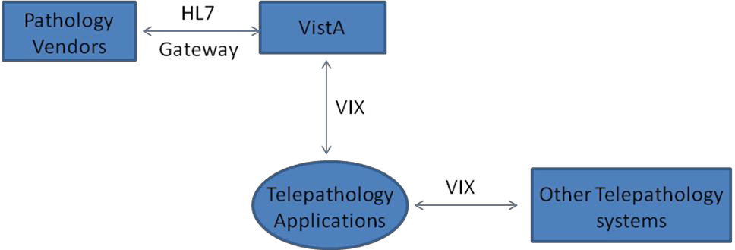

**Figure 2: Application Context**

The clients will use existing LAB and IMAGING storage in VistA to store data. The communication will be handled via the VIX. Third-party vendor systems can be connected to the system via HL7 messages and the DICOM Image Gateway to facilitate remote reading and image capture and transfer. This system will handle the capturing and storing of snapshots and digital pathology images. Case management communication between the outside system and VistA will be conducted using HL7 messages. In the future, the outside system can send back images using the Gateway. Inside the VHA, each client can contact each other using the VIX.

### High Level Application Design

This section is not applicable to the solution

### Application Locations

**Table 5: Application Locations**

|  |  |  |  |
| --- | --- | --- | --- |
| **Application Component** | **Description** | **Location at Which Component is Run** | **Type** |
| Telepathology Worklist | The Telepathology Worklist provides a centralized gateway for all pathology cases from the VistA database | Lab Workstations connected to the VA Intranet and authenticated to the VistA server | Computer |
| Telepathology Configurator | Pathology Worklist Configurator provide a tool for a site to configure the working environment for the worklist | Lab Workstations connected to the VA Intranet and authenticated to the VistA server | Computer |

### Application Users

**Table 6: Application Users**

|  |  |  |
| --- | --- | --- |
| **Application Component** | **Location** | **User** |
| Telepathology Worklist | VHA Lab workstations | Authorized VA and LAB users (with MAGTP WORKLIST MGR menu and MAG SYSTEM or LRLAB key  assigned) such as pathologists, technicians, clinicians, administrative  personnel |
| Telepathology Configurator | VHA Lab workstations | Authorized VA and LAB user with MAGTP WORKLIST MGR menu and MAG SYSTEM key assigned |

## Conceptual Data Design

### Project Conceptual Data Model

This section is not applicable to the solution

### Database Information

Refer to section 10.1. for more detail.

The following new and modified VistA files are included in this patch:

**Table 7: Data Inventory**

|  |  |  |  |
| --- | --- | --- | --- |
| **Database Name** | **Description** | **Type** | **Steward** |
| HLO APPLICATION REGISTRY  file(#779.2) | The file is used to register sending and receiving applications for HL7 messaging. For receiving applications, the process of registration consists of registering what messages the application is prepared to receive. | Create new file | HL7  Imaging(MAG) |
| MAG PATH  CASELIST file  (#2005.42) | The file is the Telepathology Case Worklist File. It stores information for the Telepathology Worklist that cannot be stored in the LAB DATA file. | Create new file | Imaging(MAG) |
| MAG PATH INTERPRETATION file (#2005.43) | The file is the Telepathology Interpretation file. It stores information related to the consultation and interpretation functionality for the Telepathology applications, such as case number, interpretation site, status, type of case | Create new file | Imaging(MAG) |

|  |  |  |  |
| --- | --- | --- | --- |
|  | (consultation or interpretation), and so on. |  |  |
| IMAGING SITE | The field This is the number of | Modify the file | Imaging(MAG) |
| PARAMETERS file | Minutes used as timeout for the | (#2006.1) with a |
| (#2006.1). | Telepathology Worklist. If no | new field. |
| Add new field TIMEOUT WINDOWS  TELEPATHOLOGY  (#135) | activity occurs for this number of  minutes, the user is prompted to click on the Stay Connected button. If the user does not respond in 60 seconds, the application shuts down. |
| MAG PATH  CONFIG file  (#2006.13) | The file is the Telepathology Configuration file. It stores site configuration parameters related to the Telepathology applications, such as templates, acquisition site list, reading site list, user preferences, and other site-related parameters. | Create new file | Imaging(MAG) |

## Conceptual Infrastructure Design

### System Criticality and High Availability

This section is not applicable to the solution

### Special Technology

Refer to section 2.5.7 for workstation requirements.

### Technology Locations

This section is not applicable to the solution.

### Conceptual Infrastructure Diagram

This section is not applicable to the solution.

# System Architecture

## Hardware Architecture

The solution will use existing hardware architecture.

## Software Architecture

The client is consisted of the following modules:

###### Aga.Control:

###### The module is used by the Worklist Manager module.

###### It handles tree representation for the cases in the worklists.

###### Environment: C# .NET 4.0 CCOW:

###### The module is used by the Worklist Manager module.

###### It handles user contexts and patients context for the application.

###### Environment: C# .NET 4.0 CCOWRPCBroker:

###### The module is used by the Worklist Configurator and the Worklist Manager modules.

###### It handles the communication with the broker service.

###### Environment: C++ Common:

###### The module is used by the Worklist Configurator and the Worklist Manager modules.

###### It contains the common classes used by the clients

###### Environment: C# .NET 4.0 Communication:

###### The module is used by the Worklist Configurator and the Worklist Manager

###### modules.

###### It handles communication between the clients and VistA either through the RPC broker calls or VIX calls.

###### Environment: C# .NET 4.0 Logging:

###### The module is used by the Worklist Configurator and the Worklist Manager modules.

###### It contains the logging mechanism for the clients.

###### Environment: log4net C# .NET4.0 Worklist Configurator:

###### The module handles setting up the environment for the Worklist Manager.

###### Environment: WPF C# .NET 4.0 Worklist Manager

###### The module contains the main worklist application.

###### Environment: WPF C# .NET 4.0

## Communications Architecture

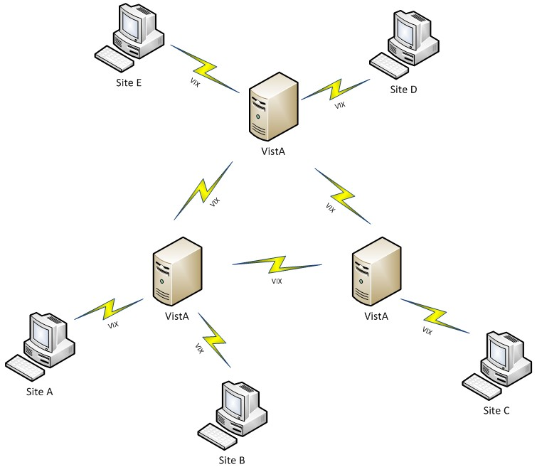

**Figure 3: Site to Site Communication**

Following VISA architecture, sites that have the Telepathology solution installed will communicate with one another via the VIX.

# Data Design

## Database Management System Files

This section is not applicable to the solution

## Non-Database Management System Files

This section is not applicable to the solution

# Detailed Design

## Hardware Detailed Design

This section is not applicable to the solution.

## Software Detailed Design

6.2.1. **VIX Client Facade**

With the exception of login and initial configuration settings, all communication between the clients and the database will be done through the VIX. This conforms to the VISA architecture being put into place by the VistA Imaging team.

All interfaces are defined using REST functionality (unless otherwise specified). The input and output is formatted in XML. All interfaces are defined in the Integration Discovery Service (IDS); the application path and the path to operations should be taken from IDS and not hard coded. Method paths specified in this document are not expected to change and can be hard coded.

### Security

The applications (Telepathology Worklist and Telepathology Configurator) will use a secure connection to communicate with the VIX using HTTPS protocol. The port for this connection will be obtained through a new site service with RESTful interface which provides VIX connection information.

All methods require the following HTTP headers as part of every request:

|  |  |
| --- | --- |
| xxx-duz | DUZ of the authenticated user at the authenticated site |
| xxx-fullname | Full name of the user at the authenticated site |
| xxx-sitename | Name of the authentication site |
| xxx-sitenumber | Site number (primary site station number) of the authentication site |
| xxx-ssn | SSN of the user at the authentication site |
| xxx-transaction-id | A unique transaction ID. All requests must have a unique ID (such as a Windows GUID) |
| xxx-securityToken | Broker Security Enhancement (BSE) token generated at the authenticating site |
| xxx-client-version | The version of the client making the request (purely for informational purposes) |

In addition to the custom headers above, all interfaces should provide the following credentials when making all calls using BASIC authentication:

|  |  |
| --- | --- |
| **Username** | **Password** |
| alexdelarge | 655321 |

### Pathology Service

This is the client facing façade that provides methods for accessing and updating Pathology data.

IDS Definition

|  |  |  |
| --- | --- | --- |
| **Type** | **Version** | **Metadata Operation** |
| Pathology | 1 | Metadata |

**Methods**

###### **URI** pathology/patient/{siteId}/{patientId}

###### {siteId}: The site to request the patient from

###### {patientId}: Patient identifier, may be encoded DFN or

|  |  |
| --- | --- |
|  | ICN or raw ICN |
| **Description** | Retrieve information about a specific patient |
| **Method** | GET |
| **RPCs Called** | MAGG PAT INFO |
| **Result** | The information about the patient specified |

|  |  |
| --- | --- |
| **URI** | pathology/cases/unreleased/{siteId}/{days}/{requestingSiteId} {siteId}: the site to retrieve data from (this determines what site the VIX gets data from){days}: The number of days to include{requestingSiteId}: the site interested in getting information about (this is used as a parameter in making the call to VistA) |
| **Description** | Get a list of the unreleased pathology reports |
| **Method** | GET |
| **RPCs Called** | MAGTP GET ACTIVE MAGTP GET CONSULT |
| **Result** | The list of reports |

|  |  |
| --- | --- |
| **URI** | pathology/cases/unreleased/{siteId}/{days} {siteId}: the site to retrieve data from (this determines what site the VIX gets data from){days}: The number of days to include |
| **Description** | Get a list of the unreleased pathology reports |
| **Method** | GET |
| **RPCs Called** | MAGTP GET ACTIVE MAGTP GET CONSULT |
| **Result** | The list of reports |

|  |  |
| --- | --- |
| **URI** | pathology/cases/released/{siteId}/{days}/{requestingSiteId} {siteId}: the site to retrieve data from (this determines what site the VIX gets data from){days}: The number of days to include{requestingSiteId}: the site interested in getting information about (this is used as a parameter in making the call to VistA) |
| **Description** | Get a list of the released pathology reports |
| **Method** | GET |
| **RPCs Called** | MAGTP GET ACTIVE MAGTP GET CONSULT |
| **Result** | The list of reports |

|  |  |
| --- | --- |
| **URI** | pathology/cases/released/{siteId}/{days} {siteId}: the site to retrieve data from (this determines what site the VIX gets data from){days}: The number of days to include |
| **Description** | Get a list of the released pathology reports |
| **Method** | GET |
| **RPCs Called** | MAGTP GET ACTIVE MAGTP GET CONSULT |
| **Result** | The list of reports |

|  |  |
| --- | --- |
| **URI** | pathology/cases/patient/{siteId}/{patientId} {siteId}: the site to retrieve data from (this determines what site the VIX gets data from){patientIdcn}: VA patient identifier |
| **Description** | Get a list of the cases for a specific patient |
| **Method** | GET |

|  |  |
| --- | --- |
| **RPCs Called** | MAGTP GET PATIENT MAGTP GET CONSULT |
| **Result** | The list of cases |

|  |  |
| --- | --- |
| **URI** | pathology/acquisition/{siteId} {siteId}: The site to retrieve data from (this determines what site the VIX gets data from) |
| **Description** | Get the acquisition sites |
| **Method** | GET |
| **RPCs Called** | MAGTP GET SITE CONFIG |
| **Result** | Returns the acquisition sites |

|  |  |
| --- | --- |
| **URI** | pathology/reading/{siteId} {siteId}: The site to retrieve data from (this determines what site the VIX gets data from) |
| **Description** | Get the reading sites |
| **Method** | GET |
| **RPCs Called** | MAGTP GET SITE CONFIG |
| **Result** | Returns the reading sites |

|  |  |
| --- | --- |
| **URI** | pathology/case/lock/{caseId}/{lock} {caseId}: ID of the case to lock{lock }: true or false to determine if locking or unlocking |
| **Description** | Lock or unlock a pathology case |
| **Method** | GET |
| **RPCs Called** | MAGTP SECOND LOCK |
| **Result** | Result indicating if successful or error message |

|  |  |
| --- | --- |
| **URI** | pathology/case/consultation/{caseId}/{stationNumber} {caseId}: ID of the case add consultation{stationNumber}: the site to do the consultation |
| **Description** | Request a consultation for a case |
| **Method** | GET |
| **RPCs Called** | MAGTP PUT CONSULT |
| **Result** | Result indicating if successful or error message |

|  |  |
| --- | --- |
| **URI** | pathology/case/interpretation/{caseId}/{stationNumber} {caseId}: ID of the case add interpretation{stationNumber}: the site to do the interpretation |
| **Description** | Request an interpretation for a case |
| **Method** | GET |
| **RPCs Called** | MAGTP PUT CONSULT |
| **Result** | Result indicating if successful or error message |

|  |  |
| --- | --- |
| **URI** | pathology/case/specimens/{caseId} {caseId}: ID of the case to retrieve specimens for |
| **Description** | Request the list of specimens for a case |
| **Method** | GET |
| **RPCs Called** | MAGTP GET SLIDES |
| **Result** | List of specimens |

###### **URI** pathology/templates/{siteId}/{apSections}

###### {siteId}: the site to retrieve data from (this determines what site the VIX gets data from)

|  |  |
| --- | --- |
|  | {apSections}: a caret (^) delimited list of Pathology sections to get the templates for |
| **Description** | Request the list of templates from a site |
| **Method** | GET |
| **RPCs Called** | MAGTP GET TEMPLATE XML |
| **Result** | List of templates, one for each included in the apSections field |

|  |  |
| --- | --- |
| **URI** | pathology/reading/{siteId} {siteId}: the site to retrieve data from (this determines what site the VIX gets data from) |
| **Description** | Update the reading sites |
| **Method** | POST |
| **RPCs Called** | MAGTP PUT SITE CONFIG |
| **Result** | True if successful, exception otherwise |

|  |  |
| --- | --- |
| **URI** | pathology/acquisition/{siteId} {siteId}: the site to retrieve data from (this determines what site the VIX gets data from) |
| **Description** | Update the acquisition sites |
| **Method** | POST |
| **RPCs Called** | MAGTP PUT SITE CONFIG |
| **Result** | True if successful, exception otherwise |

|  |  |
| --- | --- |
| **URI** | pathology/template/{siteId}/{apSection} {siteId}: the site to retrieve data from (this determines what site the VIX gets data from){apSection}: section of template to update |
| **Description** | Update the template |

|  |  |
| --- | --- |
| **Method** | POST |
| **RPCs Called** | MAGTP PUT TEMPLATE XML |
| **Result** | True if successful, false otherwise |

|  |  |
| --- | --- |
| **URI** | pathology/case/supplementalreports/{caseId} {caseId}: ID of the case to retrieve supplemental reports for |
| **Description** | Get the case supplemental reports |
| **Method** | GET |
| **RPCs Called** | MAGTP GET SUP REPORTS |
| **Result** | Array of supplemental reports |

|  |  |
| --- | --- |
| **URI** | pathology/case/report/{caseId} {caseId}: ID of the case to retrieve report for |
| **Description** | Get the case report |
| **Method** | GET |
| **RPCs Called** | MAGTP GET CPRS REPORT |
| **Result** | Report |

|  |  |
| --- | --- |
| **URI** | pathology/case/template/{caseId} {caseId}: ID of the case to retrieve template |
| **Description** | Get the case template |
| **Method** | POST |
| **RPCs Called** | MAGTP GET TEMPLATE DATA |
| **Result** | Template |

|  |  |
| --- | --- |
| **URI** | pathology/case/reserve/{caseId}/{lock} {caseId}: ID of the case to lock{lock }: true or false to determine if locking or unlocking |
| **Description** | Reserves a case |
| **Method** | GET |
| **RPCs Called** | MAGTP RESERVE CASE |
| **Result** | Status of reservation or exception if there was an error |

|  |  |
| --- | --- |
| **URI** | pathology/esigneeded/{siteId}/{apSection} {siteId}: The site to check if the e-sig is needed from{apSection}: Pathology section |
| **Description** | Check if an electronic signature is required and if the user is allowed for a specific AP section |
| **Method** | GET |
| **RPCs Called** | MAGTP GET ESIGN |
| **Result** | Result indicating if electronic signature is needed and a message explaining the reason or an exception if there was an error |

|  |  |
| --- | --- |
| **URI** | pathology/fields/{siteId}/{field}/{searchParameter} {siteId}: The site to get data from{field}: The field to search{searchParameter}: Search value to find matching values |
| **Description** | Find values of a particular field matching the search parameter |
| **Method** | GET |
| **RPCs Called** | MAGTP GET LIST |
| **Result** | Result to indicate if successful lock |

|  |  |
| --- | --- |
| **URI** | pathology/case/consultation/{caseConsultationId}/{status} { caseConsultationId }: The ID of the case consultation{status}: Pathology section |
| **Description** | Update the status of a case consultation |
| **Method** | POST |
| **RPCs Called** | MAGTP CHANGE CONS STATUS |
| **Result** | True if successful, exception otherwise |

|  |  |
| --- | --- |
| **URI** | pathology/case/report/{caseId} { caseId }: The ID of the case |
| **Description** | Update the case report fields |
| **Method** | POST |
| **RPCs Called** | MAGTP PUT REPORT FIELD |
| **Result** | True if successful, exception otherwise |

|  |  |
| --- | --- |
| **URI** | pathology/case/supplementalreport/{caseId}/{date}/{verified} { caseId }: The ID of the case{date}: The date of the new supplemental report in YYYYMMDDHHMM format, local time{verified}: Boolean to determine if the report is verified |
| **Description** | Save a new supplemental report to the case |
| **Method** | POST |
| **RPCs Called** | MAGTP PUT SUP REPORT |
| **Result** | True if successful, exception otherwise |

###### **URI** pathology/sites/{siteId}

###### { siteId }: The site to get the list of sites from

|  |  |
| --- | --- |
| **Description** | Get all available sites from the database |
| **Method** | GET |
| **RPCs Called** | MAGTP GET SITES |
| **Result** | The list of sites |

|  |  |
| --- | --- |
| **URI** | pathology/lock/{siteId}/{minutes} { siteId }: The site to store the lock timeout for{minutes}: The minutes to set for the lock |
| **Description** | Set the lock timeout in minutes |
| **Method** | POST |
| **RPCs Called** | MAGTP PUT LOCK MINS |
| **Result** | True if successful, exception otherwise |

|  |  |
| --- | --- |
| **URI** | pathology/lock/{siteId} { siteId }: The site to store the lock timeout for |
| **Description** | Get the lock timeout in minutes |
| **Method** | GET |
| **RPCs Called** | MAGTP GET LOCK MINS |
| **Result** | The lock timeout value |

|  |  |
| --- | --- |
| **URI** | pathology/preferences/{siteId}/{label}/{userId} { siteId }: The site to retrieve the preferences from{label}: The label to describe the preferences{userId}: The DUZ of the user to retrieve the preferences for |
| **Description** | Get user preferences |

|  |  |
| --- | --- |
| **Method** | GET |
| **RPCs Called** | MAGTP GET PREFERENCES |
| **Result** | The XML representing the user preferences |

|  |  |
| --- | --- |
| **URI** | pathology/preferences/{siteId}/{label} { siteId }: The site to retrieve the preferences from{label}: The label to describe the preferences |
| **Description** | Get user preferences, defaults to user logged in |
| **Method** | GET |
| **RPCs Called** | MAGTP GET PREFERENCES |
| **Result** | The XML representing the user preferences |

|  |  |
| --- | --- |
| **URI** | pathology/preferences/{siteId}/{label}/{userId} { siteId }: The site to store the preferences{label}: The label to describe the preferences{userId}: The DUZ of the user to save the preferences for |
| **Description** | Saves user preferences |
| **Method** | POST |
| **RPCs Called** | MAGTP PUT PREFERENCES |
| **Result** | True if successful, exception otherwise |

|  |  |
| --- | --- |
| **URI** | pathology/preferences/{siteId}/{label} { siteId }: The site to store the preferences{label}: The label to describe the preferences |
| **Description** | Saves user preferences |
| **Method** | POST |

|  |  |
| --- | --- |
| **RPCs Called** | MAGTP PUT PREFERENCES |
| **Result** | True if successful, exception otherwise |

|  |  |
| --- | --- |
| **URI** | pathology/case/snomed/{caseId} { caseId }: The ID of the case |
| **Description** | Retrieve the SNOMED codes for a specific case |
| **Method** | GET |
| **RPCs Called** | MAGTP GET SNOMED CODES |
| **Result** | List of SNOMED codes for the case |

|  |  |
| --- | --- |
| **URI** | pathology/case/snomed/{caseId}/{tissueId}/{fieldId} { caseId }: The ID of the case{tissueId}: The ID of the tissue within that case (not a globally unique ID){fieldId}: The ID of the field to add (pathologyFieldURN) |
| **Description** | Saves a snowmed code to a tissue |
| **Method** | POST |
| **RPCs Called** | MAGTP PUT SNOMED CODES |
| **Result** | The internal ID of the SNOMED code added (unique to the tissue only) |

###### **URI** pathology/case/snomed/{caseId}/{tissueId}/{morphologyId}/{etiologyFieldId}

###### { caseId }: The ID of the case

###### {tissueId}: The ID of the tissue within that case (not a globally unique ID)

###### {morphologyId}: The ID of the morphology within the tissue (not a globally unique ID)

###### {etiologyfieldId}: The ID of the etiology field to add (pathologyFieldURN)

|  |  |
| --- | --- |
| **Description** | Saves an etiology snowmed code for a morphology to a tissue |
| **Method** | POST |
| **RPCs Called** | MAGTP PUT SNOMED CODES |
| **Result** | The internal ID of the SNOMED code added (unique to the morphology only) |

|  |  |
| --- | --- |
| **URI** | pathology/case/cpt/{caseId}/{locationId} { caseId }: The ID of the case{locationId}: The ID of the location for the CPT code (PathologyFieldURN) |
| **Description** | Saves a CPT code for a case |
| **Method** | POST |
| **RPCs Called** | MAGTP PUT CPT CODES |
| **Result** | For each CPT code a description if it was stored successfully |

|  |  |
| --- | --- |
| **URI** | pathology/case/cpt/{caseId} { caseId }: The ID of the case |
| **Description** | Gets the CPT codes for a case |
| **Method** | GET |
| **RPCs Called** | MAGTP GET CPT CODES |
| **Result** | CPT codes for a case |

|  |  |
| --- | --- |
| **URI** | pathology/keys/{siteId} {siteId}: The site to get the keys from |
| **Description** | Retrieve the keys for the user from the specified site |
| **Method** | GET |
| **RPCs Called** | MAGTP GET USER |

**Result** String array of user keys

|  |  |
| --- | --- |
| **URI** | pathology/cases |
| **Description** | Get information for specific cases |
| **Method** | GET |
| **RPCs Called** | MAGTP GET CASES |
| **Result** | Case information for requested cases |

|  |  |
| --- | --- |
| **URI** | pathology/consultations/{siteId}/{stationNumber} {siteId}: The site to make this call at{stationNumber}: Interpreting (reading) station |
| **Description** | Determine if there are consultations for an interpreting station |
| **Method** | GET |
| **RPCs Called** | MAGTP CHECK CONS |
| **Result** | True if there are consultations, false if there are none |

|  |  |
| --- | --- |
| **URI** | pathology/case/tissues/{caseId}/{tissueId} {caseId }: The ID of the case{tissueId}: The Pathology Field URN of type topography for the tissue/organ to add to the case |
| **Description** | Save tissues for a case |
| **Method** | POST |
| **RPCs Called** | MAGTP PUT SNOMED CODES |
| **Result** | The internal ID of the tissue added (unique to the case only) |

###### **URI** pathology/case/copy/{siteId}/{caseId}

|  |  |
| --- | --- |
|  | {siteId}: The site to store copy of the case at{ caseId }: The ID of the case to copy |
| **Description** | Copy the case |
| **Method** | POST |
| **RPCs Called** | MAGTP COPY CASE |
| **Result** | The PathologyCaseURN of the newly created case |

### User Service

###### The user service is an existing service in the VIX; however, it has been modified slightly to support methods for Pathology.

**IDS Definition**

|  |  |  |
| --- | --- | --- |
| **Type** | **Version** | **Metadata Operation** |
| User | 1 | Metadata |

**Methods**

|  |  |
| --- | --- |
| **URI** | verifyElectronicSignature/{siteId}/{electronicSignature} {siteId}: The site to verify the electronic signature of the user at{ electronicSignature }: The user's electronic signature (in clear text) |
| **Description** | Verify the electronic signature of the user at the specified site |
| **Method** | GET |
| **RPCs Called** | MAGG VERIFY ESIG |
| **Result** | True if the e-sig is correct, false otherwise |

### Patient Service

The patient service is an existing service in the VIX; however, it has been modified slightly to support methods for Pathology.

IDS Definition

|  |  |  |
| --- | --- | --- |
| **Type** | **Version** | **Metadata Operation** |
| Patient | 1 | Metadata |

Methods

|  |  |
| --- | --- |
| **URI** | sensitive/check/{siteId}/{patientId}   * {siteId}: The site to check the patient sensitivity at * {patientId}: The patient to check the sensitivity of |
| **Description** | Check the sensitivity of a patient |
| **Method** | GET |
| **RPCs Called** | DG SENSITIVE RECORD ACCESS |
| **Result** | Status of sensitivity and warning message if status requires it |

|  |  |
| --- | --- |
| **URI** | sensitive/log/{siteId}/{patientId}   * {siteId}: The site to check the patient sensitivity at * {patientId}: The patient to check the sensitivity of |
| **Description** | Log access to the sensitive patient |
| **Method** | GET |
| **RPCs Called** | DG SENSITIVE RECORD BULLETIN |
| **Result** | True if successful, false otherwise |

|  |  |
| --- | --- |
| **URI** | information/{siteId}/{patientId}   * {siteId}: The site to get the patient information from * {patientId}: The patient to get patient information for |
| **Description** | Get patient information |
| **Method** | GET |
| **RPCs Called** | MAGG PAT INFO |
| **Result** | Patient information |

|  |  |
| --- | --- |
| **URI** | healthsummaries/{siteId}   * {siteId}: The site to get the list of health summaries from |
| **Description** | Get the list of health summaries from the site |
| **Method** | GET |
| **RPCs Called** | MAGGHSLIST |
| **Result** | List of health summaries available at the site |

|  |  |
| --- | --- |
| **URI** | healthsummary/{patientId}/{summaryId}   * {patientId}: The patient to retrieve the health summary for * {summaryId}: The HealthSummary URN to retrieve for the patient |
| **Description** | Get a specific health summary for a patient |
| **Method** | GET |
| **RPCs Called** | MAGGHS |
| **Result** | A specific health summary for a patient |

### VIX Commands

These are the new and modified commands to support Pathology:

* + - * + GetPathologyAcquisitionSitesCommandImpl- retrieve the list of acquisition sites
        + GetPathologyCaseCptCodesCommandImpl – get the CPT codes for a case
        + GetPathologyCaseReportCommandImpl – get the CPRS report for a case
        + GetPathologyCasesCommandImpl – get cases
        + GetPathologyCaseSnomedCodesCommandImpl – get SNOMED codes for a case
        + GetPathologyCaseSpecimensCommandImpl – get specimens for a case
* GetPathologyCaseSupplementalReportsCommandImpl – get supplemental reports for a case
* GetPathologyCaseTemplateDataCommandImpl – get case template data
* GetPathologyElectronicSignatureNeedCommandImpl – check if an electronic signature is needed
* GetPathologyFieldValuesCommandImpl – get field values
* GetPathologyLockMinutesCommandImpl – get lock timeout in minutes
* GetPathologyPatientCasesCommandImpl – get cases for a patient
* GetPathologyPendingConsultationsCommandImpl – determine if cases are pending consultations
* GetPathologyPreferencesCommandImpl – get user preferences
* GetPathologyReadingSitesCommandImpl – get reading sites
* GetPathologySitesCommandImpl – get all sites
* GetPathologySiteTemplateCommandImpl – get site templates
* GetPathologySpecificCasesCommandImpl – get specific cases
* GetPathologyUserKeysCommandImpl – get pathology user keys (non MAG keys)
* PostPathologyAcquisitionSiteListCommandImpl – update the acquisition site list
* PostPathologyCaseAssistanceCommandImpl – update case assistance
* PostPathologyCaseConsultationStatusCommandImpl – update the consultation status for a case
* PostPathologyCaseCptCodesCommandImpl – add CPT codes for a case
* PostPathologyCaseLockCommandImpl – lock or unlock a case
* PostPathologyCaseMorphologySnomedCodeCommandImpl – add etiology to morphology SNOMED code
* PostPathologyCaseReportFieldsCommandImpl – add case report field
* PostPathologyCaseReserveCommandImpl – reserve a case
* PostPathologyCaseSnomedCodeCommandImpl – add SNOMED codes to a case
* PostPathologyCaseSupplementalReportCommandImpl – add a supplemental report to a case
* PostPathologyCaseTissueCommandImpl – add a tissue to a case
* PostPathologyCopyCaseCommandImpl – copy a case
* PostPathologyLockMinutesCommandImpl – set the lock minutes
* PostPathologyPreferencesCommandImpl – save user preferences
* PostPathologyReadingSiteListCommandImpl – save the reading site list
* PostPathologySiteTemplateCommandImpl – save a site template

### VIX Service Provider Interfaces

These are the new and modified SPIs to support Pathology:

* + - * + UserDataSourceSpi (modified) – This SPI defines methods for retrieving information about the logged in user

verifyElectronicSignature (new) – this method verifies the electronic signature matches the value in the database

* + - * + PatientDataSourceSpi (modified) – This SPI defines methods for retrieving information about a patient

getHealthSummyTypes (new) – this method retrieves the list of possible health summaries that are available in the database

getHealthSummary (new) – this method retrieves the specific health summary for a patient

* + - * + PathologyDatasourceSpi (new) – This SPI defines methods for retrieving pathology information

getCases – this method retrieves the released or unreleased cases

getCaseSpecimens – this method retrieves the specimens for a case

getPatientCases – this method retrieves the cases for a patient

getSites – this method retrieves the reading or acquisition sites

lockCase – this method locks or unlocks a case

addCaseAssistance – this method adds assistance to a case

getSiteTemplate – retrieve the templates for AP sections

saveSiteTemplate – save a template for an AP section

updateReadingSiteList – update the list of reading sites

updateAcquisitionSiteList – update the list of acquisition sites

getPathologyCaseReport – retrieve the CPRS report for a case

getCaseSupplementalReports – retrieve the supplemental reports for a case

getCaseTemplateData – retrieve the fields for a case

reserveCase – reserve a case

checkElectronicSignatureNeeded – checks if the user needs to provide an

electronic signature for an AP section

getPathologyFields – retrieve information about specific fields

updateConsultationStatus – update the consulation status for a case

saveCaseReportFields – save fields for a case

saveCaseSupplementalReport – save a supplemental report for a case

getSites – retrieve a list of all sites in the database

getLockExpiresMinutes – get the lock expired time

setLockExpireMinutes – set the lock expire time

getPreferences – retrieve user preferences

setPreferences – set user preferences

getCaseSnomedCodes – retrieve the SNOMED codes for a case

saveCaseEtiologySnomedCodeForMorphology – save an etiology SNOMED code

for a morphology code

saveCaseTissue – save tissue for a case

saveCaseCptCodes – save CPT codes for a case

getCaseCptCodes – retrieve the CPT codes assigned for a case

getPathologyUserKeys – retrieve the pathology user keys (not MAG keys)

getSpecificCases – retrieve the case information based on the specified case IDs o checkPendingConsultationStatus – checks if there are any pending consultations o copyCase – copy a case

### VIX Data Source Provider Implementations

The following data source providers were modified to support Pathology

* + - * VistaImagingDataSourceProvider

The VistA Imaging data source provider has been modified to support calling the new RPCs as part of this patch to support the necessary SPIs

* + - * FederationDataSourceProvider

The Federation data source provider has been updated to version 6 to support the new SPIs and methods necessary for Pathology

### Telepathology Report Editor

* + - 1. **Structure**



Report GUI

ReportView Supplementary ReportView CaseOrganTissueView

View Models

ReportVM Supplementary ReportVM

CaseOrganTissueVM

DataSource IWorklistDataSource

WorklistDataSource

VistA Database

VixClient

VistA Client

IVistaClient VistaClient

**Figure 4: Report Editor Structure**

The implementation of the Telepathology Report Editor is based on the MVVM design pattern with the help of MVVM Light toolkit. However, it currently only uses some of the functionality in the toolkit for updating data binding. This module can be separated into two parts: Graphical User Interface (GUI) and Communication. The GUI includes the Report GUI which contains all the user viewable implementation. Each of these views will be complemented with a view model which handles all the processing of data. These data will be transferred to the Communication part via the DataSource. The Communication side will handle just the transporting of report data back and forth between the GUI and the VistA database. All the communication will be transferred through the VIX.

* + - 1. **Rules of Operation**

Because the LAB package interface in VistA does not provide a means to prevent data from being overwritten, the Report Editor will follow the following rules to resolve the problem:

* All controls and data in the report will be read-only if the patient has not been registered at the site. Patients will be looked up with their unique enterprise identifier (ICN).
* A locking mechanism is implemented to only allow single access to a case from the reporting GUI. The report data will still be available through the existing roll-and-scroll interface. User with LRAPSUPER security key can overwrite this lock.
* If the site is remote and its type is 'consultation', the reporting GUI will appear as read-only except for the supplementary area.
* Once a supplementary report is verified, its content will be read-only. However, users can still modify it through the existing roll-and-scroll interface.
* Once the main report is verified, all the controls and data will be read-only except for entering new supplementary reports or Clinical Procedure Terminology (CPT) codes.
* CPT codes may only be entered by users at the same VistA system as the report.

For remote readings (both consultation and primary interpretation), a new report will be

created and verified with the reading site as the acquisition site and referencing the original case. Users at remote sites can enter CPT codes in this newly generated case.

* A user can only verify reports or complete consultations if the site enables electronic signature and the user has a valid role as defined in the business rules and valid credentials in the form of VistA security keys.

6.2.5.3. Report Template

The Reporter GUI is implemented to support data entry for the following three types of anatomic pathology: Cytology (CY), Electron Microscopy (EM), and Surgical Pathology (SP). Users with profile that matches the description in section 3.1.4 can use the configurator to configure the view of reports at their sites. When a user launches the GUI from the worklist, the application will fetch the appropriate template according to the accession number (e.g. SP 12 1, CY 12 12) at the acquisition site of the case. The template will be processed and displayed. Only fields that a user can modify and that are configured to be in the display list of the template will be visible to the user. If any of the fields that had been worked on and contains data were removed from the display list, the fields would still be available in the report window. If the fields are configured to be required, they will be marked with a * in the GUI. Users will need to enter these required fields prior to completing and verifying the main report. Cases that are automatically generated and verified (for remote consultation and primary interpretation) will not have this requirement.

After the template has been processed, the application will retrieve data for the fields that are displayed. The data is organized into observable objects and managed by the report view models. These data objects will be bound to the corresponding fields. In this way all the changes from the users will be updated right away and will be ready for saving back to the database that hosts the case.

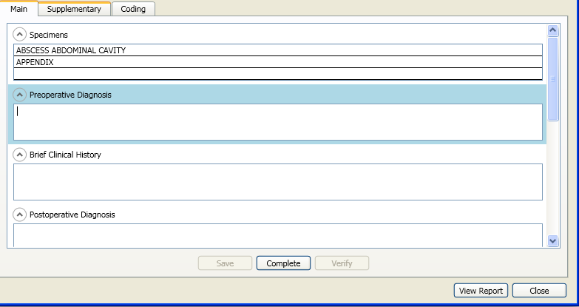

**Figure 5: Report Templates Being Applied in the Report Editor**

* + - 1. **Supplementary Reports**

The supplementary report section of the reporting GUI is also managed by a set of bindable observable objects. All processing is done through the SupplementaryReportViewModel object. Each supplementary report and its corresponding object will be represented on the GUI as items in a list. Only unverified supplementary reports can be modified through the editor, which is also available on the reporting GUI.

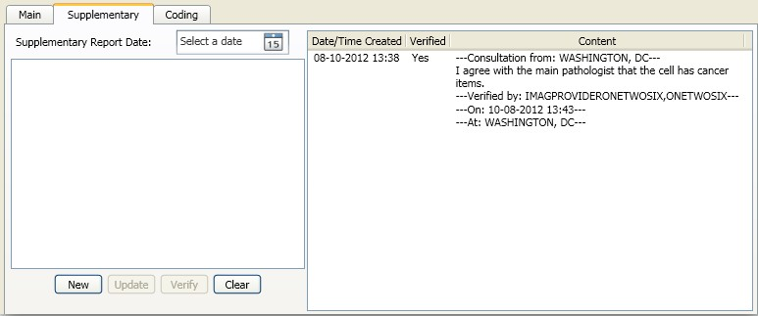

**Figure 6: Supplementary Report Editor**

Since the supplementary report is used as a tool for consultation, the code will check to see the type of site that the current user is logging into. If the site is a consulting site, a new supplementary report will have a boilerplate header to indicate that the supplementary report is a consultation from that site. A boilerplate footer will also be added once the user has completed the consultation. These boilerplate texts will serve as a "soft lock" to maintain the integrity of the consultation. While a consultation is being drafted, it contains only the header and only users at that consulting site can modify the content; no other site can change the report or verify it even if the site is an interpreting site. In order for the consultation to be completed, the consultation report must have a proper header, which was added automatically when the consultation is first saved. Once the consultation has been completed, a duplicate of the case will be created at the consulting site referencing the original case. The completed report will have a footer which will allow acquisition sites or interpretation sites to verify the report. A flaw in this design is that users from that consulting site can remove part of the header or the entire header allowing other sites to modify the consultation through the reporting GUI. All data can also be changed outside of the GUI through the traditional roll-and-scroll user interface at any time. Each entered supplementary report must be verified by a user from an interpretation site before the main report can be verified.

* + - 1. **Systematized Nomenclature of Medicine (SNOMED) Coding**

The reporting GUI also allows users to enter SNOMED coding for a case. Users can add or remove SNOMED codes until the main report has been verified and released. The codes are organized into a tree structure. Each branch of the tree represents a different organizational level. The tree will have a maximum depth of 5 levels. Each organ tissue is represented as a branch in the tree; this is level 1. On level 2, the organ tissue is branched out to 4 different types of branches: Morphologies, Functions, Procedures, and Diseases. Level 3 consists of all the SNOMED codes for the organ tissue based on the branch. For Morphologies, each morphology can have a lower level consisting of etiologies. This etiology list is the content of level 4 and 5.

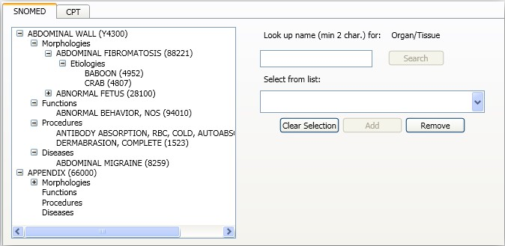

**Figure 7: SNOMED Editor**

Since the data is branched out into groups based on type, it is important to add new codes to the appropriate levels. Users must select the type of code before adding a new code. The type is determined by the selection of the tree item. For simplicity, the coding GUI is set up so that users can only add new organ tissues when the tree does not have any item selected. To add new morphology, etiology, function, procedure, or disease, the appropriate category must be selected. To avoid errors in adding new SNOMED codes, users can only add new codes that are selected from a list generated after querying the acquisition site database. The search will be based on the type of the item to be added and a search description. Users can also remove existing codes from the tree if they wish to. Deletion works both on individually-typed items or group-typed items. The removal process will remove all sub-items. All the data processing will be managed by the CaseOrganTissueViewModel object.

* + - 1. **Clinical Procedure Terminology (CPT) Coding**

The CPT coding GUI is designed to reflect the CPT codes for a case at the site at which it originated. In order to avoid duplication, only users at the site at which the case originated can add new CPT codes for it. Each CPT code is associated with an ordering location. Users must select this facility from a list queried from VistA. A new code entry can consist of a single code or a group of codes. All codes in the group entry must be separated by a comma (,) character. If the user desires to enter a single code multiple times, the user can add the codes individually, or as a group (separated by commas). Each code entered normally will increase the overall multiplier for that code in the case by 1. To enter the same code multiple times, the user can use a shorthand expression in the following format: code*multiplier (order specific). A user can enter CPT codes at any point in the case’s life.

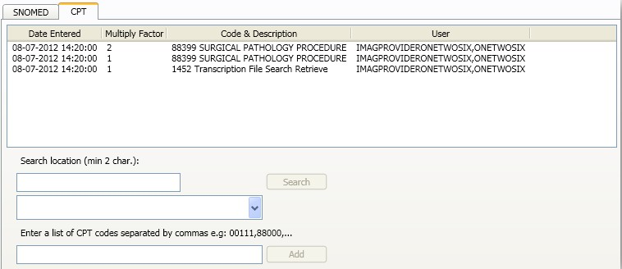

**Figure 8: CPT Coding Editor**

### Telepathology Configurator

The purpose of the configurator is to set up the environment in order that the worklist will function correctly. The implementation of the configurator is also based on the MVVM design pattern with the help of the MVVL Light Toolkit.



Configurator GUI

AcquisitionSiteSetupView ReadingSiteSetupView ReportTemplateView OtherSettingsView

ViewModel

AcquisitionSiteSetupVM ReadingSiteSetupVM ReportTemplateVM OtherSettinsVM

|  |  |
| --- | --- |
| DataSource IConfiguratorDatasource  ConfiguratorDatasource | |
|  |  |

VistA Database

VixClient

VistAClient

IVistaClient VistaClient

**Figure 9: Telepathology Configurator Structure**



**6.2.6.1. Acquisition Site Setup**

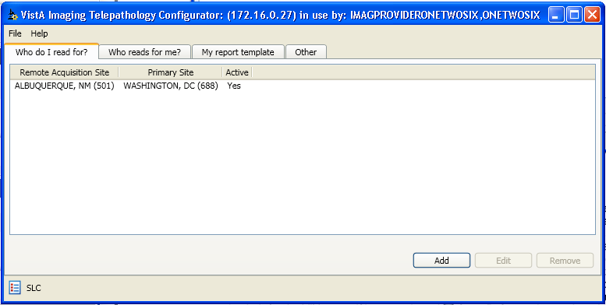

**Figure 10: Acquisition Site Setup View**

This setup GUI is designed to be used by a reading site. A reading site can use this view to manage its acquisition site list. The Telepathology Worklist will use this list to identify what site (in the list of primary acquisition sites) it should try to retrieve case list data from. Only the sites that are on this list with active status can be retrieved. The worklist will also always retrieve the case list from user’s local primary site. The final worklist that users see in the Telepathology Worklist will be a consolidated worklist from all these sites. This applies to all three kinds of lists: unread, patient, and read list. To add a new site or edit an existing site, users will use the Acquisition Site View. If adding a new site, users will get a dropdown containing all sites that are available in the local database (INSTITUTION file #4). The acquisition site is typically a site where the case is being accessioned or documented (this can be a clinic, division, etc…). The primary acquisition site is where the data resides. This is the reason why before a site can be added, a validity check will be conducted to see if the information is correct. The client will try to invoke the SOAP service at this site to see if it’s available. Once the site has been added, a user can only either change the site's active status or remove the site from the list. A site can be removed or have its status changed if and only if there’s no pending consultation with the user’s site (using station number and not primary station number). Since all the communication will be done through the VIX, these sites are identified by station numbers.

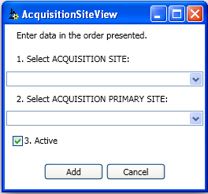

**Figure 10: New/Edit Acquisition Site View**

**6.2.6.2. Reading Site Setup**

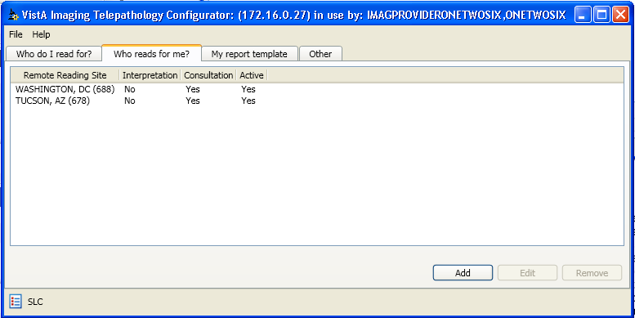

**Figure 11: Reading Site Setup View**

Reading site setup is used at the acquisition site to specify other sites that will either do primary interpretation for or provide consultative service to the acquisition site. The system is designed so that retrieval of the case list is an agreement of both acquisition site and reading site: reading sites must have the acquisition site on their acquisition site list to be able to send case list requests, and the acquisition site must have the reading site on its reading site list to respond with a valid case list. Otherwise, requests from unknown sources will be responded to with an empty case list.

Reading sites are usually categorized into either Interpretation or Consultation type. However, a site can be configured to be both an interpretation and a consultation site. The Interpretation

option will allow the site to see all available cases at the acquisition site. The interpretation site will have all the functions that are available for the acquisition site. This is used when circumstances prevent the acquisition site from reading its own cases. The Consultation option will identify sites from which an acquisition or interpretation site can request a consultation. A consultation site will only see cases from the acquisition sites that have a consultation request to their site worklist. In case the site is categorized as Both, it can do an interpretation on a case or provide a consultation for a case if requested. For a remote reading site, users from this site would see their site’s name in the Worklist’s consultation window among other configured reading sites for the acquisition site of the case. If the site is an Interpretation or Both type, they can request a consultation from themselves.

Users can add a new reading site or edit an existing one with the Reading Site View. A list of available sites is compiled from all the available sites in the local database (INSTITUTION file

#4). Users can change the site type or the active status, or remove the site from the list. Deactivating a site will prevent the site from being able to be requested for consultations from that point forward, but doesn’t prevent them from viewing existing consultation cases. To disassociate with the reading site completely, a user can remove the site from the list, but only if the site has no pending consultation with the user’s primary site (using primary station number).

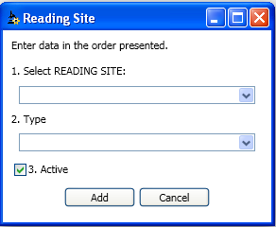

**Figure 12: New/Edit Reading Site View**

* + - 1. **Report Template**

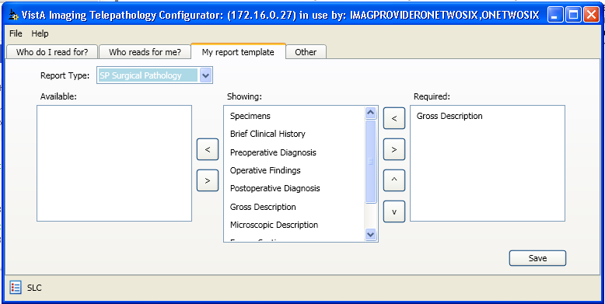

**Figure 13: Report Template Setting**

The report template setting is designed to be used by the user’s local site. The template will dictate what users from either local site or remote site see when they are viewing the case through the reporting GUI. All the fields in the template are predefined according to the three anatomic pathology case types: CY, EM, and SP. All the fields will be marked as either available or showing. Available fields are available for the user but not visible in the reporting GUI. Only fields that are marked as showing will be displayed in the reporting GUI. Showing fields can also be marked as required if the site sees fit. Required fields will be marked with a n asterisk (*) next to the field header. Required fields must be entered before a report can be completed or verified in the reporting GUI. However, this requirement only works if the reporting GUI is being used. For automatically generated and verified cases, or for cases accessed via the VistA Laboratory roll and scroll menu, the requirement will not be enforced. Sites can further customize their report entry views by changing the order of appearance of fields.

* + - 1. **Other Settings**

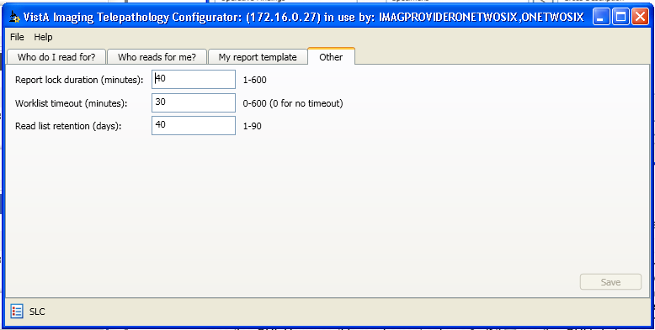

**Figure 14: Other Settings**

This tab will be used for some other minor configurations to the site such as

- The Report lock duration, worklist timeout, and read list retention period. So that the reporting GUI can enforce a single entry rule, which means only one user can edit the report at a time, a logical lock is set whenever the report is accessed. The lock duration setting provides a failsafe solution in case the report is locked inadvertently. A user who does not have overwrite privileges can wait until the lock expires to return to the report GUI or have a privileged user (holder of LRAPSUPER security key) reset the lock. It is recommended that only the LAB administrator should have the LRAPSUPER security key, otherwise concurrent editing of the same Case’s report is possible and the one who saves it last, overwrites all other concurrent editors report, because the lock operation does not apply for the user who holds the LRAPSUPER key.

- The Worklist timeout setting will come into play when the Worklist application is left unattended for a period of time. Once the application reaches the timeout value, a 1 minute warning will be shown to the user. If there is no further action from the user, the application will automatically shut down.

-The Read list retention setting will serve as a time boundary for the worklist. When the application queries for the read list, it will only receive back the cases that are verified and released from the current date minus the amount of days set. The values on this tab are stored as a preference for the local site. Each of these settings will have a default value of 30.

### Telepathology Worklist

The Telepathology Worklist is the entry point for users to perform their duties related to cases that are ready to be read or assigned to them.

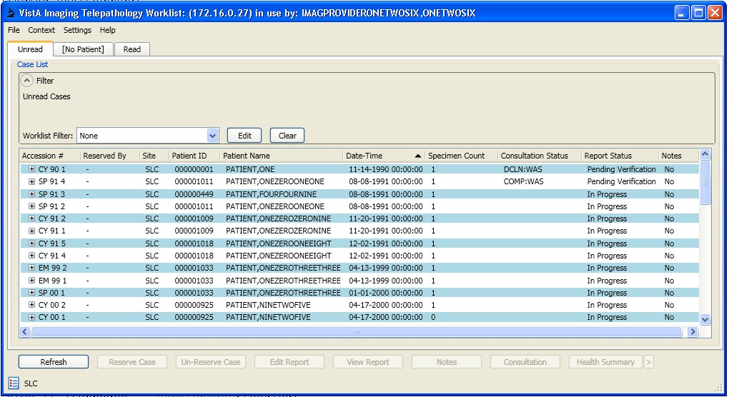

**Figure 15: Telepathology Worklist**

The Telepathology Worklist main window consists of a menu bar, tabs with worklists, and buttons below the worklist tabs.

The menu bar consists of the File, Context, Settings, and Help menus. The user can logout and login to a different site or exit the application from the File menu. The Context menu will contain options for CCOW. The Settings menu contains actions for the Filter Settings, Layout Preferences, Save Settings, and Message Log.

The Telepathology Worklist consists of tab-based list views, which display the worklists that pathologists work with. The worklist itself is a tree list of cases. For each case, the worklist can be expanded to show specimen and slide information. There are three tabs that contain worklists: the Unread tab, the Patient tab and the Read tab. Each tab contains its own filter panel.

The Unread tab displays all cases that are to be worked on or are being currently worked on. These cases (In Progress, Pending Verification) are retrieved from sites that the user’s site has permission to read from.

The Patient tab displays cases that belong to a patient whose case is selected in the previous worklist (either Unread or Read) that was displayed prior to the Patient tab being selected. If multiple cases are selected in the Unread or Read tab and the cases belong to more than one patient, then the first case in the selection determines the patient whose cases are displayed in the Patient tab.

The Read tab displays all cases that have been verified and released (*i.e.*, the report status is “Released”). The case lists for all three tabs are retrieved from the list of acquisition sites using their primary site station number.

Inside each worklist tab there is a region called “Filter”, which displays the current filter that is being applied. There are controls on the panel that allow the user to edit the current filter, clear the current filter, or apply another filter from a dropdown combo box.

The buttons below the worklists are actions that can be performed when a case is selected. From the Unread tab, users can perform the following actions: refresh worklist, edit report, view report, notes, consultations, or view health summaries. From the Patient tab, users can perform: refresh, edit/view report, notes, or view health summaries. From the Read tab, users can do all the actions except for consultations.

Although there is a Refresh button, it will be rarely used as a periodic (every 2..4 seconds) refresh applies for the Worklist.

**6.2.7.1. Worklist Use Cases**

This section gives a high-level overview of the functionality provided by the Telepathology Worklist client.

The following table gives a list of the use cases along wi th a brief description. Following the table, the use cases are explained in detail with steps; also, a description/flow is given with the user interface screens.

**Table 8: Use Cases Description**

|  |  |
| --- | --- |
| **Name** | **Description** |
| Logging in to application | Log in to the application and view worklists |
| Editing report | Edit report data for a case. On entry, Case locking applies and if it shows in the Locked By column, no other user can modify the report. Otherwise the user goes to read-only mode. |
| Viewing report | View released report data for a case |
| Requesting a consultation and recalling or declining an existing consultation request | Request a consultation for a case to another site. Recall or decline an existing consultation request from a site. The case is locked by the user who holds the Consultation dialog. (see under Edit report!) |
| Viewing Health Summary List and the Default Health Summary | View the list of health summary report types and the default health summary report. |
| Adding notes | Make comments on a case. |

|  |  |
| --- | --- |
| Creating worklist filters | Creating user-defined worklist filters. |
| Applying a filter | Applying an existing or an *ad hoc* filter to the worklist. |
| Editing an existing filter | Edit a worklist filter. |
| Viewing log | Viewing the log file. |

Normal Flow:

* + - * 1. **Logging in to the Application**

Users launch the Telepathology application

Users select a VistA server from a list of servers.

Users enter the User Name and Password to log into the application Post-Conditions:

The Unread worklist is displayed

*Description/Flow*

The Connect To window is the first window that is displayed when the application is launched:

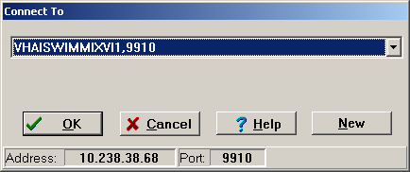

**Figure 16: Connect To**

The user selects a VistA server and clicks OK.

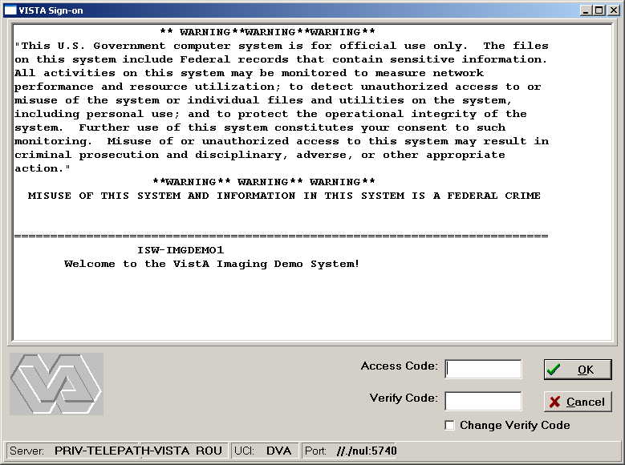

**Figure 17: Authentication Screen**

The user enters the Access and Verify codes and clicks on the “OK” button or just hits the Enter key. If the credentials are accepted the user may be prompted to choose a division:

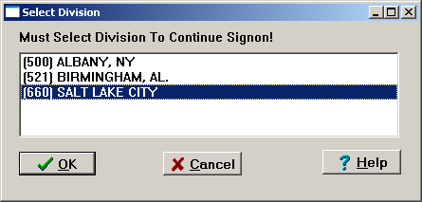

**Figure 18: Division Selection**

If prompted, the user selects a division and clicks the “OK” button or hits the Enter key.

The main Telepathology Worklist window is displayed with the Unread tab in focus.



**Figure 20: Unread List**

On each of these worklists, users can reorganize the columns, sorting (ascending and descending) and/or resizing each column as they like. The layout preferences will be associated with the user’s display setting and stored in VistA. The layout preferences can be saved on exit or on demand.

Preconditions:

* + - * 1. **Edit a Report**

“Login to Application” use case is successfully executed.

Normal Flow:

A user chooses the Unread, Patient, or Read worklist.

A user selects a case.

A user clicks on the “Edit Report” button.

Alternate Flow:

A user selects a case, brings up the right context menu and selects Edit Report.

Post-conditions:

The report editor for the selected case is displayed.

Description/Flow

The main Telepathology Worklist window is displayed as shown below with the Unread worklist displayed.

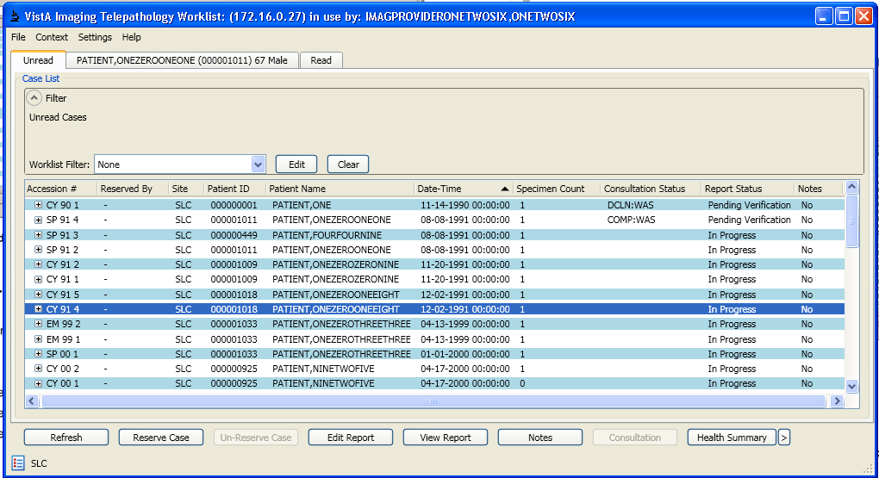

**Figure 22: Selecting a Case to Edit a Report**

The user selects a case and clicks the Edit Report button. The user can also select a case and right click to bring up the context menu as shown below and choose the “Edit Report” menu option to display the report editor. The report editor is then displayed.

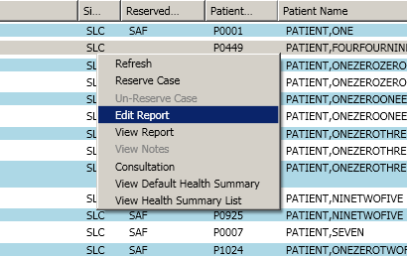

**Figure 23: Editing a Report**

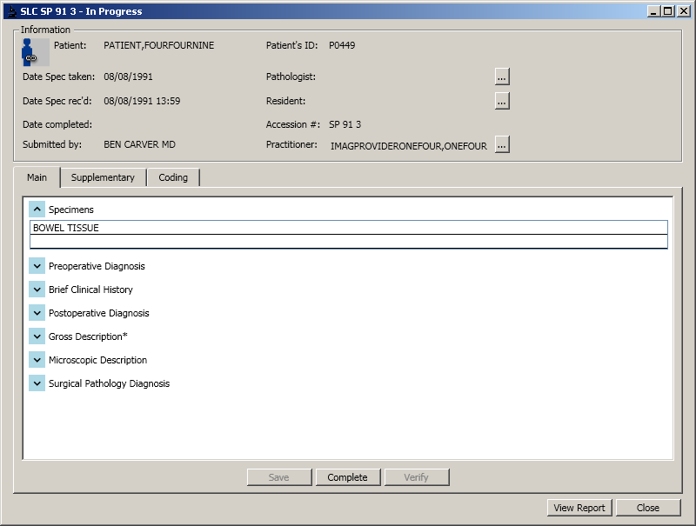

**Figure 24: Reporting GUI**

Preconditions:

* + - * 1. **Viewing a Report**

“Login to Application” use case is successfully executed

Normal Flow:

A user chooses the Unread, Patient, or Read worklist.

A user selects a case.

A user clicks on the “View Report” button.

Alternate Flow:

A user selects a case, brings up the right-click context menu and selects View Report.

Post-conditions:

The released report for the selected case is displayed. Description/Flow

The Telepathology Worklist window is displayed as shown below with the Unread worklist displayed.

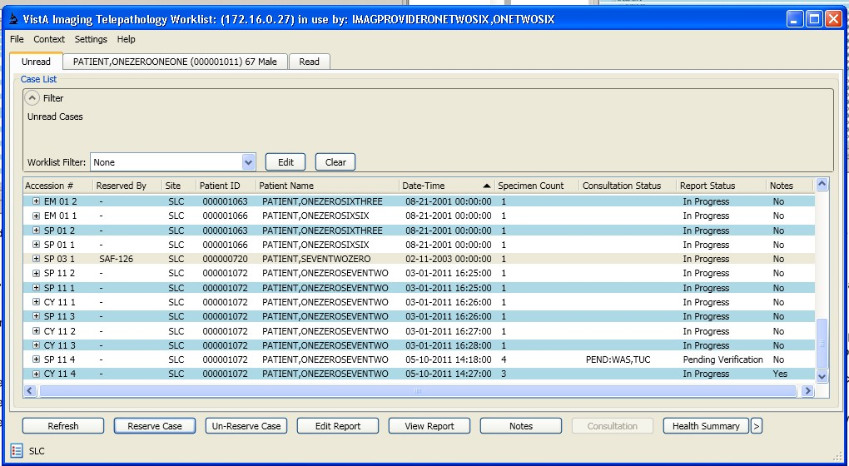

**Figure 25: Selecting a Case to View the Report**

The user selects a case and clicks the View Report button. The user can also select a case and right-click to bring up the context menu as shown below and then choose the “View Report” menu option to display the report for the case.

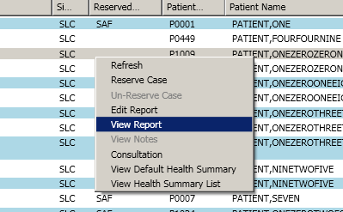

**Figure 26: Viewing Report**

The report for the case is then displayed. Depending on the status of the report, the content of the report will vary. Users can only view the final report if the report has been verified and released.

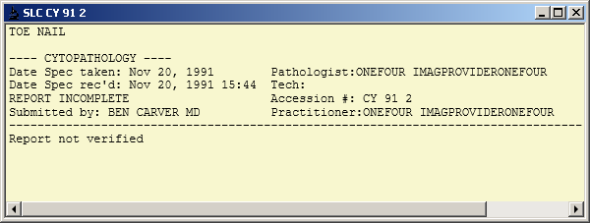

**Figure 30: Report Viewer**

Preconditions:

* + - * 1. **Requesting a Consultation or Recall, Refusing an Existing Consultation Request**

“Login to Application” use case is successfully executed.

Normal Flow:

A user chooses the Unread worklist.

A user selects a case with pending verification status.

A user clicks on the Consultation button.

Using the Consultation window, the user makes, recalls, or declines a consultation request.

Alternate Flow:

A user selects a case with pending verification status, brings up the right context menu

and selects Consultation button.

Selected case must be in pending verification status.

Post-conditions:

Consultation window is displayed.

Consultation window closes when an action is applied and update the case status on the worklist

Description/Flow

The Telepathology Worklist window is displayed as shown below with the Unread worklist displayed.

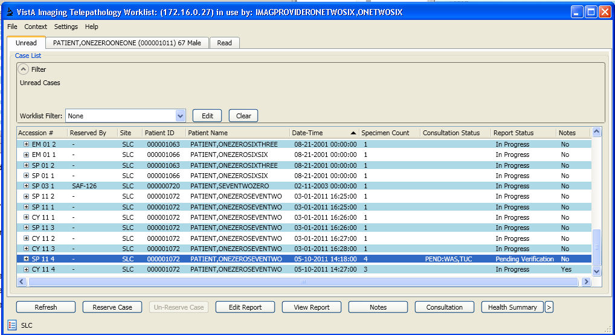

**Figure 31: Selecting a Case for Consultation**

The user selects a case and clicks the Consultation button. The user can also select a case and right-click to bring up the context menu as shown below, and then can choose the “Consultation” menu option.

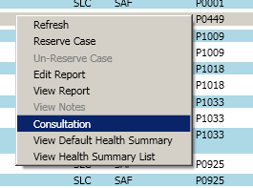

**Figure 32: Select Consultation**

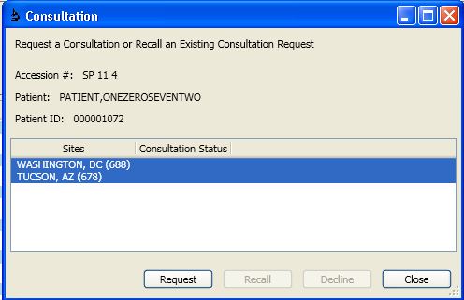The Consultation Window is then displayed.

**Figure 33: Consultation Window**

The user then selects one or more sites and clicks the Request button.

The Consultation Status of the selected sites is now changed to “PENDING”.

The Consultation Status of the case will display as “PEND:[Sites]” on the worklist.



**Figure 27: Requesting Consultation**

To recall an existing consultation request, the user selects a site with the consultation status of “PENDING” from the list of sites and clicks the Recall button.

The consultation status of the selected site is cleared from the PEND list on the worklist

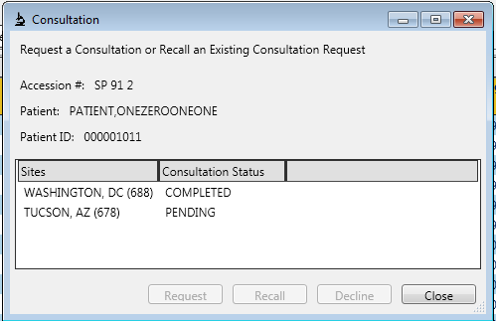

**Figure 28: Recalling Consultation**

A consultation site has option to decline the consultation request. To do so, users must select their site that has a pending status and click the decline button. Once declined, the case will be dropped from the user’s worklist. The case will remain on the acquisition site’s worklist with a

DECL status on the worklist. The acquisition site can submit a request to somewhere else or the declined site again.

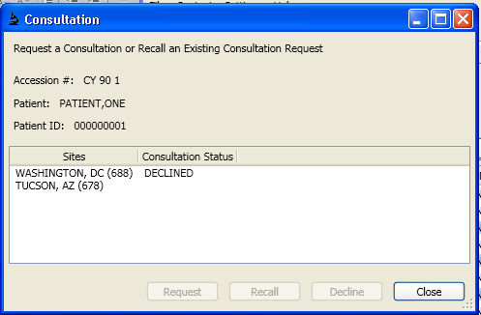

**Figure 29: Declined Consultation**

Preconditions:

* + - * 1. **Viewing Default Health Summary and Health Summary List**

“Login to Application” use case is successfully executed

Normal Flow:

A user chooses the Unread, Patient, or Read worklist.

A user selects a case.

A user clicks on the Default Health Summary or Health Summary List (>) button.

Using the Health Summary List window, the user can view various reports.

Alternate Flow:

A user selects a case, brings up the right-click context menu and selects the Health Summary or the Health Summary List button.

Post-conditions:

Either the Health Summary window or the health summary report is displayed.

Description/Flow

The Telepathology Worklist window is displayed as shown below with the Unread worklist displayed.

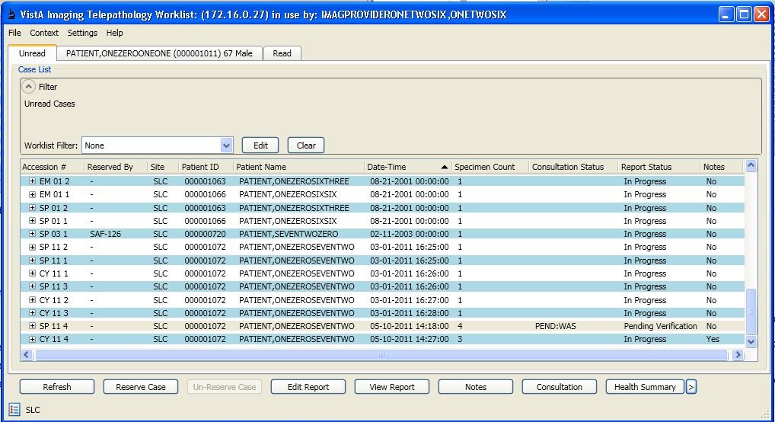

**Figure 30: Selecting a Case to View Health Summary Report**

The user selects a case and clicks the Health Summary button. The user can also select a case and right-click to bring up the context menu as shown below and choose the “View Default Health Summary” menu option.

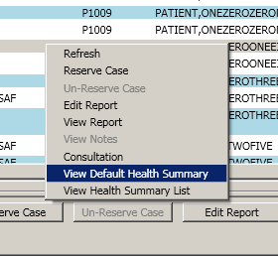

**Figure 31: View Default Health Summary Report**

If a default health summary type has already been set, then the default health summary report is displayed.

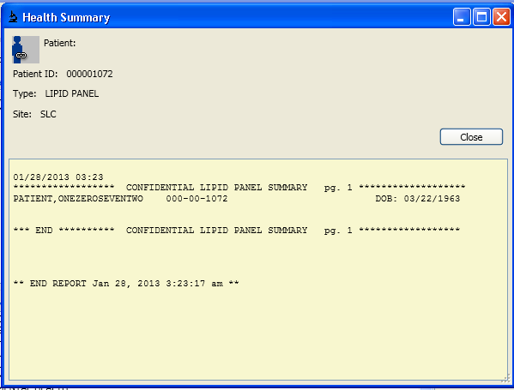

**Figure 32: Health Summary report**

If a default health summary is not set, then the Health Summary List window is displayed. Using this window the user can configure frequently viewed health summary report types for easy lookup, pick a default health summary type or simply view the report from a list of available health summary report types.

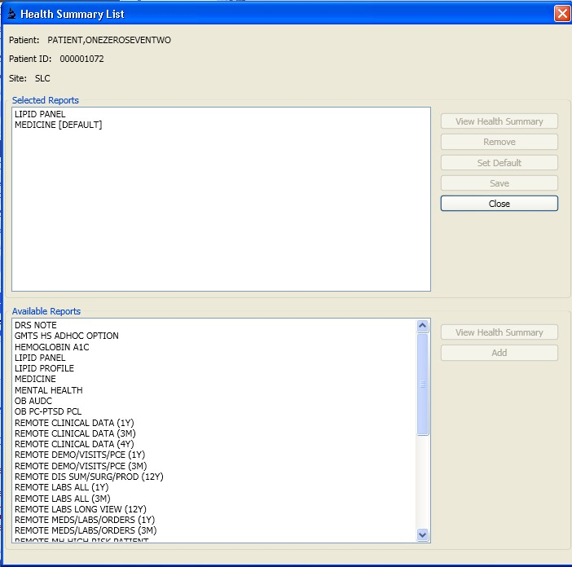

**Figure 40: Health Summary List**

Using the View Health Summary button, the user can view the report for the selected heath summary report type. Using the Add and Remove buttons, the user can create a list of frequently used health summary report types.

* + - * 1. **Creating Worklist Filters, Applying Filters and Editing Filters.**

Preconditions:

* “Login to Application” use case is successfully executed.

Normal Flow:

* A user chooses Settings->Filter settings menu item.
* Filter Settings window is displayed.

Post-conditions:

* A new user defined filter is created with a unique name.

Description/Flow

* The Telepathology Worklist window is displayed as shown below with the Unread

worklist displayed.

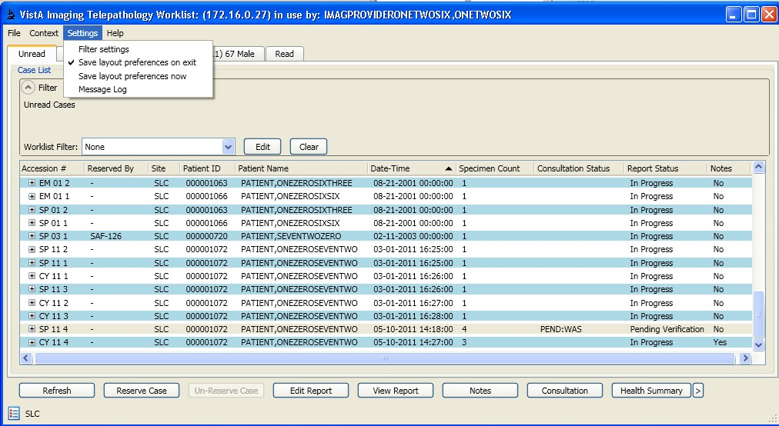

**Figure 41: Normal Caselist**

The user clicks in the Settings menu and selects Filter settings menu item. The Filter Settings window is displayed.

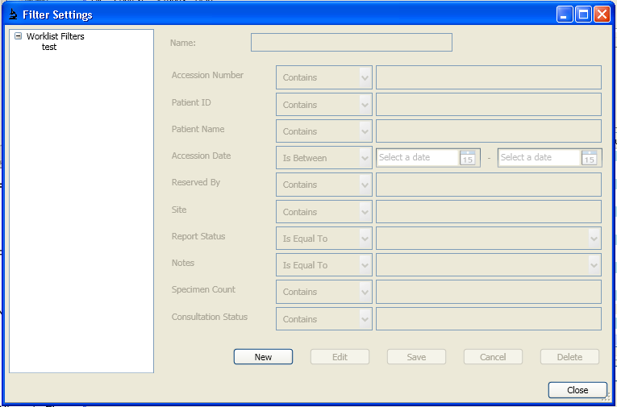

**Figure 42: Worklist Filter Settings**

The user clicks the New button to create a new worklist filter, Edit to edit selected filter. The user then enters a worklist filter name and other filter parameter values. The user then can click the Save button to save the worklist filter. Since the filter list is storing each filter as an individual object, it’s possible to have different filters with same content (name, parameters ); however, to avoid confusions to the users, each filter must have a unique name, and that name will stay with the filter for the entire filter’s life. User can also delete saved filters from the list.

The newly created worklist now appears in the worklist filter dropdown i n each tab.

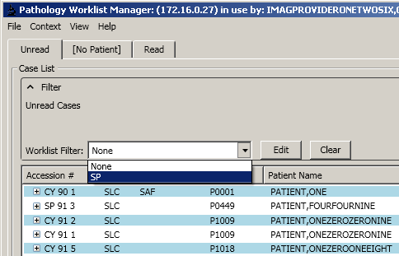

**Figure 43: Pre-defined Filter List**

Selecting this worklist will filter the worklist items.

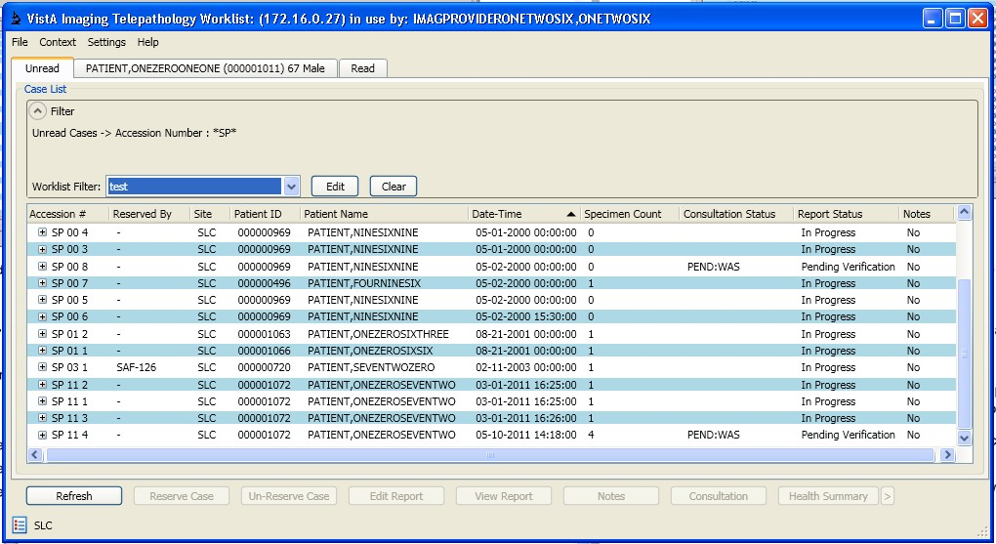

**Figure 44: Filtered Case List**

Currently selected worklist can be cleared by clicking the Clear button. This will remove the filter and return the worklist to its original state.

The user can create temporary filters using the Edit button. This will modify the currently applied filter (even the default filter which does not filter anything).

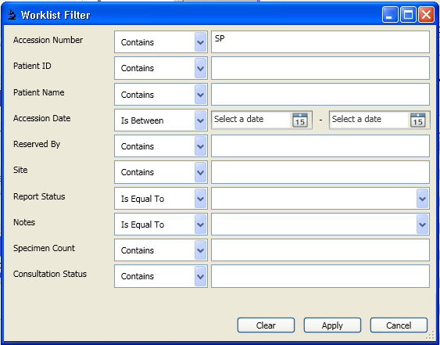

**Figure 33: Temporary Filter editor**

Entering new values and clicking Apply will create a temporary filter and apply it to the worklist. The original filter is not modified.

Preconditions:

* + - * 1. **View Log File**

“Login to Application” use case is successfully executed.

Description/Flow

The Telepathology Worklist window is displayed as shown below with the Unread worklist displayed.

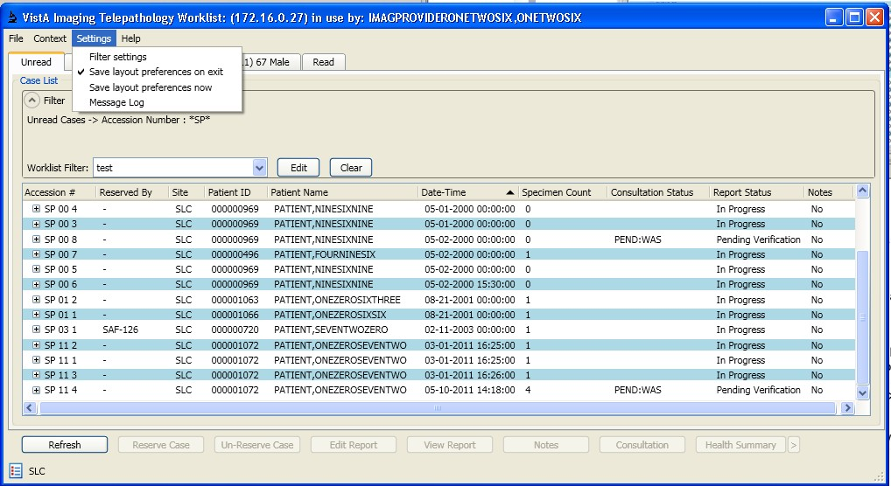

**Figure 34: Telepathology Worklist**

The user selects Settings -> Message Log menu item or the Message Log icon  in the lower left.

The log file is displayed in User Log mode. For users that hold MAG SYSTEM key, they have the option to view a complete log file with the System Log. The view for this log will be displayed with a yellow background.

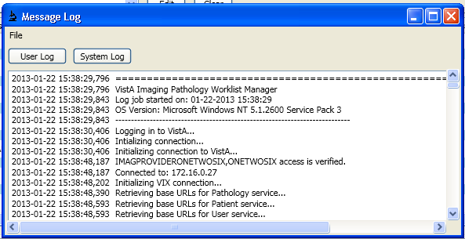

**Figure 35: Application Logs**

The log views here are generated from a continuous application log file stored on the local machine. The maximum size of the file is set to be 1MB. Once the log has reached the maximum size, a history file is created in the same folder with a new log file.

* + - * 1. **Making Notes**

Preconditions:

* “Login to Application” use case is successfully executed.

Description/Flow

* The Telepathology Worklist window is displayed as shown below with the Unread

worklist displayed.

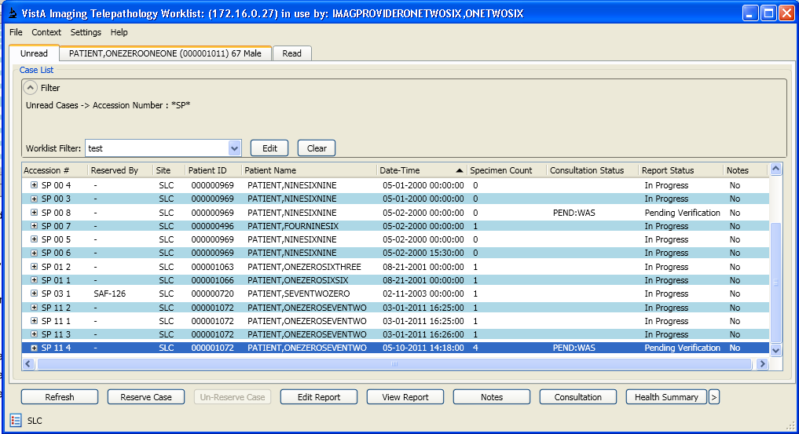

**Figure 36: User Select a Case to View Notes**

Select a case and click on the Notes button. Users can also right click on the case and select View Notes in the context menu. If there are existing notes for the case (Yes in the Notes column), the Notes window will display them.

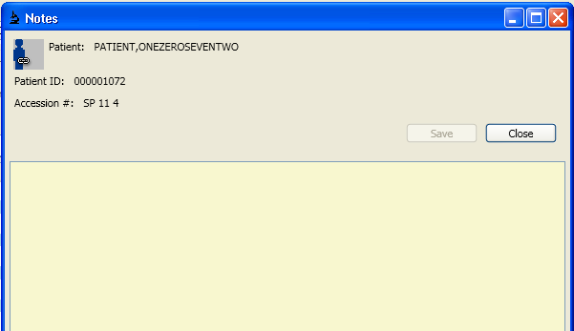

**Figure 37: Notes Window**

User can make changes to the text field and save or discard changes. Closing the window will update the Notes status for the case.

6.2.8. **M Code Design**

* + - 1. **Mail Groups**

MailMan Mail Group TP REG PAT has been created to send a message to a notification pool with the purpose of registering a patient at a consultation reading site where the patient has not been previously recorded.

* + - 1. **Routines (Entry Points)**

|  |  |  |  |  |
| --- | --- | --- | --- | --- |
| Routine Name | F^LRAPLG1 |  |  |  |
| Enhancement Category | New | Modify | Delete | No Change |
| Requirement Traceability Matrix | TP-TPWL-FR-2,TP-TPWL-FR-18, TP-TPWL-FR-19, TP-TPR-FR-13 | | | |
| Related Options | MAGTP WORKLIST MGR | | |  |
| Related Routines | Routines “Called By” | | Routines “Called” | |
|  | LRAPLG |  | ^DIE X^LRAPLG1 CK^LRAPCWK | |

|  |  |  |  |  |  |
| --- | --- | --- | --- | --- | --- |
| Routine Name | F^LRAPLG1 | |  |  |  |
| DISP^SROSPLG  ^LRUWLF  ^LRAPCWK  ^LRAPSWK  ^LRSPGD EN^XQOR OERR^LR7OB63D | | | | | |
| Data Dictionary (DD) References | N/A |  |  |  |  |
| Related Protocols | LR7O AP EVSEND OR, MAGTP ACCESSION PROCESSING | | | | |
| Related Integration Control Registrations (ICRs) | IA #10096, IA #10060, IA #10003, IA #10142, IA #10018, IA #893 | | | | |
| Data Passing | Input | Output Reference | Both | Global Reference | Local |
| Input Attribute Name and Definition | N/A (Tag F is only a marker for a GOTO call) | | |  |  |
| Output Attribute Name and Definition | N/A (Tag F is only a marker for a GOTO call) | | | |  |
| Current Logic | | | | | |
| Tag to generate a case interactively, used in FileMan. It doesn’t populate Telepathology caselist file (#2005.42). | | | | | |
| Modified Logic (Changes are in bold) | | | | | |
| Added call to protocol MAGTP ACCESSION PROCESSING to send HL7 messages and call ADD^MAGTP005 to populate Telepathology caselist file (#2005.42) with new case entry.  S X="MAGTP ACCESSION PROCESSING",DIC=101 D EN^XQOR ; Process Telepathology  protocol | | | | | |

|  |  |  |
| --- | --- | --- |
| Routine Name | GETTD^MAGTP001 | |
| Enhancement Category | New Modify No Change Delete | |
| Requirement Traceability Matrix | TP-TPWL-FR-2,TP-TPR-FR-2 | |
| Related Options | MAGTP WORKLIST MGR | |
| Related Routines | Routines “Called By” | Routines “Called” |

|  |  |  |  |  |  |
| --- | --- | --- | --- | --- | --- |
| Routine Name | GETTD^MAGTP001 | |  |  |  |
|  | RPC Broker | | CONTEXT^MAGTP006 GETS^DIQ  FIELD^DID  FRMTVAL^MAGTP006 | |  |
| Data Dictionary (DD) References | N/A |  |  |  |  |
| Related Protocols | N/A |  |  |  |  |
| Related Integration Control Registrations (ICRs) | N/A |  |  |  |  |
| Data Passing | Input | Output Reference | Both | Global Reference | Local |
| Input Attribute Name and Definition | ENT Input array. The field numbers must be listed one on each line.  LRSS AP Section  YEAR Accession Year (Two figures)  LRAN Accession Number | | | | |
| Output Attribute Name and Definition | Name: MAGRY Definition:  If MAGRY(0) 1st '^'-piece is 0, then an error occurred during execution of the procedure:  0^0^ ERROR explanation: When no other lines of output are generated  0^ Total Number of Lines: if an error occurred while extracting one of the fields  Otherwise, the output array is as follows: MAGRY(0) Description  ^01: 1  ^02: Total Number of Lines  MAGRY(i) Description  ^01: Field Number  ^02: Field Label  ^03: Data [entries separated by pipes (|)] | | | | |
| Current Logic | | | | | |
| N/A | | | | | |

|  |  |
| --- | --- |
| Routine Name | GETTD^MAGTP001 |
| Modified Logic (Changes are in bold) | |
| Read the inputs LRSS, YEAR and LRAN described above, validate them and select a case in the LAB DATA file.  Read ENT and select one or more fields to display their content in MAGRY according to their type (single, multiple, word processing).  Transform dates into external format (MM/DD/YYYY hh:mm:ss) Update MAGRY accordingly. | |

|  |  |  |  |  |  |  |
| --- | --- | --- | --- | --- | --- | --- |
| Routine Name | PUTFIELD^MAGTP001 | | |  |  |  |
| Enhancement Category | New |  | Modify | Delete | No Change |  |
| Requirement Traceability Matrix | TP-TPR-FR-1, TP-TPR-FR-3, TP-TPR-FR-6, TP-TPR-FR-8, TP-TPR-  FR-12 | | | | | |
| Related Options | MAGTP WORKLIST MGR | | | |  |  |
| Related Routines | Routines “Called By” | | | Routines “Called” | |  |
|  | RPC Broker | |  | CONTEXT^MAGTP006 FIELD^DID  WP^DIE UPDATE^DIE  ^DIK LOCKR^MAGTP003 VERADCPT^MAGTP009 SNDALRT^MAGTP006 PUTINTRP^MAGTP007 | |  |
| Data Dictionary (DD) References | N/A |  |  |  |  |  |
| Related Protocols | N/A |  |  |  |  |  |
| Related Integration Control Registrations (ICRs) | N/A |  |  |  |  |  |
| Data Passing | Input | Output Reference | | Both | Global Reference | Local |
| Input Attribute Name and Definition | ENT Input array. The field numbers and entry data must be listed one on each line as:  ENT(n) = Field Number ^ N: Total Number of lines of data ENT(n+1) = Field Number ^ DATA (1)  ...  ENT(n+N) = Field Number ^ DATA (N) | | | | | |

|  |  |
| --- | --- |
| Routine Name | PUTFIELD^MAGTP001 |
|  | LRSS AP Section  YEAR Accession Year (Two figures)  LRAN Accession Number |
| Output Attribute Name and Definition | Name: MAGRY Definition:  If MAGRY(0) 1st '^'-piece is 0, then an error occurred during  execution of the procedure:  0^0^ ERROR explanation: When no other lines of output are generated  Otherwise, the output array is as follows: MAGRY(0) Description  ^01: 1  ^02: 0  ^03: In the case of entry of Field # .11 (Release Report Date), the entry will read "Release alert will be sent to: " followed by  the name(s) of the pathologist and/or the patient's PCP. |
| Current Logic | |
| N/A | |
| Modified Logic (Changes are in bold) | |
| Read the inputs LRSS, YEAR and LRAN described above, validate them and select a case in the LAB DATA file.  Read ENT and select one or more fields to update, according to their type (single, multiple, word processing).  In the case of entry of Field # .11 (Release Report Date) a message will be sent to the pathologist and/or the patient's PCP.  If the report is completed (Field # .03) generate an interpretation for the case. Update MAGRY accordingly. | |

|  |  |  |
| --- | --- | --- |
| Routine Name | GETSR^MAGTP002 | |
| Enhancement Category | New Modify No Change Delete | |
| Requirement Traceability Matrix | TP-CONSULTS-FR-8 | |
| Related Options | MAGTP WORKLIST MGR | |
| Related Routines | Routines “Called By” | Routines “Called” |

|  |  |  |  |  |  |
| --- | --- | --- | --- | --- | --- |
| Routine Name | GETSR^MAGTP002 | |  |  |  |
|  | RPC Broker | | CONTEXT^MAGTP006 GET1^DID  GETS^DIQ  FMTE^XLFDT | |  |
| Data Dictionary (DD) References | N/A |  |  |  |  |
| Related Protocols | N/A |  |  |  |  |
| Related Integration Control Registrations (ICRs) | N/A |  |  |  |  |
| Data Passing | Input | Output Reference | Both | Global Reference | Local |
| Input Attribute Name and Definition | LRSS AP Section  YEAR Accession Year (Two figures) LRAN Accession Number | | |  |  |
| Output Attribute Name and Definition | Name: MAGRY Definition:  If MAGRY(0) 1st '^'-piece is 0, then an error occurred during execution of the procedure: 0^0^ ERROR explanation  Otherwise, the output array is as follows: MAGRY(0) Description  ^01: 1  ^02: Total Number of Lines  MAGRY(i) Description  ^01: Date of Supplementary Report  ^02: SR Verified (YES/NO  ^03: Name of provider who verified (if Verified = YES)  ^04: SR Text [entries separated by pipes (|)] | | | | |
| Current Logic | | | | | |
| N/A | | | | | |
| Modified Logic (Changes are in bold) | | | | | |
| Read the inputs LRSS, YEAR and LRAN described above, validate them and select a case in the LAB DATA file.  Extract information about all the supplementary reports for that case, to display them in the MAGRY array as detailed above. | | | | | |

|  |  |  |  |  |  |  |
| --- | --- | --- | --- | --- | --- | --- |
| Routine Name | PUTSR^MAGTP002 | | |  |  |  |
| Enhancement Category | New |  | Modify | Delete | No Change |  |
| Requirement Traceability Matrix | TP-CONSULTS-FR-7 | | |  |  |  |
| Related Options | MAGTP WORKLIST MGR | | | |  |  |
| Related Routines | Routines “Called By” | | | Routines “Called” | |  |
|  | RPC Broker | |  | CONTEXT^MAGTP006 RELEAS1^MAGTP006 GETRPT^MAGTP006 RELEAS2^MAGTP006 COPY^MAGTP006 RPT^MAGTP006 RELEASE^MAGTP006 COMPARE^MAGTP006 UPDATE^MAGTP006 STORE^MAGTP006 | |  |
| Data Dictionary (DD) References | N/A |  |  |  |  |  |
| Related Protocols | N/A |  |  |  |  |  |
| Related Integration Control Registrations (ICRs) | N/A |  |  |  |  |  |
| Data Passing | Input | Output Reference | | Both | Global Reference | Local |
| Input Attribute Name and Definition | ENT Input array:  First Line: ^01: DATE  ^02: RELEASE? (1:YES/0:NO)  Following Lines: TEXT of Supplementary Report LRSS AP Section  YEAR Accession Year (Two figures)  LRAN Accession Number | | | | | |
| Output Attribute Name and Definition | Name: MAGRY Definition:  If MAGRY(0) 1st '^'-piece is 0, then an error occurred during execution of the procedure: 0^0^ ERROR explanation  Otherwise, the output array is as follows: MAGRY(0) Description | | | | | |

|  |  |
| --- | --- |
| Routine Name | PUTSR^MAGTP002 |
|  | ^01: 1  ^02: 0  ^03: Message with the outcome of the action on the Supplementary Report  ^04: In the case of release of the Supplementary Report  this entry will read: "Release alert will be sent to: " followed by the name(s) of the pathologist and/or the patient's PCP. |
| Current Logic | |
| N/A | |
| Modified Logic (Changes are in bold) | |
| Read the inputs LRSS, YEAR and LRAN described above, validate them and select a case in the LAB DATA file.  Read ENT and select by date a Supplementary Report to update, or to create if not already existent.  If the Supplementary Report is marked for release, release it and send a mes sage to the pathologist and/or the patient's PCP.  If the main report is verified, record all changes. Update MAGRY accordingly. | |

|  |  |  |  |  |  |  |
| --- | --- | --- | --- | --- | --- | --- |
| Routine Name | GETPAT^MAGTP003 | | |  |  |  |
| Enhancement Category | New |  | Modify | Delete | No Change |  |
| Requirement Traceability Matrix | TP-TPWL-FR-20 | | |  |  |  |
| Related Options | MAGTP WORKLIST MGR | | | |  |  |
| Related Routines | Routines “Called By” | | | Routines “Called” | |  |
|  | RPC Broker | |  | GET1^DIQ GETCASE^MAGTP009  $$EMPSENS^MAGUE007() | |  |
| Data Dictionary (DD) References | N/A |  |  |  |  |  |
| Related Protocols | N/A |  |  |  |  |  |
| Related Integration Control Registrations (ICRs) | N/A |  |  |  |  |  |
| Data Passing | Input | Output Reference | | Both | Global Reference | Local |

|  |  |
| --- | --- |
| Routine Name | GETPAT^MAGTP003 |
| Input Attribute Name and Definition | DFN Patient's ID number |
| Output Attribute Name and Definition | Name: MAGRY Definition:  If @MAGRY@(0) 1st '^'-piece is < 0, then an error  occurred during execution of the procedure: 0^0^ ERROR explanation Otherwise, the output is as follows:  MAGRY(0) Description  ^01: 1  ^02: Total Number of Lines  ^03: "Patient's Reports"  MAGRY(i) Description  ^01: Case Number  ^02: Lock Entry (0/1 for Unlocked/Locked)  ^03: Initials of who locked the case in the LAB DATA file (#63)  ^04: Patient's Name  ^05: Patient's ID Number  ^06: Priority  ^07: Slide(s) Available  ^08: Date/Time Specimen Taken  ^09: Case Status  ^10: Site Initials  ^11: AP Section  ^12: Year  ^13: Accession Number  ^14: ICN  ^15: Specimen Count  ^16: Reading Method  ^17: Patient's Short ID  ^18: Is there a Note? (Yes/No)  ^19: Employee/Sensitive? (1/0 for Yes/No) |
| Current Logic | |
| N/A | |
| Modified Logic (Changes are in bold) | |
| Read the input DFN described above, validate it and select a patient in the LAB DATA file. Extract LAB DATA information for all cases related to that patient, to display it in the MAGRY  array as detailed above. | |

|  |  |  |  |
| --- | --- | --- | --- |
| Routine Name | LOCKR^MAGTP003 | | |
| Enhancement Category | New | Modify | No Change |

|  |  |  |  |  |  |
| --- | --- | --- | --- | --- | --- |
| Routine Name | LOCKR^MAGTP003 | |  |  |  |
| Delete | | | | | |
| Requirement Traceability Matrix | TP-TPWL-FR-18, TP-TPWL-FR-19 | | |  |  |
| Related Options | MAGTP WORKLIST MGR | |  |  |  |
| Related Routines | Routines “Called By” | | Routines “Called” | |  |
|  | RPC Broker | | CONTEXT^MAGTP006 GET1^DIQ FMTE^XLFDT NOW^XLFDT UPDATE^DIE | |  |
| Data Dictionary (DD) References | N/A |  |  |  |  |
| Related Protocols | N/A |  |  |  |  |
| Related Integration Control Registrations (ICRs) | IA #2171, IA #10060 | |  |  |  |
| Data Passing | Input | Output Reference | Both | Global Reference | Local |
| Input Attribute Name and Definition | LFLAG Flag that controls whether to lock or unlock LRSS AP Section  YEAR Accession Year (Two figures)  LRAN Accession Number | | | |  |
| Output Attribute Name and Definition | Name: MAGRY Definition:  If MAGRY(0) 1st '^'-piece is < 0, then an error occurred during execution of the procedure: <code>^0^ ERROR explanation  Otherwise, the output array is as follows: MAGRY(0) Description  ^01: 0  ^02: 0 if case record is unlocked, 1 if case record is locked  ^03: "Reservation ended" if case record is unlocked "Case reserved" if case record is locked | | | | |

|  |  |
| --- | --- |
| Routine Name | LOCKR^MAGTP003 |
| Current Logic | |
| N/A | |
| Modified Logic (Changes are in bold) | |
| Read the inputs LRSS, YEAR and LRAN described above, validate them and select a case in the LAB DATA file and the corresponding record entry in the caselist file (#2005.42)  Read LFLAG and set the FIRST LOCK field (#1) in File 2005.42 accordingly. Set the FIRST LOCK DATE/TIME field (#1.1) to the current Fileman date and time and the FIRST LOCK USER field (#1.2) to the current DUZ.  Update MAGRY to return the appropriate code for success (0) or failure (< 0) and the corresponding human-readable explanation. | |

|  |  |  |  |  |  |  |
| --- | --- | --- | --- | --- | --- | --- |
| Routine Name | GETLMINS^MAGTP003 | | |  |  |  |
| Enhancement Category | New |  | Modify | Delete | No Change |  |
| Requirement Traceability Matrix | TP-TPR-FR-13 | |  |  |  |  |
| Related Options | MAGTP WORKLIST MGR | | | |  |  |
| Related Routines | Routines “Called By” | | | Routines “Called” | |  |
|  | RPC Broker | |  | GET1^DIQ | |  |
| Data Dictionary (DD) References | N/A |  |  |  |  |  |
| Related Protocols | N/A |  |  |  |  |  |
| Related Integration Control Registrations (ICRs) | N/A |  |  |  |  |  |
| Data Passing | Input | Output Reference | | Both | Global Reference | Local |
| Input Attribute Name and Definition | N/A |  |  |  |  |  |
| Output Attribute Name and Definition | Name: MAGRY Definition:  If MAGRY(0) 1st '^'-piece is 0, then an error occurred during execution of the procedure: 0^0^ ERROR explanation  Otherwise, the output array is as follows: MAGRY(0) Description | | | | | |

|  |  |
| --- | --- |
| Routine Name | GETLMINS^MAGTP003 |
|  | ^01: 1  ^02: 1  MAGRY(1) Description  ^01: Number of Minutes |
| Current Logic | |
| N/A | |
| Modified Logic (Changes are in bold) | |
| Extract from the configuration file (#2006.13) the number of minutes a lock is effective until it expires.  Update MAGRY accordingly. | |

|  |  |  |  |  |  |  |
| --- | --- | --- | --- | --- | --- | --- |
| Routine Name | PUTLMINS^MAGTP003 | | |  |  |  |
| Enhancement Category | New |  | Modify | Delete | No Change |  |
| Requirement Traceability Matrix | TP-TPR-FR-13 | |  |  |  |  |
| Related Options | MAGTP WORKLIST MGR | | | |  |  |
| Related Routines | Routines “Called By” | | | Routines “Called” | |  |
|  | RPC Broker | |  | UPDATE^DIE | |  |
| Data Dictionary (DD) References | N/A |  |  |  |  |  |
| Related Protocols | N/A |  |  |  |  |  |
| Related Integration Control Registrations (ICRs) | N/A |  |  |  |  |  |
| Data Passing | Input | Output Reference | | Both | Global Reference | Local |
| Input Attribute Name and Definition | MINUTES Number of minutes a lock is effective until it expires. | | | | | |
| Output Attribute Name and Definition | Name: MAGRY Definition:  If MAGRY(0) 1st '^'-piece is 0, then an error occurred during execution of the procedure: 0^0^ ERROR explanation  Otherwise, the output array is as follows: | | | | | |

|  |  |
| --- | --- |
| Routine Name | PUTLMINS^MAGTP003 |
|  | MAGRY(0) Description  ^01: 1  ^02: 0  ^03: "Number of Locking Minutes Updated" |
| Current Logic | |
| N/A | |
| Modified Logic (Changes are in bold) | |
| Read the input MINS described above, validate it and set it in the configuration file (#2006.13). Update MAGRY accordingly. | |

|  |  |  |  |  |  |  |
| --- | --- | --- | --- | --- | --- | --- |
| Routine Name | GETAC^MAGTP004 | | |  |  |  |
| Enhancement Category | New |  | Modify | Delete | No Change |  |
| Requirement Traceability Matrix | TP-TPWL-FR-1, TP-TPWL-FR-2, TP-TPWL-FR-5, TP-TPWL-FR-6, TP-  TPWL-FR-15, TP-TPWL-FR-18, TP-TPWL-FR-19, TP-TPR-FR-9 | | | | | |
| Related Options | MAGTP WORKLIST MGR | | | |  |  |
| Related Routines | Routines “Called By” | | | Routines “Called” | |  |
|  | RPC Broker | |  | IEN^XUAF4 GET1^DIQ NOW^XLFDT FMADD^XLFDT  ISCONSLT^MAGTP009 GETCASE^MAGTP009 ARY2GLB^MAGTP009  $$EMPSENS^MAGUE007() | |  |
| Data Dictionary (DD) References | N/A |  |  |  |  |  |
| Related Protocols | N/A |  |  |  |  |  |
| Related Integration Control Registrations (ICRs) | IA #2171 |  |  |  |  |  |
| Data Passing | Input | Output Reference | | Both | Global Reference | Local |
| Input Attribute Name and Definition | FLAG Flag that controls execution:  0 Selects only unreleased reports. | | | | |  |

|  |  |
| --- | --- |
| Routine Name | GETAC^MAGTP004 |
|  | 1 Selected only released reports.  One may go back in time by DAYS number  of days (see next input)  DAYS Number of days one may go back in time to retrieve data in case of released reports.  STAT 1) If STAT is not null and in the Reading List in file (#2006.13) display the case if it has  a consultation for an interpreting station number equal to  STAT  2) If STAT is null, display all cases. |
| Output Attribute Name and Definition | Name: MAGRY Definition:  If @MAGRY@(0) 1st '^'-piece is < 0, then an error  occurred during execution of the procedure: 0^0^ ERROR explanation Otherwise, the output is as follows:  @MAGRY@(0) Description  ^01: 1  ^02: Total Number of Lines  ^03: "Released Reports" or "Unreleased Reports"  @MAGRY@(i) Description  ^01: Case Number  ^02: Reserved Entry (0/1 for Not Reserved/Reserved)  ^03: Initials of who reserved the case in the LAB DATA file (#63)  ^04: Patient's Name  ^05: Patient's ID Number  ^06: Priority  ^07: Slide(s) Available  ^08: Date/Time Specimen Taken  ^09: Case Status  ^10: Site Initials  ^11: AP Section  ^12: Year  ^13: Accession Number  ^14: ICN  ^15: Specimen Count  ^16: Reading Method  ^17: Patient's Short ID  ^18: Is there a Note? (Yes/No)  ^19: Employee/Sensitive? (1/0 for Yes/No) |
| Current Logic | |
| N/A | |
| Modified Logic (Changes are in bold) | |

|  |  |
| --- | --- |
| Routine Name | GETAC^MAGTP004 |
| Read the inputs FLAG, DAYS and STAT described above.  Check that STAT (if present) is a station number in the local site Reading List.  Check that STAT is of type CONSULTATION, then set a flag to select only the cases with their station number matching STAT.  Loop over the LAB DATA file indexes to find all cases, filter for output only those matching FLAG (0 for unreleased, 1 for released up to DAYS ago).  Further filter the cases, if STAT was present, to show only those with at least one consultation matching STAT.  Extract the info detailed above to populate MAGRY. | |

|  |  |  |  |  |  |  |
| --- | --- | --- | --- | --- | --- | --- |
| Routine Name | GETSD^MAGTP004 | | |  |  |  |
| Enhancement Category | New |  | Modify | Delete | No Change |  |
| Requirement Traceability Matrix | TP-TPWL-FR-2 | | |  |  |  |
| Related Options | MAGTP WORKLIST MGR | | | |  |  |
| Related Routines | Routines “Called By” | | | Routines “Called” | |  |
|  | RPC Broker | |  | CONTEXT^MAGTP006 GETS^DIQ  GET1^DID  FMTE^XLFDT | |  |
| Data Dictionary (DD) References | DD(SUBF SUBF:Subfield for Specimen | | | | |  |
| Related Protocols | N/A |  |  |  |  |  |
| Related Integration Control Registrations (ICRs) | N/A |  |  |  |  |  |
| Data Passing | Input | Output Reference | | Both | Global Reference | Local |
| Input Attribute Name and Definition | LRSS AP Section  YEAR Accession Year (Two figures) LRAN Accession Number | | | |  |  |
| Output Attribute Name and Definition | Name: MAGRY Definition:  If MAGRY(0) 1st '^'-piece is 0, then an error  occurred during execution of the procedure: 0^0^ ERROR explanation | | | | |  |

|  |  |
| --- | --- |
| Routine Name | GETSD^MAGTP004 |
|  | Otherwise, the output array is as follows:  MAGRY(0) Description  ^01: 1  ^02: Total Number of Lines  ^03: "Specimen"  ^04: "Smear Prep"  ^05: "Stain/Procedure"  ^06: "# of Slides"  ^07: "Last Stain Date"  MAGRY(i) Description  ^01: Specimen  ^02: Smear Prep/Block Name  ^03: Stain/Procedure/Slide Name  ^04: Number of Stains/Procedures/Slides  ^05: Date of Entry of the Last Stain/Procedure/Slide |
| Current Logic | |
| N/A | |
| Modified Logic (Changes are in bold) | |
| Read the inputs LRSS, YEAR and LRAN described above, validate them and select a case in the LAB DATA file.  Extract specimen, smear/prep/block and stain/procedure/slide info from the LAB DATA file (#63) for that case.  Update MAGRY accordingly. | |

|  |  |  |
| --- | --- | --- |
| Routine Name | GETXT^MAGTP005 | |
| Enhancement Category | New Modify No Change Delete | |
| Requirement Traceability Matrix | TP-TPC-FR-7 | |
| Related Options | MAGTP WORKLIST MGR | |
| Related Routines | Routines “Called By” | Routines “Called” |
|  | RPC Broker | GET1^DIQ |
| Data Dictionary (DD) References | N/A | |
| Related Protocols | N/A | |
| Related Integration Control Registrations | N/A | |

|  |  |  |  |  |  |
| --- | --- | --- | --- | --- | --- |
| Routine Name | GETXT^MAGTP005 | |  |  |  |
| (ICRs) | | | | | |
| Data Passing | Input | Output Reference | Both | Global Reference | Local |
| Input Attribute Name and Definition | LRSS AP Section | |  |  |  |
| Output Attribute Name and Definition | Name: MAGRY Definition:  If MAGRY(0) 1st '^'-piece is 0, then an error occurred during execution of the procedure: 0^0^ ERROR explanation  Otherwise, the output array is as follows: MAGRY(0) Description  ^01: 1  ^02: Total Number of Lines  MAGRY(i) Description  ^01: XML Line of Text | | | | |
| Current Logic | | | | | |
| N/A | | | | | |
| Modified Logic (Changes are in bold) | | | | | |
| Read the input LRSS described above and validate it.  Extract the XML template for the present site from the configuration file (#2006.13), according to the AP section given by LRSS.  Update MAGRY accordingly. | | | | | |

|  |  |  |
| --- | --- | --- |
| Routine Name | PUTXT^MAGTP005 | |
| Enhancement Category | New Modify No Change Delete | |
| Requirement Traceability Matrix | TP-TPC-FR-6, TP-TPC-FR-7 | |
| Related Options | MAGTP WORKLIST MGR | |
| Related Routines | Routines “Called By” | Routines “Called” |
|  | RPC Broker | WP^DIE |
| Data Dictionary (DD) References | N/A | |

|  |  |  |  |  |  |
| --- | --- | --- | --- | --- | --- |
| Routine Name | PUTXT^MAGTP005 | |  |  |  |
| Related Protocols | N/A |  |  |  |  |
| Related Integration Control Registrations (ICRs) | N/A |  |  |  |  |
| Data Passing | Input | Output Reference | Both | Global Reference | Local |
| Input Attribute Name and Definition | ENT Input array. One XML line of text must be on each line of the array.  LRSS AP Section | | | |  |
| Output Attribute Name and Definition | Name: MAGRY Definition:  If MAGRY(0) 1st '^'-piece is 0, then an error  occurred during execution of the procedure: 0^0^ ERROR  explanation  Otherwise, the output array is as follows: MAGRY(0) Description  ^01: 1  ^02: 0  ^03: "<LRSS> Template Updated" | | | |  |
| Current Logic | | | | | |
| N/A | | | | | |
| Modified Logic (Changes are in bold) | | | | | |
| Read the inputs ENT and LRSS described above and validate them.  Set the XML template for the present site into the configuration file (#2006.13) according to the AP section given by LRSS.  Update MAGRY accordingly. | | | | | |

|  |  |  |
| --- | --- | --- |
| Routine Name | PUTPRI^MAGTP005 | |
| Enhancement Category | New Modify No Change Delete | |
| Requirement Traceability Matrix | Future Enhancements/Postponed Requirements | |
| Related Options | MAGTP WORKLIST MGR | |
| Related Routines | Routines “Called By” | Routines “Called” |

|  |  |  |  |  |  |
| --- | --- | --- | --- | --- | --- |
| Routine Name | PUTPRI^MAGTP005 | |  |  |  |
|  | RPC Broker | | CONTEXT^MAGTP006 GET1^DIQ UPDATE^DIE | |  |
| Data Dictionary (DD) References | N/A |  |  |  |  |
| Related Protocols | N/A |  |  |  |  |
| Related Integration Control Registrations (ICRs) | N/A |  |  |  |  |
| Data Passing | Input | Output Reference | Both | Global Reference | Local |
| Input Attribute Name and Definition | PRI Priority flag (0:ROUTINE, 1:HIGH, 2:STAT). Default ROUTINE.  LRSS AP Section  YEAR Accession Year (Two figures) LRAN Accession Number | | | | |
| Output Attribute Name and Definition | Name: MAGRY Definition:  If MAGRY(0) 1st '^'-piece is 0, then an error occurred during execution of the procedure:  Otherwise, the output array is as follows: MAGRY(0) Description  ^01: 1  ^02: 0  ^03: "Priority Updated" | | | |  |
| Current Logic | | | | | |
| N/A | | | | | |
| Modified Logic (Changes are in bold) | | | | | |
| Read the inputs PRI, LRSS, YEAR and LRAN described above, validate them and select a case in the LAB DATA file.  Find the corresponding entry in the caselist file (#2005.42) and update it setting the priority (PRI) for the case.  Update MAGRY accordingly. | | | | | |

|  |  |  |  |  |
| --- | --- | --- | --- | --- |
| Routine Name | ADD^MAGTP005 | | | |
| Enhancement Category | New | Modify | Delete | No Change |

|  |  |  |  |  |  |
| --- | --- | --- | --- | --- | --- |
| Routine Name | ADD^MAGTP005 | |  |  |  |
| Requirement Traceability Matrix | TP-TPWL-FR-2,TP-TPWL-FR-18, TP-TPWL-FR-19, TP-TPR-FR-13 | | | | |
| Related Options | MAGTP WORKLIST MGR | |  |  |  |
| Related Routines | Routines “Called By” | | Routines “Called” | |  |
|  | LRAPLG1 MAGITP00 | | UPDATE^DIE | |  |
| Data Dictionary (DD) References | N/A |  |  |  |  |
| Related Protocols | N/A |  |  |  |  |
| Related Integration Control Registrations (ICRs) | N/A |  |  |  |  |
| Data Passing | Input | Output Reference | Both | Global Reference | Local |
| Input Attribute Name and Definition | LRAC Accession Code | |  |  |  |
| Output Attribute Name and Definition | N/A |  |  |  |  |
| Current Logic | | | | | |
| N/A | | | | | |
| Modified Logic (Changes are in bold) | | | | | |
| Read the input LRAC (accession Number) described a bove and set it in the caselist file (# 2005.42). Set by default Priority, Slide Available, Method, Reservation and Second Lock to 0 in the same file. | | | | | |

|  |  |  |
| --- | --- | --- |
| Routine Name | CONTEXT^MAGTP006 | |
| Enhancement Category | New Modify No Change Delete | |
| Requirement Traceability Matrix | TP-TPWL-FR-2,TP-TPR-FR-2, TP-TPR-FR-13 | |
| Related Options | MAGTP WORKLIST MGR | |
| Related Routines | Routines “Called By” | Routines “Called” |
|  | GETTD^MAGTP001 PUTFIELD^MAGTP001 GETSR^MAGTP002 PUTSR^MAGTP002 LOCKR^MAGTP003 | N/A |

|  |  |  |  |  |  |
| --- | --- | --- | --- | --- | --- |
| Routine Name | CONTEXT^MAGTP006 | |  |  |  |
| GETSD^MAGTP004  PUTPRI^MAGTP005 GETREP^MAGTP007 SECNLOCK^MAGTP008 PUTMETH^MAGTP010 PUTCPT^MAGTP010 PUTSNOMD^MAGTP011 GETSNOMD^MAGTP011 GETCPT^MAGTP012 DELSNOMD^MAGTP013 | | | | | |
| Data Dictionary (DD) References | N/A |  |  |  |  |
| Related Protocols | N/A |  |  |  |  |
| Related Integration Control Registrations (ICRs) | N/A |  |  |  |  |
| Data Passing | Input | Output Reference | Both | Global Reference | Local |
| Input Attribute Name and Definition | LRSS AP Section  YEAR Accession Year (Two figures) LRAN Accession Number | | |  |  |
| Output Attribute Name and Definition | Name: MAGRY Definition:  If MAGRY(0) 1st '^'-piece is 0, then an error  occurred during execution of the procedure: 0^0^ ERROR explanation  Otherwise, the output array is as follows: MAGRY(0) Description  ^01: 1  ^02: 0  Return value is a string:  “LRSF,LRI,LRDFN,” if successful “” if error  Where:  LRSF Subfield Number in LAB DATA file (#63) | | | |  |

|  |  |
| --- | --- |
| Routine Name | CONTEXT^MAGTP006 |
|  | LRI Reverse Date entry in LAB DATA file (#63)  LRDFN LAB DATA file (#63) DFN for a patient |
| Current Logic | |
| N/A | |
| Modified Logic (Changes are in bold) | |
| Read the inputs LRSS, YEAR and LRAN described above, validate them and select an entry in the LAB DATA file.  Return the output string "LRSF,LRI,LRDFN," as described above, extracted from the LAB DATA file (#63).  Update MAGRY accordingly. | |

|  |  |  |  |  |  |
| --- | --- | --- | --- | --- | --- |
| Routine Name | FRMTVAL^MAGTP006 | |  |  |  |
| Enhancement Category | New | Modify | Delete | No Change |  |
| Requirement Traceability Matrix | TP-TPWL-FR-2,TP-TPR-FR-2 | | |  |  |
| Related Options | MAGTP WORKLIST MGR | | |  |  |
| Related Routines | Routines “Called By” | | Routines “Called” | |  |
|  | GETTD^MAGTP001 | | FMTE^XLFDT | |  |
| Data Dictionary (DD) References | N/A |  |  |  |  |
| Related Protocols | N/A |  |  |  |  |
| Related Integration Control Registrations (ICRs) | N/A |  |  |  |  |
| Data Passing | Input | Output Reference | Both | Global Reference | Local |
| Input Attribute Name and Definition | X Input data in internal or external format  IE Flags data as external ("E") or internal ("I") | | | |  |
| Output Attribute Name and Definition | If input data is in Internal format: The input is Date/Time  The output is Date/Time in MM/DD/YYYY hh:mm:ss  format  If input data is in External format: The input is not a date The output is the same as the input | | | | |

|  |  |
| --- | --- |
| Routine Name | FRMTVAL^MAGTP006 |
| Current Logic | |
| N/A | |
| Modified Logic (Changes are in bold) | |
| Read the inputs X and IE described above.  Convert data X given in internal format (when input IE=”I”), i.e. dates, into the MM/DD/YYYY hh:mm:ss format.  If data X is in external format (when input IE=”E”) return X unchanged. | |

|  |  |  |  |  |  |
| --- | --- | --- | --- | --- | --- |
| Routine Name | SNDALRT^MAGTP006 | |  |  |  |
| Enhancement Category | New | Modify | Delete | No Change |  |
| Requirement Traceability Matrix | TP-TPR-FR-11 | |  |  |  |
| Related Options | MAGTP WORKLIST MGR | | |  |  |
| Related Routines | Routines “Called By” | | Routines “Called” | |  |
|  | PUTFIELD^MAGTP001 RELEASE^MAGTP006 | | GET1^DIQ GETDOCS^LRAPUTL NAME^XUSER LAB^ORB3LAB | |  |
| Data Dictionary (DD) References | N/A |  |  |  |  |
| Related Protocols | N/A |  |  |  |  |
| Related Integration Control Registrations (ICRs) | N/A |  |  |  |  |
| Data Passing | Input | Output Reference | Both | Global Reference | Local |
| Input Attribute Name and Definition | LRDFN LAB DATA file (#63) DFN for a patient LRSS AP Section  LRI Reverse Date entry in LAB DATA file (#63)  LRSF Subfield Number in LAB DATA file (#63) | | | |  |
| Output Attribute Name and Definition | LRMSG Message with recipients if successful,  otherwise return "No Ordering Provider or PCP for alert" | | | | |
| Current Logic | | | | | |
| N/A | | | | | |

|  |  |
| --- | --- |
| Routine Name | SNDALRT^MAGTP006 |
| Modified Logic (Changes are in bold) | |
| Read the inputs described above.  Validates that the patient is in the patient file (#2).  Obtain the ordering provider and/or PCP if they exist, and send them an alert that a main or supplementary report has been released; otherwise return a message that no recipient exists.  The array LRMSG with the message detailed above gets populated and returned. | |

|  |  |  |  |  |  |
| --- | --- | --- | --- | --- | --- |
| Routine Name | RELEAS1^MAGTP006 | |  |  |  |
| Enhancement Category | New | Modify | Delete | No Change |  |
| Requirement Traceability Matrix | TP-CONSULTS-FR-7 | |  |  |  |
| Related Options | MAGTP WORKLIST MGR | | |  |  |
| Related Routines | Routines “Called By” | | Routines “Called” | |  |
|  | PUTSR^MAGTP002 | | GET1^DIQ | |  |
| Data Dictionary (DD) References | N/A |  |  |  |  |
| Related Protocols | N/A |  |  |  |  |
| Related Integration Control Registrations (ICRs) | N/A |  |  |  |  |
| Data Passing | Input | Output Reference | Both | Global Reference | Local |
| Input Attribute Name and Definition | LRSF Subfield Number in LAB DATA file (#63)  IEN LAB DATA file (#63) IEN for a case | | | |  |
| Output Attribute Name and Definition | LRRLS Parameter indicating whether the main report is already released | | | | |
| Current Logic | | | | | |
| N/A | | | | | |
| Modified Logic (Changes are in bold) | | | | | |
| Read the inputs LRSF and IEN described above.  Return LRRLS indicating whether the main report has been already released. | | | | | |

|  |  |  |  |  |  |
| --- | --- | --- | --- | --- | --- |
| Routine Name | GETRPT^MAGTP006 | |  |  |  |
| Enhancement Category | New | Modify | Delete | No Change |  |
| Requirement Traceability Matrix | TP-CONSULTS-FR-7 | |  |  |  |
| Related Options | MAGTP WORKLIST MGR | | |  |  |
| Related Routines | Routines “Called By” | | Routines “Called” | |  |
|  | PUTSR^MAGTP002 | | GET1^DID | |  |
| Data Dictionary (DD) References | N/A |  |  |  |  |
| Related Protocols | N/A |  |  |  |  |
| Related Integration Control Registrations (ICRs) | N/A |  |  |  |  |
| Data Passing | Input | Output Reference | Both | Global Reference | Local |
| Input Attribute Name and Definition | ENT Input array First Line: 01^: Date  02^: REL: Release?  Following lines: Supplementary report text  LRDFN LAB DATA file (#63) DFN for a patient LRSS AP Section  LRI Reverse Date entry in LAB DATA file (#63) LRSF Subfield Number in LAB DATA file (#63) | | | |  |
| Output Attribute Name and Definition | MAGRY If MAGRY(0) 1st '^'-piece is 0, then an error occurred during execution of the procedure:  0^0^ ERROR explanation: When no other lines of output are generated  Otherwise, the output array MAGRY is as follows: MAGRY(0) Description  ^01: 1  ^02: 0  LRFILE1 Sub-subfield of the AP subfield ("CY":63.09, "EM":63.02, "SP":63.08) where the supplementary report is stored | | | | |

|  |  |
| --- | --- |
| Routine Name | GETRPT^MAGTP006 |
|  | LRQUIT Parameter determining whether to quit and how: 0: Do not quit  1: Quit after tag is executed, no error 2: Quit with error  LRDA Part of the IEN of the sub-subfield for the supplementary report  REL Determines whether or not the supplementary report is to be released |
| Current Logic | |
| N/A | |
| Modified Logic (Changes are in bold) | |
| Read the inputs ENT, LRDFN, LRSS, LRI, LRSF described above. Extract a date and the release flag REL from input array ENT.  The date will select an existing supplementary report to update, or it will create a new one. The release flag REL will determine whether or not the supplementary report is to be released.  Array MAGRY is generated and variables LRFILE1, LRQUIT and LRDA are extracted from the  LAB DATA file (#63). | |

|  |  |  |  |  |  |
| --- | --- | --- | --- | --- | --- |
| Routine Name | RELEAS2^MAGTP006 | |  |  |  |
| Enhancement Category | New | Modify | Delete | No Change |  |
| Requirement Traceability Matrix | TP-CONSULTS-FR-7 | |  |  |  |
| Related Options | MAGTP WORKLIST MGR | | |  |  |
| Related Routines | Routines “Called By” | | Routines “Called” | |  |
|  | PUTSR^MAGTP002 | | GET1^DIQ | |  |
| Data Dictionary (DD) References | N/A |  |  |  |  |
| Related Protocols | N/A |  |  |  |  |
| Related Integration Control Registrations (ICRs) | N/A |  |  |  |  |
| Data Passing | Input | Output Reference | Both | Global Reference | Local |
| Input Attribute Name and | LRDA Part of the IEN of the sub-subfield for the supplementary report | | | | |

|  |  |
| --- | --- |
| Routine Name | RELEAS2^MAGTP006 |
| Definition | LRI Reverse Date entry in LAB DATA file (#63) LRDFN LAB DATA file (#63) DFN for a patient  LRFILE1 Sub-subfield of the AP subfield |
| Output Attribute Name and Definition | LRIENS “LRDA,LRI,LRDFN,” IEN of the sub-subfield of the supplementary report  LRRLS1 Parameter indicating whether the supplementary report is already released |
| Current Logic | |
| N/A | |
| Modified Logic (Changes are in bold) | |
| Read the inputs LRDA, LRI, LRDFN and LRFILE1 described above.  Return LRRLS1 indicating whether the supplementary report uner modification has been already released.  Return LRIENS, described above. | |

|  |  |  |  |  |  |
| --- | --- | --- | --- | --- | --- |
| Routine Name | COPY^MAGTP006 | |  |  |  |
| Enhancement Category | New | Modify | Delete | No Change |  |
| Requirement Traceability Matrix | TP-CONSULTS-FR-7 | |  |  |  |
| Related Options | MAGTP WORKLIST MGR | | |  |  |
| Related Routines | Routines “Called By” | | Routines “Called” | |  |
|  | PUTSR^MAGTP002 | | GETS^DIQ | |  |
| Data Dictionary (DD) References | N/A |  |  |  |  |
| Related Protocols | N/A |  |  |  |  |
| Related Integration Control Registrations (ICRs) | N/A |  |  |  |  |
| Data Passing | Input | Output Reference | Both | Global Reference | Local |
| Input Attribute Name and Definition | LRFILE1 Sub-subfield of the AP subfield where the supplementary report is stored  LRIENS “LRDA,LRI,LRDFN,” i.e. the IEN of the sub-subfield of  the supplementary report | | | | |
| Output Attribute Name and Definition | MAGRY If MAGRY(0) 1st '^'-piece is 0, then an error occurred during execution of the procedure: | | | | |

|  |  |
| --- | --- |
| Routine Name | COPY^MAGTP006 |
|  | 0^0^ ERROR explanation: When no other lines of output are generated  Otherwise, the output array is as follows: MAGRY(0) Description  ^01: 1  ^02: 0  LRQUIT Parameter determining whether to quit and how 0: Do not quit  1: Quit after tag is executed, no error  2: Quit with error |
| Current Logic | |
| N/A | |
| Modified Logic (Changes are in bold) | |
| Read the inputs LRFILE1 and LRIENS described above.  Make a copy of the supplementary report under modification and store it in the  ^TMP("MAGTP",$J,"SR") global node.  Set the MAGRY array and the LRQUIT variable. | |

|  |  |  |  |  |  |
| --- | --- | --- | --- | --- | --- |
| Routine Name | RPT^MAGTP006 | |  |  |  |
| Enhancement Category | New | Modify | Delete | No Change |  |
| Requirement Traceability Matrix | TP-CONSULTS-FR-7 | |  |  |  |
| Related Options | MAGTP WORKLIST MGR | | |  |  |
| Related Routines | Routines “Called By” | | Routines “Called” | |  |
|  | PUTSR^MAGTP002 | | WP^DIE |  |  |
| Data Dictionary (DD) References | N/A |  |  |  |  |
| Related Protocols | N/A |  |  |  |  |
| Related Integration Control Registrations (ICRs) | N/A |  |  |  |  |
| Data Passing | Input | Output Reference | Both | Global Reference | Local |

|  |  |
| --- | --- |
| Routine Name | RPT^MAGTP006 |
| Input Attribute Name and Definition | ENT Input array  First Line:  01^: Date  02^: REL: Release? 03^: Entered DUZ  Following lines: Supplementary report text  LRRLS Parameter indicating whether the main report is already released  LRRLS1 Parameter indicating whether the supplementary report is already released  LRFILE1 Sub-subfield of the AP subfield where the supplementary report is stored  LRIENS “LRDA,LRI,LRDFN,” i.e IEN of the sub-subfield of the supplementary report |
| Output Attribute Name and Definition | MAGRY If MAGRY(0) 1st '^'-piece is 0, then an error occurred during execution of the procedure  0^0^ ERROR explanation: When no other lines of output are generated  Otherwise, the output array is as follows: MAGRY(0) Description  ^01: 1  ^02: 0  ^03: Supplementary Report Updated (if main report not released)  Or: Supplementary Report Already Released, No Update  LRQUIT Parameter determining whether to quit and how 0: Do not quit  1: Quit after tag is executed, no error 2: Quit with error |
| Current Logic | |
| N/A | |
| Modified Logic (Changes are in bold) | |
| Read the input array ENT and the input variables LRRLS, LRRLS1, LRFILE1, LRIENS. Update the supplementary report only if not already released.  Set the MAGRY array and the LRQUIT variable. | |

|  |  |  |  |  |  |
| --- | --- | --- | --- | --- | --- |
| Routine Name | COMPARE^MAGTP006 | |  |  |  |
| Enhancement Category | New | Modify | Delete | No Change |  |
| Requirement Traceability Matrix | TP-CONSULTS-FR-7 | |  |  |  |
| Related Options | MAGTP WORKLIST MGR | | |  |  |
| Related Routines | Routines “Called By” | | Routines “Called” | |  |
|  | PUTSR^MAGTP002 | | N/A |  |  |
| Data Dictionary (DD) References | N/A |  |  |  |  |
| Related Protocols | N/A |  |  |  |  |
| Related Integration Control Registrations (ICRs) | N/A |  |  |  |  |
| Data Passing | Input | Output Reference | Both | Global Reference | Local |
| Input Attribute Name and Definition | LRDA Part of the IEN of the sub-subfield for the supplementary report  LRFILE1 Sub-subfield of the AP subfield where the supplementary report is stored  LRIENS “LRDA,LRI,LRDFN,” i.e. IEN of the sub-subfield of the supplementary report  LRDFN LAB DATA file (#63) DFN for a patient LRSS AP Section  LRI Reverse Date entry in LAB DATA file (#63) | | | | |
| Output Attribute Name and Definition | MAGRY If MAGRY(0) 1st '^'-piece is 0, then an error occurred during execution of the procedure  0^0^ ERROR explanation: When no other lines of output are generated  Otherwise, the output array is as follows: | | | | |

|  |  |
| --- | --- |
| Routine Name | COMPARE^MAGTP006 |
|  | MAGRY(0) Description  ^01: 1  ^02: 0  ^03: Supplementary Report Updated  Or: No changes were made to the Supplementary Report Or: Empty Supplementary report – Cannot release  LRQUIT Parameter determining whether to quit and how 0: Do not quit  1: Quit after tag is executed, no error  2: Quit with error or stop completely |
| Current Logic | |
| N/A | |
| Modified Logic (Changes are in bold) | |
| Read the input variables LRDA, LRFILE1, LRIENS, LRDFN, LRSS and LRI described above. Compare the updated report with the old one, stored in the global node  ^TMP("MAGTP",$J,"SR").  If no changes were made stop, then release the supplementary report if marked for release. If changes were made, continue to the next procedures.  Set the MAGRY array and the LRQUIT variable. | |

|  |  |  |
| --- | --- | --- |
| Routine Name | UPDATE^MAGTP006 | |
| Enhancement Category | New Modify No Change Delete | |
| Requirement Traceability Matrix | TP-CONSULTS-FR-7 | |
| Related Options | MAGTP WORKLIST MGR | |
| Related Routines | Routines “Called By” | Routines “Called” |
|  | PUTSR^MAGTP002 | UPDATE^LRPXRM GET1^DIQ NOW^XLFDT UPDATE^DIE |
| Data Dictionary (DD) References | N/A | |
| Related Protocols | N/A | |
| Related Integration Control Registrations | N/A | |

|  |  |  |  |  |  |
| --- | --- | --- | --- | --- | --- |
| Routine Name | UPDATE^MAGTP006 | |  |  |  |
| (ICRs) | | | | | |
| Data Passing | Input | Output Reference | Both | Global Reference | Local |
| Input Attribute Name and Definition | LRDFN DFN from LAB DATA file (#63) for a patient  LRSS AP Section  LRI Reverse Date entry in LAB DATA file (#63)  LRIENS LRIENS=LRDA,LRI,LRDFN, - IEN of the sub-subfield of the supplementary report  LRFILE1 Sub-subfield of the AP subfield ("CY":63.09, "EM":63.02, "SP":63.08) where the supplementary report is stored  REL Determines whether or not the supplementary report is to be released | | | | |
| Output Attribute Name and Definition | MAGRY If MAGRY(0) 1st '^'-piece is 0, then an error occurred during execution of the procedure  0^0^ ERROR explanation: When no other lines of output are generated  Otherwise, the output array is as follows: MAGRY(0) Description  ^01: 1  ^02: 0  ^03: Supplementary Report Updated  LRQUIT Parameter determining whether to quit and how 0: Do not quit  1: Quit after tag is executed, no error  2: Quit with error  LRORIEN IEN of the newly generated entry that stores the supplementary report before it is updated  LRFILE Supplementary report modified sub-subfield | | | | |
| Current Logic | | | | | |
| N/A | | | | | |
| Modified Logic (Changes are in bold) | | | | | |
| Read the inputs LRDFN, LRSS, LRI, LRIENS, LRFILE1, LRESSW and REL described above. Store the date of the change and user ID.  Set the “supplementary report modified” flag to 1 if the report is not marked for release. | | | | | |

|  |  |
| --- | --- |
| Routine Name | UPDATE^MAGTP006 |
| Set the MAGRY and LRORIEN arrays and the LRQUIT and LRFILE variables. | |

|  |  |  |  |  |  |
| --- | --- | --- | --- | --- | --- |
| Routine Name | STORE^MAGTP006 | |  |  |  |
| Enhancement Category | New | Modify | Delete | No Change |  |
| Requirement Traceability Matrix | TP-CONSULTS-FR-7 | |  |  |  |
| Related Options | MAGTP WORKLIST MGR | | |  |  |
| Related Routines | Routines “Called By” | | Routines “Called” | |  |
|  | PUTSR^MAGTP002 | | WP^DIE |  |  |
| Data Dictionary (DD) References | N/A |  |  |  |  |
| Related Protocols | N/A |  |  |  |  |
| Related Integration Control Registrations (ICRs) | N/A |  |  |  |  |
| Data Passing | Input | Output Reference | Both | Global Reference | Local |
| Input Attribute Name and Definition | LRORIEN IEN of the newly generated entry that stores the supplementary report before it is updated  LRIENS “LRDA,LRI,LRDFN,” i.e. IEN of the sub-subfield of the supplementary report  LRFILE Supplementary report modified sub-subfield | | | | |
| Output Attribute Name and Definition | MAGRY If MAGRY(0) 1st '^'-piece is 0, then an error occurred during execution of the procedure  0^0^ ERROR explanation: When no other lines of output are generated  Otherwise, the output array is as follows: MAGRY(0) Description  ^01: 1  ^02: 0  ^03: Supplementary Report Updated  LRQUIT Parameter determining whether to quit and how | | | | |

|  |  |
| --- | --- |
| Routine Name | STORE^MAGTP006 |
|  | 0: Do not quit  1: Quit after tag is executed, no error  2: Quit with error |
| Current Logic | |
| N/A | |
| Modified Logic (Changes are in bold) | |
| Read the inputs LRORIEN,LRIENS,LRFILE described above.  Store the original report, contained in the global node ^TMP("MAGTP",$J,"SR"), into the LAB DATA file (#63).  Set the MAGRY array and the LRQUIT variable. | |

|  |  |  |  |  |  |
| --- | --- | --- | --- | --- | --- |
| Routine Name | RELEASE^MAGTP006 | |  |  |  |
| Enhancement Category | New | Modify | Delete | No Change |  |
| Requirement Traceability Matrix | TP-CONSULTS-FR-7 | |  |  |  |
| Related Options | MAGTP WORKLIST MGR | | |  |  |
| Related Routines | Routines “Called By” | | Routines “Called” | |  |
|  | PUTSR^MAGTP002 | | CKSIGNR^LRAPR1 UPDATE^DIE SNDALRT^MAGTP006 | |  |
| Data Dictionary (DD) References | N/A |  |  |  |  |
| Related Protocols | N/A |  |  |  |  |
| Related Integration Control Registrations (ICRs) | N/A |  |  |  |  |
| Data Passing | Input | Output Reference | Both | Global Reference | Local |
| Input Attribute Name and Definition | LRFILE1 Sub-subfield of the AP subfield where the supplementary report is stored  LRIENS “LRDA,LRI,LRDFN,” i.e. IEN of the sub-subfield of the supplementary report  LRDFN LAB DATA file (#63) DFN for a patient LRSS AP Section | | | | |

|  |  |
| --- | --- |
| Routine Name | RELEASE^MAGTP006 |
|  | LRI Reverse Date entry in LAB DATA file (#63)  LRSF Subfield Number in LAB DATA file (#63) LRDA Part of the IEN of the sub-subfield for the  supplementary report |
| Output Attribute Name and Definition | MAGRY If MAGRY(0) 1st '^'-piece is 0, then an error occurred during execution of the procedure  0^0^ ERROR explanation: When no other lines of output are generated  Otherwise, the output array is as follows: MAGRY(0) Description  ^01: 1  ^02: 0  ^03: Supplementary Report Released  ^04: "Release alert will be sent to: " followed by the name(s) of the pathologist and/or the patient's PCP. |
| Current Logic | |
| N/A | |
| Modified Logic (Changes are in bold) | |
| Read the inputs LRFILE1, LRIENS, LRDFN, LRSS, LRI, LRSF, LRDA described above. Set the “Released” flag in the supplementary report.  Clear the modified flag in the supplementary report if it is present.  Update the supplementary report with Releaser ID and date/time. Send an alert to the ordering provider and/or PCP if present. Update MAGRY accordingly. | |

|  |  |  |
| --- | --- | --- |
| Routine Name | GETINTRP^MAGTP007 | |
| Enhancement Category | New Modify No Change Delete | |
| Requirement Traceability Matrix | TP-CONSULTS-FR-1 | |
| Related Options | MAGTP WORKLIST MGR | |
| Related Routines | Routines “Called By” | Routines “Called” |

|  |  |  |  |  |  |
| --- | --- | --- | --- | --- | --- |
| Routine Name | GETINTRP^MAGTP007 | |  |  |  |
|  | RPC Broker | | LIST^DIC FMTE^XLFDT STA^XUAF4  GET ^MAGTP008 | |  |
| Data Dictionary (DD) References | N/A |  |  |  |  |
| Related Protocols | N/A |  |  |  |  |
| Related Integration Control Registrations (ICRs) | IA #2171 |  |  |  |  |
| Data Passing | Input | Output Reference | Both | Global Reference | Local |
| Input Attribute Name and Definition | LRAC Accession Code for the case | | |  |  |
| Output Attribute Name and Definition | Name: MAGRY Definition:  If MAGRY(0) 1st '^'-piece is 0, then an error occurred during execution of the procedure:  0^0^ ERROR explanation: When no other lines of output are generated  Otherwise, the output array is as follows: MAGRY(0) Description  ^01: 1  ^02: Number of Lines  ^03: "Consult IEN"  ^04: "Type"  ^05: "Reservation Date"  ^06: "Interpreting Station"  ^07: "Site Abbreviation"  ^08: "Status"  MAGRY(i) Description  ^01: Consult IEN  ^02: Type  ^03: Reservation Date  ^04: Interpreting Station  ^05: Site Abbreviation  ^06: Status | | | | |
| Current Logic | | | | | |
| N/A | | | | | |

|  |  |
| --- | --- |
| Routine Name | GETINTRP^MAGTP007 |
| Modified Logic (Changes are in bold) | |
| Read the input LRAC described above, validate it and select a case in the LAB DATA file (#63). Extract a list of all consultations and the interpretation for case LRAC from the interpretation file  (#2005.43).  Obtain several pieces of information for each entry. Update MAGRY accordingly, listing all the extracted info. | |

|  |  |  |  |  |  |  |
| --- | --- | --- | --- | --- | --- | --- |
| Routine Name | PUTINTRP^MAGTP007 | | |  |  |  |
| Enhancement Category | New |  | Modify | Delete | No Change |  |
| Requirement Traceability Matrix | TP-CONSULTS-FR-1, TP-CONSULTS-FR-2, TP-CONSULTS-FR-3,  TP-CONSULTS-FR-4 | | | | | |
| Related Options | MAGTP WORKLIST MGR | | | |  |  |
| Related Routines | Routines “Called By” | | | Routines “Called” | |  |
|  | RPC Broker | |  | IEN^XUAF4 CHECKDFN^MAGTP013 LIST^DIC  NOW^XLFDT UPDATE^DIE | |  |
| Data Dictionary (DD) References | N/A |  |  |  |  |  |
| Related Protocols | N/A |  |  |  |  |  |
| Related Integration Control Registrations (ICRs) | IA #2171 |  |  |  |  |  |
| Data Passing | Input | Output Reference | | Both | Global Reference | Local |
| Input Attribute Name and Definition | LRAC Accession Code for the case TYPE Type of Consultation (0:INTERPRETATION,1:CONSULTATION)  STAT Interpreting Station Number | | | | |  |
| Output Attribute Name and Definition | Name: MAGRY Definition:  If MAGRY(0) 1st '^'-piece is 0, then an error occurred during execution of the procedure:  0^0^ ERROR explanation: When no other lines of output are | | | | | |

|  |  |
| --- | --- |
| Routine Name | PUTINTRP^MAGTP007 |
|  | generated  Otherwise, the output array is as follows: MAGRY(0) Description  ^01: 1  ^02: 0  ^03: Interpretation File Updated  ^04: CKDFN: See description in CHECKDFN^MAGTP013 |
| Current Logic | |
| N/A | |
| Modified Logic (Changes are in bold) | |
| Read the inputs LRAC,TYPE,STAT described above, validate them and select a case in the LAB DATA file.  In the case of consultations (TYPE=1) check that:   1. A patient exists at a site and if not send a Mailman email to the site user group to register the patient 2. An interpretation is present 3. No other pending consultations are present with the same STAT.   If the previous tests are passed or in the case of an interpretation (TYPE=0) update the interpretation file (#2005.43) with the new entry, populating its Case Number, Type, Reservation Date (NOW Date/Time in internal format), Station Number, Parent record number (TYPE=1 only) and (Default to 0:PENDING).  Update MAGRY accordingly. | |

|  |  |  |
| --- | --- | --- |
| Routine Name | GETREP^MAGTP007 | |
| Enhancement Category | New Modify No Change Delete | |
| Requirement Traceability Matrix | TP-TPR-FR-2, TP-TPR-FR-5, TP-TPR-FR-10 | |
| Related Options | MAGTP WORKLIST MGR | |
| Related Routines | Routines “Called By” | Routines “Called” |
|  | RPC Broker | CONTEXT^MAGTP006 GET1^DIQ  GET1^DID RPT^ORWRP |
| Data Dictionary (DD) References | N/A | |

|  |  |  |  |  |  |
| --- | --- | --- | --- | --- | --- |
| Routine Name | GETREP^MAGTP007 | |  |  |  |
| Related Protocols | N/A |  |  |  |  |
| Related Integration Control Registrations (ICRs) | N/A |  |  |  |  |
| Data Passing | Input | Output Reference | Both | Global Reference | Local |
| Input Attribute Name and Definition | LRSS AP Section  YEAR Accession Year (Two figures) LRAN Accession Number | | |  |  |
| Output Attribute Name and Definition | Name: MAGRY Definition:  If MAGRY(0) 1st '^'-piece is 0, then an error occurred during execution of the procedure:  0^0^ ERROR explanation: When no other lines of output are generated  Otherwise, the output array reproduces the structure of global  ^TMP("ORDATA",$J) containing the CPRS report:  MAGRY(0) Description  ^01: 1  ^02: Number of Lines  MAGRY(i) Description  ^01: Text from CPRS Report | | | | |
| Current Logic | | | | | |
| N/A | | | | | |
| Modified Logic (Changes are in bold) | | | | | |
| Read the inputs LRSS, YEAR and LRAN described above, validate them and select a case in the LAB DATA file (#63)  Obtain the list of CPRS reports for the interested patient and extract the one for the selected case.  Update MAGRY accordingly. | | | | | |

|  |  |
| --- | --- |
| Routine Name | PUTSLIDE^MAGTP007 |
| Enhancement Category | New Modify No Change Delete |
| Requirement Traceability | Future Enhancements/ Postponed Requirements |

|  |  |  |  |  |  |
| --- | --- | --- | --- | --- | --- |
| Routine Name | PUTSLIDE^MAGTP007 | |  |  |  |
| Matrix | | | | | |
| Related Options | MAGTP WORKLIST MGR | |  |  |  |
| Related Routines | Routines “Called By” | | Routines “Called” | |  |
|  | RPC Broker | | UPDATE^DIE | |  |
| Data Dictionary (DD) References | N/A |  |  |  |  |
| Related Protocols | N/A |  |  |  |  |
| Related Integration Control Registrations (ICRs) | N/A |  |  |  |  |
| Data Passing | Input | Output Reference | Both | Global Reference | Local |
| Input Attribute Name and Definition | SLIDES Slides Available? (0:"NO", 1:"YES"). Default 0:"NO". LRAC Accession Code for the case | | | | |
| Output Attribute Name and Definition | Name: MAGRY Definition:  If MAGRY(0) 1st '^'-piece is 0, then an error occurred during execution of the procedure:  0^0^ ERROR explanation: When no other lines of output are generated  Otherwise, the output array is as follows: MAGRY(0) Description  ^01: 1  ^02: 0  ^03: "Slides Available? Updated" | | | | |
| Current Logic | | | | | |
| N/A | | | | | |
| Modified Logic (Changes are in bold) | | | | | |
| Read the inputs SLIDES and LRAC described above, validate them and select a case in the LAB DATA file (#63).  Set the "Slides Available" entry in the caselist file (#2005.42) according to the SLIDES parameter.  Update MAGRY accordingly. | | | | | |

|  |  |  |  |  |  |  |
| --- | --- | --- | --- | --- | --- | --- |
| Routine Name | PUTCONF^MAGTP007 | | |  |  |  |
| Enhancement Category | New |  | Modify | Delete | No Change |  |
| Requirement Traceability Matrix | TP-TPC-FR-2, TP-TPC-FR-4, TP-TPC-FR-5 | | | | |  |
| Related Options | MAGTP WORKLIST MGR | | | |  |  |
| Related Routines | Routines “Called By” | | | Routines “Called” | |  |
|  | RPC Broker | |  | FIELD^DID IEN^XUAF4 FIND1^DIC  ^DIK  UPDATE^DIE | |  |
| Data Dictionary (DD) References | N/A |  |  |  |  |  |
| Related Protocols | N/A |  |  |  |  |  |
| Related Integration Control Registrations (ICRs) | IA #2171 |  |  |  |  |  |
| Data Passing | Input | Output Reference | | Both | Global Reference | Local |
| Input Attribute Name and Definition | ENT List of inputs:  Reading List:  ^01: 1 (for Reading)  ^02: 1:Add or 0:Delete  ^03: Reading Station Number  ^04: Site Type (0:Primary, 1:Consultation, 2:Both  ^05: Active? (1:Yes, 0:No)  Acquisition List:  ^01: 0 (for Acquisition)  ^02: 1:Add or 0:Delete  ^03: Acquisition Station Number  ^04: Primary Station Number  ^05: Active? (1:Yes, 0:No) | | | | |  |
| Output Attribute Name and Definition | Name: MAGRY Definition:  If MAGRY(0) 1st '^'-piece is 0, then an error  occurred during execution of the procedure: 0^0^ ERROR explanation  Otherwise, the output array is as follows: | | | | |  |

|  |  |
| --- | --- |
| Routine Name | PUTCONF^MAGTP007 |
|  | MAGRY(0) Description  ^01: 1  ^02: 0  ^03: <Label> <Entry> - Added/Updated or  <Label> <Entry> - Deleted |
| Current Logic | |
| N/A | |
| Modified Logic (Changes are in bold) | |
| Read the input ENT described above and validate it.  Extract from the input ENT which list, labeled by a Station Number, must be added, updated or deleted (Reading or Acquisition). The info is set into the configuration file (#2006.13).  Update MAGRY accordingly. | |

|  |  |  |  |  |  |  |
| --- | --- | --- | --- | --- | --- | --- |
| Routine Name | GETCONF^MAGTP007 | | |  |  |  |
| Enhancement Category | New |  | Modify | Delete | No Change |  |
| Requirement Traceability Matrix | TP-TPC-FR-3 | |  |  |  |  |
| Related Options | MAGTP WORKLIST MGR | | | |  |  |
| Related Routines | Routines “Called By” | | | Routines “Called” | |  |
|  | RPC Broker | |  | FIELD^DID GETS^DIQ STA^XUAF4  GETABBR^MAGTP008 | |  |
| Data Dictionary (DD) References | N/A |  |  |  |  |  |
| Related Protocols | N/A |  |  |  |  |  |
| Related Integration Control Registrations (ICRs) | IA #2171 |  |  |  |  |  |
| Data Passing | Input | Output Reference | | Both | Global Reference | Local |
| Input Attribute Name and Definition | ENT Flag to denote the field number (0:Acquisition List, 1:Reading List) | | | | |  |
| Output Attribute Name | Name: MAGRY | | |  |  |  |

|  |  |
| --- | --- |
| Routine Name | GETCONF^MAGTP007 |
| and Definition | Definition:  If MAGRY(0) 1st '^'-piece is 0, then an error occurred during execution of the procedure:  0^0^ ERROR explanation: When no other lines of output are generated  Otherwise, the output array is as follows: MAGRY(0) Description  ^01: 1  ^02: Total Number of Lines  ^03: Label (Acquisition List/Reading List)  MAGRY(i) Description for Reading List:  ^01: Active?  ^02: Reading Site IEN  ^03: Reading Station Number  ^04: Reading Site Abbreviation  ^05: Reading Site Name  ^06: Type (0:Primary, 1:Consultation, 2:Both)  MAGRY(i) Description for Acquisition List:  ^01: Active?  ^02: Acquisition Site IEN  ^03: Acquisition Station Number  ^04: Acquisition Site Abbreviation  ^05: Acquisition Site Name  ^06: Primary Site IEN  ^07: Primary Station Number  ^08: Primary Site Abbreviation  ^09: Primary Site Name |
| Current Logic | |
| N/A | |
| Modified Logic (Changes are in bold) | |
| Read the input ENT described above, validate it and select a list type (Reading or Acquisition). Extract all relevant information about the list from the configuration file (#2006.13).  Update MAGRY accordingly. | |

|  |  |  |  |  |
| --- | --- | --- | --- | --- |
| Routine Name | USERINF^MAGTP008 | |  | |
| Enhancement Category | New | Modify | Delete | No Change |

|  |  |  |  |  |  |
| --- | --- | --- | --- | --- | --- |
| Routine Name | USERINF^MAGTP008 | |  |  |  |
| Requirement Traceability Matrix | TP-TPWL-FR-3 | |  |  |  |
| Related Options | MAGTP WORKLIST MGR | |  |  |  |
| Related Routines | Routines “Called By” | | Routines “Called” | |  |
|  | RPC Broker | | GET1^DIQ SITE^VASITE PLACE^MAGBAPI PROD^XUPROD | |  |
| Data Dictionary (DD) References | N/A |  |  |  |  |
| Related Protocols | N/A |  |  |  |  |
| Related Integration Control Registrations (ICRs) | IA #10060, IA #10076, IA #4440 | | |  |  |
| Data Passing | Input | Output Reference | Both | Global Reference | Local |
| Input Attribute Name and Definition | N/A |  |  |  |  |
| Output Attribute Name and Definition | Name: MAGRY Definition:  If MAGRY(0) 1st '^'-piece is 0, then an error occurred during execution of the procedure:  0^0^ ERROR explanation: When no other lines of output are generated Otherwise, the output array is as follows:  MAGRY(0) Description  ^01: DUZ  ^02: NAME  ^03: INITIALS  ^04: SSN  ^05: UserLocalStationNumber  ^06: PrimarySiteStationNumber  ^07: SiteServiceURL  ^08: SiteCode  ^09: SiteName  ^10: Production account? 0:"NO",1:"YES"  MAGRY(1:N) Description  LAB DATA file (#63) Security Keys | | | |  |
| Current Logic | | | | | |

|  |  |
| --- | --- |
| Routine Name | USERINF^MAGTP008 |
| N/A | |
| Modified Logic (Changes are in bold) | |
| Initialize session and collect the user’s info.  Update MAGRY accordingly, detailing all the info collected about the user and the location. | |

|  |  |  |  |  |  |  |
| --- | --- | --- | --- | --- | --- | --- |
| Routine Name | GETSITES^MAGTP008 | | |  |  |  |
| Enhancement Category | New |  | Modify | Delete | No Change |  |
| Requirement Traceability Matrix | TP-TPC-FR-3 | |  |  |  |  |
| Related Options | MAGTP WORKLIST MGR | | | |  |  |
| Related Routines | Routines “Called By” | | | Routines “Called” | |  |
|  | RPC Broker | |  | LIST^DIC GETABBR^MAGTP008 ARY2GLB^MAGTP009 | |  |
| Data Dictionary (DD) References | N/A |  |  |  |  |  |
| Related Protocols | N/A |  |  |  |  |  |
| Related Integration Control Registrations (ICRs) | N/A |  |  |  |  |  |
| Data Passing | Input | Output Reference | | Both | Global Reference | Local |
| Input Attribute Name and Definition | N/A |  |  |  |  |  |
| Output Attribute Name and Definition | Name: MAGRY Definition:  If MAGRY(0) 1st '^'-piece is 0, then an error occurred during execution of the procedure:  0^0^ ERROR explanation: When no other lines of output are generated  Otherwise, the output array is as follows:  MAGRY(0) Description  ^01: 1 | | | | | |

|  |  |
| --- | --- |
| Routine Name | GETSITES^MAGTP008 |
|  | ^02: Total Number of Lines  ^03: "Site Number"  ^04: "Site Name"  ^05: "Station Number"  ^06: "Site Abbreviation"  MAGRY(i) Description  ^01: Site Number  ^02: Site Name  ^03: Station Number  ^04: Site Abbreviation |
| Current Logic | |
| N/A | |
| Modified Logic (Changes are in bold) | |
| Generate a list of available sites obtained from the institution file (#4), and extract site number (IEN) , name, station number and its abbreviation from file (#2006.19).  Update MAGRY accordingly. | |

|  |  |  |  |  |  |  |
| --- | --- | --- | --- | --- | --- | --- |
| Routine Name | CHNGSTAT^MAGTP008 | | |  |  |  |
| Enhancement Category | New |  | Modify | Delete | No Change |  |
| Requirement Traceability Matrix | TP-CONSULTS-FR-6 | | |  |  |  |
| Related Options | MAGTP WORKLIST MGR | | | |  |  |
| Related Routines | Routines “Called By” | | | Routines “Called” | |  |
|  | RPC Broker | |  | UPDATE^DIE GET1^DIQ | |  |
| Data Dictionary (DD) References | N/A |  |  |  |  |  |
| Related Protocols | N/A |  |  |  |  |  |
| Related Integration Control Registrations (ICRs) | N/A |  |  |  |  |  |
| Data Passing | Input | Output Reference | | Both | Global Reference | Local |
| Input Attribute Name and Definition | CIEN IEN for the interpretation/consultation to be updated or deleted  STATUS Status of the interpretation/consultation (0:PENDING, | | | | | |

|  |  |
| --- | --- |
| Routine Name | CHNGSTAT^MAGTP008 |
|  | 1:COMPLETED, 2:REFUSED **or** 3:RECALLED**)** |
| Output Attribute Name and Definition | Name: MAGRY Definition:  If MAGRY(0) 1st '^'-piece is 0, then an error occurred during execution of the procedure:  0^0^ ERROR explanation: When no other lines of output are generated  Otherwise, the output array is as follows:  MAGRY(0) Description  ^01: 1  ^02: 0  ^03: Status updated for <CIEN> |
| Current Logic | |
| N/A | |
| Modified Logic (Changes are in bold) | |
| Read the inputs CIEN and STATUS described above and validate them.  If STATUS is 0 or 1 update the interpretation or consultation given by CIEN accordingly 0:PENDING, 1:COMPLETED, 2:REFUSED or 3:RECALLED). Only 0:PENDING entries may be  set to 3:RECALLED.  .  Update MAGRY accordingly. | |

|  |  |  |
| --- | --- | --- |
| Routine Name | SECNLOCK^MAGTP008 | |
| Enhancement Category | New Modify No Change Delete | |
| Requirement Traceability Matrix | TP-TPR-FR-13 | |
| Related Options | MAGTP WORKLIST MGR | |
| Related Routines | Routines “Called By” | Routines “Called” |
|  | RPC Broker | CONTEXT^MAGTP006 GET1^DIQ NOW^XLFDT FMADD^XLFDT FMTE^XLFDT UPDATE^DIE |

|  |  |  |  |  |  |
| --- | --- | --- | --- | --- | --- |
| Routine Name | SECNLOCK^MAGTP008 | |  |  |  |
| Data Dictionary (DD) References | N/A |  |  |  |  |
| Related Protocols | N/A |  |  |  |  |
| Related Integration Control Registrations (ICRs) | IA #10060, IA #10076 | |  |  |  |
| Data Passing | Input | Output Reference | Both | Global Reference | Local |
| Input Attribute Name and Definition | LFLAG Flag that controls whether to lock or unlock LRSS AP Section  YEAR Accession Year (Two figures)  LRAN Accession Number | | | |  |
| Output Attribute Name and Definition | Name: MAGRY Definition:  If MAGRY(0) 1st '^'-piece is 0, then an error occurred during execution of the procedure:  0^0^ ERROR explanation: When no other lines of output are generated  Otherwise, the output array is as follows: MAGRY(0) Description  ^01: 1  ^02: 0  ^03: If locking is successful: "File Locked"/"File Unlocked"  If locking is unsuccessful: "File Locked by <USER> Since <DATE/TIME>" | | | | |
| Current Logic | | | | | |
| N/A | | | | | |
| Modified Logic (Changes are in bold) | | | | | |
| Read parameter LFLAG and check that the user can update the record (the user is the same, the case is not locked, the user is a superuser or the lock is expired).  Read the inputs LRSS, YEAR and LRAN described above, validate them and select a case in the LAB DATA file and the corresponding record entry in the caselist file (#2005.42).  If the user can update the lock, change the lock date/time to the present one, otherwise obtain the last user’s name and date/time of locking.  Update MAGRY accordingly. | | | | | |

|  |  |  |  |  |  |
| --- | --- | --- | --- | --- | --- |
| Routine Name | GETABBR^MAGTP008 | |  |  |  |
| Enhancement Category | New | Modify | Delete | No Change |  |
| Requirement Traceability Matrix | TP-TPWL-FR-2 ,TP-TPWL-FR-4 | | |  |  |
| Related Options | MAGTP WORKLIST MGR | | |  |  |
| Related Routines | Routines “Called By” | | Routines “Called” | |  |
|  | GETINTRP^MAGTP007 GETCONF^MAGTP007 GETSITES^MAGTP008 GETCASE^MAGTP009 | | N/A |  |  |
| Data Dictionary (DD) References | N/A |  |  |  |  |
| Related Protocols | N/A |  |  |  |  |
| Related Integration Control Registrations (ICRs) | N/A |  |  |  |  |
| Data Passing | Input | Output Reference | Both | Global Reference | Local |
| Input Attribute Name and Definition | SITE Site Number (IEN) | | |  |  |
| Output Attribute Name and Definition | Name:ABBR Abbreviation relative to SITE | | | |  |
| Current Logic | | | | | |
| N/A | | | | | |
| Modified Logic (Changes are in bold) | | | | | |
| Read the input SITE described above and validate it: if present in file (#2006.19) extract its abbreviation.  Return ABBR as its abbreviation. | | | | | |

|  |  |  |
| --- | --- | --- |
| Routine Name | GETCASE^MAGTP009 | |
| Enhancement Category | New Modify No Change Delete | |
| Requirement Traceability Matrix | TP-TPWL-FR-1, TP-TPWL-FR-2 | |
| Related Options | MAGTP WORKLIST MGR | |
| Related Routines | Routines “Called By” | Routines “Called” |

|  |  |  |  |  |  |
| --- | --- | --- | --- | --- | --- |
| Routine Name | GETCASE^MAGTP009 | |  |  |  |
|  | GETPAT^MAGTP003 GETAC^MAGTP004 GETCAS^MAGTP013 | | GET1^DIQ FMTE^XLFDT GETABBR^MAGTP008 GETICN^MAGUE006 LIST^DIC | |  |
| Data Dictionary (DD) References | N/A |  |  |  |  |
| Related Protocols | N/A |  |  |  |  |
| Related Integration Control Registrations (ICRs) | IA #2701 |  |  |  |  |
| Data Passing | Input | Output Reference | Both | Global Reference | Local |
| Input Attribute Name and Definition | LRSS AP Section  LRAC Accession Code for the case LRSF AP Section Subfield Number  IEN Internal Entry Number String in the Subfield REC Record number in file (#2005.42)  FLAG Flag to select reports: 0:Unreleased reports  1:Released reports  PNM Patient Name DFN Patient ID | | | |  |
| Output Attribute Name and Definition | OUTPUT Description  ^01: Reserved Flag  ^02: Reserved By (Initials + ‘-‘ + DUZ)  ^03: Patient's Name  ^04: Patients's ID  ^05: Priority  ^06: Slide Available  ^07: Specimen Taken Date/Time  ^08: Report Status  ^09: Site Location (Abbr.)  ^10: AP Section  ^11: Year  ^12: Accession Number  ^13: ICN  ^14: Specimen Count  ^15: Reading Method  ^16: Patient's Short ID  ^17: Is there a Note? (Yes/No) | | | |  |
| Current Logic | | | | | |
| N/A | | | | | |

|  |  |
| --- | --- |
| Routine Name | GETCASE^MAGTP009 |
| Modified Logic (Changes are in bold) | |
| Read the inputs LRSS, LRAC, LRSF, IEN, REC, FLAG, PNM, DFN described above. Extract info from the LAB DATA file (#63) and the caselist file (#2005.42).  Extract the location abbreviation from file (#2006.19), the patient’s ICN, and specimen count from the LAB DATA file (#63).  Generate the OUTPUT string (its piece structure described above). | |

|  |  |  |  |  |  |  |
| --- | --- | --- | --- | --- | --- | --- |
| Routine Name | ARY2GLB^MAGTP009 | |  |  |  |  |
| Enhancement Category | New | Modify | Delete | | No Change |  |
| Requirement Traceability Matrix | TP-TPWL-FR-1, TP-TPWL-FR-2, TP-TPWL-FR-5, TP-TPWL-FR-6, TP-  TPWL-FR-15, TP-TPWL-FR-18, TP-TPWL-FR-19, TP-TPR-FR-9, TP- TPC-FR-3, TP-CODE-FR-2,TP-CODE-FR-5 | | | | | |
| Related Options | MAGTP WORKLIST MGR | | |  |  |  |
| Related Routines | Routines “Called By” | |  | Routines “Called” | |  |
|  | GETAC^MAGTP004 GETSITES^MAGTP008 GETUPART^MAGTP011 | | | RTRNFMT^XWBLIB | |  |
| Data Dictionary (DD) References | N/A |  |  |  |  |  |
| Related Protocols | N/A |  |  |  |  |  |
| Related Integration Control Registrations (ICRs) | N/A |  |  |  |  |  |
| Data Passing | Input | Output Reference |  | Both | Global Reference | Local |
| Input Attribute Name and Definition | N/A |  |  |  |  |  |
| Output Attribute Name and Definition | Name: MAGRY Definition:  MAGRY=$NA(^TMP("MAGTP",$J,"AC")) | | | | |  |
| Current Logic | | | | | | |
| N/A | | | | | | |
| Modified Logic (Changes are in bold) | | | | | | |
| If the line count gets too large in the calling procedures GETAC^MAGTP004, GETSITES^MAGTP008 and GETUPART^MAGTP011, this procedure switches from a local array to a global return type. | | | | | | |

|  |  |
| --- | --- |
| Routine Name | ARY2GLB^MAGTP009 |
| Set the MAGRY variable to $NA(^TMP("MAGTP",$J,"AC")) | |

|  |  |  |  |  |  |
| --- | --- | --- | --- | --- | --- |
| Routine Name | ISCONSLT^MAGTP009 | |  |  |  |
| Enhancement Category | New | Modify | Delete | No Change |  |
| Requirement Traceability Matrix | TP-TPWL-FR-2 | |  |  |  |
| Related Options | MAGTP WORKLIST MGR | | |  |  |
| Related Routines | Routines “Called By” | | Routines “Called” | |  |
|  | GETAC^MAGTP004 | | LIST^DIC | |  |
| Data Dictionary (DD) References | N/A |  |  |  |  |
| Related Protocols | N/A |  |  |  |  |
| Related Integration Control Registrations (ICRs) | N/A |  |  |  |  |
| Data Passing | Input | Output Reference | Both | Global Reference | Local |
| Input Attribute Name and Definition | LRAC Case number  SITE Site IEN Number to filter | | |  |  |
| Output Attribute Name and Definition | Return 1: if no input site is present or  if a consultation is found for case LRAC with SITE as site IEN  0: otherwise | | | | |
| Current Logic | | | | | |
| N/A | | | | | |
| Modified Logic (Changes are in bold) | | | | | |
| Read the inputs LRAC and SITE described above.  Find consultations (if present) for case LRAC and associated with site IEN SITE, extracting data from the interpretation file (#2005.43).  Return 1 if results are found, 0 otherwise. | | | | | |

Routine Name VERADCPT^MAGTP009

|  |  |  |  |  |  |
| --- | --- | --- | --- | --- | --- |
| Routine Name | VERADCPT^MAGTP009 | |  |  |  |
| Enhancement Category | New | Modify | Delete | No Change |  |
| Requirement Traceability Matrix | TP-CODE-FR-4, TP-CODE-FR-6 | | |  |  |
| Related Options | MAGTP WORKLIST MGR | | |  |  |
| Related Routines | Routines “Called By” | | Routines “Called” | |  |
|  | PUTFIELD^MAGTP001 | | LRTX^MAGTP012 WKLD^LRAPRES2 | |  |
| Data Dictionary (DD) References | N/A |  |  |  |  |
| Related Protocols | N/A |  |  |  |  |
| Related Integration Control Registrations (ICRs) | N/A |  |  |  |  |
| Data Passing | Input | Output Reference | Both | Global Reference | Local |
| Input Attribute Name and Definition | LRSS AP Section  YEAR Accession Year (Two figures)  LRAN Accession Number  LRI Reverse Date entry in LAB DATA file (#63) LRDFN DFN from LAB DATA file (#63) for a patient | | | |  |
| Output Attribute Name and Definition | Name: MAGRY Definition:  If MAGRY(0) 1st '^'-piece is 0, then an error occurred during execution of the procedure:  0^0^ ERROR explanation: When no other lines of output are generated  Otherwise, the output array is as follows: MAGRY(0) Description  ^1: 1  ^2: 0 | | | | |
| Current Logic | | | | | |
| N/A | | | | | |
| Modified Logic (Changes are in bold) | | | | | |
| Read the inputs LRSS, YEAR, LRAN, LRI, LRDFN detailed above and select a case. Checks that Workload is turned on.  Add the appropriate CPT codes to the selected case when verified.  Update MAGRY accordingly. | | | | | |

|  |  |  |  |  |  |  |
| --- | --- | --- | --- | --- | --- | --- |
| Routine Name | PUTMETH^MAGTP010 | | |  |  |  |
| Enhancement Category | New |  | Modify | Delete | No Change |  |
| Requirement Traceability Matrix | Future Enhancements/ Postponed Requirements | | | | |  |
| Related Options | MAGTP WORKLIST MGR | | | |  |  |
| Related Routines | Routines “Called By” | | | Routines “Called” | |  |
|  | RPC Broker | |  | CONTEXT^MAGTP006 GET1^DIQ UPDATE^DIE | |  |
| Data Dictionary (DD) References | N/A |  |  |  |  |  |
| Related Protocols | N/A |  |  |  |  |  |
| Related Integration Control Registrations (ICRs) | N/A |  |  |  |  |  |
| Data Passing | Input | Output Reference | | Both | Global Reference | Local |
| Input Attribute Name and Definition | METH Method (0:TRADITIONAL, 1:ROBOTICS, 2:WSI). Default  TRADITIONAL.  LRSS AP Section  YEAR Accession Year (Two figures) LRAN Accession Number | | | | |  |
| Output Attribute Name and Definition | Name: MAGRY Definition:  If MAGRY(0) 1st '^'-piece is 0, then an error  occurred during execution of the procedure: Otherwise, the output array is as follows:  MAGRY(0) Description  ^01: 1  ^02: 0  ^03: "Method Updated" | | | |  |  |
| Current Logic | | | | | | |
| N/A | | | | | | |
| Modified Logic (Changes are in bold) | | | | | | |
| Read the inputs METH, LRSS, YEAR and LRAN described above.  Set the method for the selected case by updating the caselist file (#2005.42) Update MAGRY accordingly. | | | | | | |

|  |  |  |  |  |  |  |
| --- | --- | --- | --- | --- | --- | --- |
| Routine Name | CHKESIGN^MAGTP010 | | |  |  |  |
| Enhancement Category | New |  | Modify | Delete | No Change |  |
| Requirement Traceability Matrix | TP-TPWL-FR-21, TP-TPR-FR-7 | | | |  |  |
| Related Options | MAGTP WORKLIST MGR | | | |  |  |
| Related Routines | Routines “Called By” | | | Routines “Called” | |  |
|  | RPC Broker | |  | GETDATA^LRAPESON CLSSCHK^MAGTP010 | |  |
| Data Dictionary (DD) References | N/A |  |  |  |  |  |
| Related Protocols | N/A |  |  |  |  |  |
| Related Integration Control Registrations (ICRs) | N/A |  |  |  |  |  |
| Data Passing | Input | Output Reference | | Both | Global Reference | Local |
| Input Attribute Name and Definition | LRSS AP Section | | |  |  |  |
| Output Attribute Name and Definition | Name: MAGRY Definition:  If MAGRY(0) 1st '^'-piece is not 0, then an exception  occurred during execution of the procedure: <code>^^ exception explanation Otherwise, the output array is as follows:  MAGRY(0) Description  ^01: 0  ^02: <empty>  ^03: Electronic Signature authorized | | | | | |
| Current Logic | | | | | | |
| N/A | | | | | | |
| Modified Logic (Changes are in bold) | | | | | | |
| Read the input LRSS described above.  Check whether the e-sign switch is on in the local system and whether the user has the right credentials.  Update MAGRY accordingly. | | | | | | |

|  |  |  |  |  |  |
| --- | --- | --- | --- | --- | --- |
| Routine Name | CLSSCHK^MAGTP010 | |  |  |  |
| Enhancement Category | New | Modify | Delete | No Change |  |
| Requirement Traceability Matrix | TP-TPWL-FR-21, TP-TPR-FR-7 | | |  |  |
| Related Options | MAGTP WORKLIST MGR | | |  |  |
| Related Routines | Routines “Called By” | | Routines “Called” | |  |
|  | CHKESIGN^MAGTP010 | | GET1^DIQ GET^XUA4A72 | |  |
| Data Dictionary (DD) References | N/A |  |  |  |  |
| Related Protocols | N/A |  |  |  |  |
| Related Integration Control Registrations (ICRs) | IA #1625 |  |  |  |  |
| Data Passing | Input | Output Reference | Both | Global Reference | Local |
| Input Attribute Name and Definition | LRSS AP Section | |  |  |  |
| Output Attribute Name and Definition | Name: MAGRY Definition:  If MAGRY(0) 1st '^'-piece is not 0, then an exception  occurred during execution of the procedure: <code>^^ exception explanation Otherwise, the output array is as follows:  MAGRY(0) Description  ^01: 0  ^02: <empty>  ^03: Electronic Signature authorized | | | | |
| Current Logic | | | | | |
| N/A | | | | | |
| Modified Logic (Changes are in bold) | | | | | |
| Read the input LRSS described above.  Determine if the user has the proper class settings and provider key. Update MAGRY accordingly. | | | | | |

|  |  |  |  |  |  |  |
| --- | --- | --- | --- | --- | --- | --- |
| Routine Name | PUTCPT^MAGTP010 | | |  |  |  |
| Enhancement Category | New |  | Modify | Delete | No Change |  |
| Requirement Traceability Matrix | TP-CODE-FR-4, TP-CODE-FR-6, TP-CODE-FR-7, TP-CODE-FR-8 | | | | | |
| Related Options | MAGTP WORKLIST MGR | | | |  |  |
| Related Routines | Routines “Called By” | | | Routines “Called” | |  |
|  | RPC Broker | |  | CONTEXT^MAGTP006 FIND1^DIC  GET1^DIQ SETUP^MAGTP010 CLEAN^MAGTP010 | |  |
| Data Dictionary (DD) References | N/A |  |  |  |  |  |
| Related Protocols | N/A |  |  |  |  |  |
| Related Integration Control Registrations (ICRs) | N/A |  |  |  |  |  |
| Data Passing | Input | Output Reference | | Both | Global Reference | Local |
| Input Attribute Name and Definition | LOC Ordering Location  CPT List of CPT codes, separated by commas LRSS AP Section  YEAR Accession Year (Two figures) LRAN Accession Number | | | | |  |
| Output Attribute Name and Definition | Name: MAGRY Definition:  If MAGRY(0) 1st '^'-piece is 0, then an error occurred during execution of the procedure:  0^0^ ERROR explanation: When no other lines of output are generated 0^ Total Number of Lines: if an error occurred while  extracting one of the fields  Otherwise, the output array is as follows: MAGRY(0) Description  ^01: 1  ^02: Total Number of Lines  ^03: Description of defect found  in one or more CPT codes entered (if any)  MAGRY(i) Description  ^01: (0/1) Failure/Success for a CPT code entry  ^02: CPT code  ^03: CPT description | | | | |  |

|  |  |
| --- | --- |
| Routine Name | PUTCPT^MAGTP010 |
| Current Logic | |
| N/A | |
| Modified Logic (Changes are in bold) | |
| Read the inputs LOC, CPT, LRSS, YEAR and LRAN described above and validate them. Add CPT codes to PCE workload, update file (#68).  Update MAGRY accordingly. | |

|  |  |  |  |  |  |
| --- | --- | --- | --- | --- | --- |
| Routine Name | SETUP^MAGTP010 | |  |  |  |
| Enhancement Category | New | Modify | Delete | No Change |  |
| Requirement Traceability Matrix | TP-CODE-FR-4, TP-CODE-FR-8 | | |  |  |
| Related Options | MAGTP WORKLIST MGR | | |  |  |
| Related Routines | Routines “Called By” | | Routines “Called” | |  |
|  | PUTCPT^MAGTP010 | | EN^LRCAPES1 EN^LRPARAM FMADD^XLFDT PKGON^VSIT GET1^DIQ WLN^MAGTP010 WKL^MAGTP010 | |  |
| Data Dictionary (DD) References | N/A |  |  |  |  |
| Related Protocols | N/A |  |  |  |  |
| Related Integration Control Registrations (ICRs) | IA #4390, IA #1900 | |  |  |  |
| Data Passing | Input | Output Reference | Both | Global Reference | Local |
| Input Attribute Name and Definition | LRAA Internal value of accession area  LRAD Date working on in accession area LRAN Accession Number  CPT List of CPT codes, separated by commas LRDFN DFN from LAB DATA file (#63) for a patient LRPRO Ordering provider | | | |  |
| Output Attribute Name and Definition | Name: MAGRY Definition:  If MAGRY(0) 1st '^'-piece is 0, then an error | | |  |  |

|  |  |
| --- | --- |
| Routine Name | SETUP^MAGTP010 |
|  | occurred during execution of the procedure:  If MAGRY(0) 1st '^'-piece is 0, then an error occurred during execution of the procedure:  0^0^ ERROR explanation: When no other lines of output are generated 0^ Total Number of Lines: if an error occurred while  extracting one of the fields  Otherwise, the output array is as follows: MAGRY(0) Description  ^01: 1  ^02: Total Number of Lines  ^03: Description of defect found  in one or more CPT codes entered (if any)  MAGRY(i) Description  ^01: (0/1) Failure/Success for a CPT code entry  ^02: CPT code  ^03: CPT description |
| Current Logic | |
| N/A | |
| Modified Logic (Changes are in bold) | |
| Read the inputs LRAA, LRAD, LRAN, CPT, LRDFN and LRPRO described above. Perform checks and setup PCE reporting variables.  Update MAGRY accordingly. | |

|  |  |  |
| --- | --- | --- |
| Routine Name | WLN^MAGTP010 | |
| Enhancement Category | New Modify No Change Delete | |
| Requirement Traceability Matrix | TP-CODE-FR-8 | |
| Related Options | MAGTP WORKLIST MGR | |
| Related Routines | Routines “Called By” | Routines “Called” |
|  | SETUP^MAGTP010 | GET1^DIQ FIND1^DIC |
| Data Dictionary (DD) References | N/A | |
| Related Protocols | N/A | |
| Related Integration | N/A | |

|  |  |  |  |  |  |
| --- | --- | --- | --- | --- | --- |
| Routine Name | WLN^MAGTP010 | |  |  |  |
| Control Registrations (ICRs) | | | | | |
| Data Passing | Input | Output Reference | Both | Global Reference | Local |
| Input Attribute Name and Definition | LRAA Internal value of accession area  LRAD Date working on in accession area LRAN Accession Number  LRDLOC Default LAB OOS location LOC Ordering Location | | |  |  |
| Output Attribute Name and Definition | LREDT The date/time the specimen was taken  LRDSSID Stop code number assigned to a specific location LRDSSLOC Print order of the Accession Area  LRNINS Institution name where the specific location is  LRNOP Variable storing error messages | | | |  |
| Current Logic | | | | | |
| N/A | | | | | |
| Modified Logic (Changes are in bold) | | | | | |
| Read the inputs LRAA, LRAD, LRAN, LRDLOC and LOC described above. Perform some checks on the location and the accession.  Return variables LREDT, LRDSSID, LRDSSLOC, LRNINS and LRNOP by reference. | | | | | |

|  |  |  |  |  |
| --- | --- | --- | --- | --- |
| Routine Name | WKL^MAGTP010 | |  |  |
| Enhancement Category | New | Modify | Delete | No Change |
| Requirement Traceability Matrix | TP-CODE-FR-4,TP-CODE-FR-6, TP-CODE-FR-7, TP-CODE-FR-8 | | | |
| Related Options | MAGTP WORKLIST MGR | | |  |
| Related Routines | Routines “Called By” | | Routines “Called” | |
|  | SETUP^MAGTP010 | | RANGE^LRWU2 EX1^LRCAPES GET1^DIQ LOAD^LRCAPES | |
| Data Dictionary (DD) References | N/A |  |  |  |
| Related Protocols | N/A |  |  |  |
| Related Integration Control Registrations (ICRs) | N/A |  |  |  |
| Data Passing |  | Output |  | Global |

|  |  |  |  |  |  |
| --- | --- | --- | --- | --- | --- |
| Routine Name | WKL^MAGTP010 | |  |  |  |
|  | Input | Reference | Both | Reference | Local |
| Input Attribute Name and Definition | LRAA Internal value of accession area  LRAD Date working on in accession area LRAN Accession Number  CPT List of CPT codes, separated by commas LRDFN DFN from LAB DATA file (#63) for a patient LRPRO Ordering provider  LREDT The date/time the specimen was taken  LRDSSID Stop code number assigned to a specific location LRDSSLOC Print order of the Accession Area  LRNINS Institution name where the specific location is | | | |  |
| Output Attribute Name and Definition | MAGRY Reference to a local variable where the results are returned to. | | | | |
| Current Logic | | | | | |
| N/A | | | | | |
| Modified Logic (Changes are in bold) | | | | | |
| Read the inputs LRAA, LRAD, LRAN, CPT, LRDFN, LRPRO, LREDT, LRDSSID, LRDSSLOC  and LRNINS described above.  Validate and load CPT codes, set PCE entries if necessary.  Return exception messages if some or all of the CPT codes entered fail to be accepted for the workload.  Update MAGRY accordingly. | | | | | |

|  |  |  |
| --- | --- | --- |
| Routine Name | CLEAN^MAGTP010 | |
| Enhancement Category | New Modify No Change Delete | |
| Requirement Traceability Matrix | TP-CODE-FR-4 | |
| Related Options | MAGTP WORKLIST MGR | |
| Related Routines | Routines “Called By” | Routines “Called” |
|  | PUTCPT^MAGTP010 | N/A |
| Data Dictionary (DD) References | N/A | |
| Related Protocols | N/A | |
| Related Integration Control Registrations (ICRs) | N/A | |
| Data Passing | Output Global | |

|  |  |  |  |  |  |
| --- | --- | --- | --- | --- | --- |
| Routine Name | CLEAN^MAGTP010 | |  |  |  |
|  | Input | Reference | Both | Reference | Local |
| Input Attribute Name and Definition | LRAA Internal value of accession area  LRAD Date working on in accession area LRAN Accession Number | | |  |  |
| Output Attribute Name and Definition | N/A |  |  |  |  |
| Current Logic | | | | | |
| N/A | | | | | |
| Modified Logic (Changes are in bold) | | | | | |
| Final cleanup: kill temporary global-s used in the CPT-setting procedures. | | | | | |

|  |  |  |  |  |  |  |
| --- | --- | --- | --- | --- | --- | --- |
| Routine Name | GETUPART^MAGTP011 | | |  |  |  |
| Enhancement Category | New |  | Modify | Delete | No Change |  |
| Requirement Traceability Matrix | TP-CODE-FR-2,TP-CODE-FR-5 | | | |  |  |
| Related Options | MAGTP WORKLIST MGR | | | |  |  |
| Related Routines | Routines “Called By” | | | Routines “Called” | |  |
|  | RPC Broker | |  | UCASE^MAGXCVP LIST^DIC ARY2GLB^MAGTP009 | |  |
| Data Dictionary (DD) References | N/A |  |  |  |  |  |
| Related Protocols | N/A |  |  |  |  |  |
| Related Integration Control Registrations (ICRs) | N/A |  |  |  |  |  |
| Data Passing | Input | Output Reference | | Both | Global Reference | Local |
| Input Attribute Name and Definition | FILE File Number from which to retrieve the results  PART Part of a name used to retrieve a list containing it | | | | |  |
| Output Attribute Name and Definition | Name: MAGRY Definition:  If MAGRY(0) 1st '^'-piece is 0, then an error occurred during execution of the procedure: | | | |  |  |

|  |  |
| --- | --- |
| Routine Name | GETUPART^MAGTP011 |
|  | Otherwise, the output array is as follows:  @MAGRY@(0) Description  ^01: 1  ^02: Total Number of Lines  @MAGRY@(i) Description  ^01: IEN of entry  ^02: Name of entry  ^03: (SNOMED or CPT code for SNOMED or CPT files) |
| Current Logic | |
| N/A | |
| Modified Logic (Changes are in bold) | |
| Retrieve a list of IENS, names, and CPT or SNOMED codes, given part of the name and the appropriate file number. This works for several files used in the Telepathology application. Update MAGRY accordingly. | |

|  |  |  |  |  |  |  |
| --- | --- | --- | --- | --- | --- | --- |
| Routine Name | PUTSNOMD^MAGTP011 | | |  |  |  |
| Enhancement Category | New |  | Modify | Delete | No Change |  |
| Requirement Traceability Matrix | TP-CODE-FR-1 | |  |  |  |  |
| Related Options | MAGTP WORKLIST MGR | | | |  |  |
| Related Routines | Routines “Called By” | | | Routines “Called” | |  |
|  | RPC Broker | |  | CONTEXT^MAGTP006 GET1^DID UPDATE^DIE | |  |
| Data Dictionary (DD) References | N/A |  |  |  |  |  |
| Related Protocols | N/A |  |  |  |  |  |
| Related Integration Control Registrations (ICRs) | N/A |  |  |  |  |  |
| Data Passing | Input | Output Reference | | Both | Global Reference | Local |
| Input Attribute Name and Definition | ENT List of SNOMED codes  Input array. The field numbers and entry data | | | | |  |

|  |  |
| --- | --- |
| Routine Name | PUTSNOMD^MAGTP011 |
|  | must be listed one on each line as:  ENT(n) = Organ/Tissue Number ^ Label ^ N: Total Number of lines of data  ENT(n+1) = Organ/Tissue Number ^ DATA (1)  ...  ENT(n+N) = Organ/Tissue Number ^ DATA (N) LRSS AP Section  YEAR Accession Year (Two figures)  LRAN Accession Number |
| Output Attribute Name and Definition | Name: MAGRY Definition:  If MAGRY(0) 1st '^'-piece is 0, then an error  occurred during execution of the procedure:  0^0^ ERROR explanation: When no other lines of output are generated 0^ Total Number of Lines: if an error occurred while  extracting one of the fields  Otherwise, the output array is as follows: MAGRY(0) Description  ^01: 1  ^02: Number of Lines  MAGRY(i) Description  ^01: "<Label Name> Updated" or "Updating Error: " <Error Message>  ^02: <Added IEN> |
| Current Logic | |
| N/A | |
| Modified Logic (Changes are in bold) | |
| Read the inputs ENT, LRSS, YEAR and LRAN described above and validate them. Identify the corresponding case and extract the SNOMED codes to add.  Add SNOMED codes to the selected case. Update MAGRY accordingly. | |

|  |  |
| --- | --- |
| Routine Name | GETSNOMD^MAGTP011 |
| Enhancement Category | New Modify No Change Delete |
| Requirement Traceability | TP-CODE-FR-1, TP-CODE-FR-2, TP-CODE-FR-3 |

|  |  |  |  |  |  |
| --- | --- | --- | --- | --- | --- |
| Routine Name | GETSNOMD^MAGTP011 | |  |  |  |
| Matrix | | | | | |
| Related Options | MAGTP WORKLIST MGR | |  |  |  |
| Related Routines | Routines “Called By” | | Routines “Called” | |  |
|  | RPC Broker | | CONTEXT^MAGTP006 GETS^DIQ  GET1^DID | |  |
| Data Dictionary (DD) References | N/A |  |  |  |  |
| Related Protocols | N/A |  |  |  |  |
| Related Integration Control Registrations (ICRs) | N/A |  |  |  |  |
| Data Passing | Input | Output Reference | Both | Global Reference | Local |
| Input Attribute Name and Definition | LRSS AP Section  YEAR Accession Year (Two figures) LRAN Accession Number | | |  |  |
| Output Attribute Name and Definition | Name: MAGRY Definition:  If MAGRY(0) 1st '^'-piece is 0, then an error occurred during execution of the procedure:  0^0^ ERROR explanation: When no other lines of output are generated 0^ Total Number of Lines: if an error occurred while  extracting one of the fields  Otherwise, the output array is as follows: MAGRY(0) Description  ^01: 1  ^02: Total Number of Lines  ^03:  |01: "N"  |02: "O/T Code"  ^04: "O/T Name"  ^05:  |01: "J"  |02: "Label"  ^06: "SNOMED Code"  ^07: "SNOMED Name"  ^08:  |01: "K"  |02: "Label"  ^09: "Etiology SNOMED Code"  ^10: "Etiology SNOMED Name"  MAGRY(i) Description | | | |  |

|  |  |
| --- | --- |
| Routine Name | GETSNOMD^MAGTP011 |
|  | ^01:  |01: Internal Number  |02: O/T Code  ^02: O/T Name  ^03:  |01: Internal Number  |02: <Label>  ^04: SNOMED Code  ^05: SNOMED Name  ^06:  |01: Internal Number  |02: <Label>  ^07: Etiology SNOMED Code  ^08: Etiology SNOMED Name |
| Current Logic | |
| N/A | |
| Modified Logic (Changes are in bold) | |
| Read the inputs LRSS, YEAR and LRAN described above and validate them. Identify the corresponding case and extract all the SNOMED codes related to it.  Update MAGRY accordingly. | |

|  |  |  |  |  |  |  |
| --- | --- | --- | --- | --- | --- | --- |
| Routine Name | GETUPREF^MAGTP011 | | |  |  |  |
| Enhancement Category | New |  | Modify | Delete | No Change |  |
| Requirement Traceability Matrix | TP-TPWL-FR-10, TP-TPWL-FR-12, TP-TPWL-FR-14 | | | | |  |
| Related Options | MAGTP WORKLIST MGR | | | |  |  |
| Related Routines | Routines “Called By” | | | Routines “Called” | |  |
|  | RPC Broker | |  | GET1^DIQ | |  |
| Data Dictionary (DD) References | N/A |  |  |  |  |  |
| Related Protocols | N/A |  |  |  |  |  |
| Related Integration Control Registrations (ICRs) | N/A |  |  |  |  |  |
| Data Passing | Input | Output Reference | | Both | Global Reference | Local |
| Input Attribute Name and Definition | ENT DUZ ^ LABEL  DUZ of user whose preferences are to be retrieved LABEL of preference section | | | | |  |

|  |  |
| --- | --- |
| Routine Name | GETUPREF^MAGTP011 |
|  |  |
| Output Attribute Name and Definition | Name: MAGRY Definition:  If MAGRY(0) 1st '^'-piece is 0, then an error  occurred during execution of the procedure: 0^0^ ERROR explanation Otherwise, the output array is as follows:  MAGRY(0) Description  ^01: 1  ^02: Total Number of Lines  ^03: <DUZ>: <LABEL>  MAGRY(i) Description  ^01: XML Line of Text |
| Current Logic | |
| N/A | |
| Modified Logic (Changes are in bold) | |
| Read the input ENT described above and validate it.  Get the user's setting/preferences in XML format from the configuration file (#2006.13). Update MAGRY accordingly. | |

|  |  |  |
| --- | --- | --- |
| Routine Name | PUTUPREF^MAGTP011 | |
| Enhancement Category | New Modify No Change Delete | |
| Requirement Traceability Matrix | TP-TPWL-FR-10, TP-TPWL-FR-12, TP-TPWL-FR-14 | |
| Related Options | MAGTP WORKLIST MGR | |
| Related Routines | Routines “Called By” | Routines “Called” |
|  | RPC Broker | GET1^DIQ UPDATE^DIE WP^DIE |
| Data Dictionary (DD) References | N/A | |
| Related Protocols | N/A | |
| Related Integration Control Registrations (ICRs) | N/A | |

|  |  |  |  |  |  |
| --- | --- | --- | --- | --- | --- |
| Routine Name | PUTUPREF^MAGTP011 | |  |  |  |
| Data Passing | Input | Output Reference | Both | Global Reference | Local |
| Input Attribute Name and Definition | .ENT Input array:  First Line: DUZ^Label  Following Lines: One XML line of text | | |  |  |
| Output Attribute Name and Definition | Name: MAGRY Definition:  If MAGRY(0) 1st '^'-piece is 0, then an error  occurred during execution of the procedure: 0^0^ ERROR explanation Otherwise, the output array is as follows:  MAGRY(0) Description  ^01: 1  ^02: 0  ^03: <DUZ>: <LABEL> " Preferences Updated" | | | |  |
| Current Logic | | | | | |
| N/A | | | | | |
| Modified Logic (Changes are in bold) | | | | | |
| Read the input ENT described above and validate it.  Set the user's setting/preferences in XML format in the configuration file (#2006.13) Update MAGRY accordingly. | | | | | |

|  |  |  |  |  |
| --- | --- | --- | --- | --- |
| Routine Name | COPYCASE^MAGTP012 | |  |  |
| Enhancement Category | New | Modify | Delete | No Change |
| Requirement Traceability Matrix | TP-CODE- FR-4, TP-CODE- FR-6, TP-CODE- FR-7, TP-CODE- FR-8 | | | |
| Related Options | MAGTP WORKLIST MGR | | |  |
| Related Routines | Routines “Called By” | | Routines “Called” | |
|  | RPC Broker |  | GET1^DIQ NOW^XLFDT IEN^XUAF4 NAME^XUAF4 FIND1^DIC LRTX^MAGTP012 [SP,CY,EM]^LRAPSWK A^LRAPWU UPDATE^DIE | |

|  |  |  |  |  |  |
| --- | --- | --- | --- | --- | --- |
| Routine Name | COPYCASE^MAGTP012 | |  |  |  |
| FILE^DICN  GET1^DID WP^DIE DISP^SROSPLG  ^LRUWLF  ^LRAPSWK  ^LRSPGD EN^XQOR | | | | | |
| Data Dictionary (DD) References | N/A |  |  |  |  |
| Related Protocols | MAGTP ACCESSION PROCESSING | | |  |  |
| Related Integration Control Registrations (ICRs) | IA #10035, IA #10039, IA #10040 | | |  |  |
| Data Passing | Input | Output Reference | Both | Global Reference | Local |
| Input Attribute Name and Definition | ENT List of inputs:  ^01: Patient's DFN  ^02: Original Case Number (Ex. SP 12 1)  ^03: Original Station Number | | | |  |
| Output Attribute Name and Definition | Name: MAGRY Definition:  If MAGRY(0) 1st '^'-piece is 0, then an error  occurred during execution of the procedure:  0^0^ ERROR explanation: When no other lines of output are generated Otherwise, the output array is as follows:  MAGRY(0) Description  ^01: 1  ^02: 0  ^03: Case generated  ^04: <Accession Code> | | | |  |
| Current Logic | | | | | |
| N/A | | | | | |
| Modified Logic (Changes are in bold) | | | | | |
| Read the input ENT described above and validate it.  Generate a new case by copying some entries given in the input variable ENT from a specified case in another site into the present site.  Release the created case. Update MAGRY accordingly. | | | | | |

|  |  |  |  |  |  |  |
| --- | --- | --- | --- | --- | --- | --- |
| Routine Name | LRTX^MAGTP012 | |  |  |  |  |
| Enhancement Category | New | Modify | Delete | | No Change |  |
| Requirement Traceability Matrix | TP-CODE- FR-8 | |  |  |  |  |
| Related Options | MAGTP WORKLIST MGR | | |  |  |  |
| Related Routines | Routines “Called By” | |  | Routines “Called” | |  |
|  | COPYCASE^MAGTP011 VERADCPT^MAGTP009 | | | N/A |  |  |
| Data Dictionary (DD) References | N/A |  |  |  |  |  |
| Related Protocols | N/A |  |  |  |  |  |
| Related Integration Control Registrations (ICRs) | N/A |  |  |  |  |  |
| Data Passing | Input | Output Reference |  | Both | Global Reference | Local |
| Input Attribute Name and Definition | X Name of required Laboratory test | | | |  |  |
| Output Attribute Name and Definition | Name: MAGRY Definition:  If MAGRY(0) 1st '^'-piece is 0, then an error  occurred during execution of the procedure:  0^0^ ERROR explanation: When no other lines of output are generated LRT Laboratory test workload code  if test X is in the LAB TEST file (#60) | | | | |  |
| Current Logic | | | | | | |
| N/A | | | | | | |
| Modified Logic (Changes are in bold) | | | | | | |
| Read the input X described above and validate it.  Check that the required Laboratory test is in the system and return its corresponding code if found.  Otherwise report an error message in MAGRY. | | | | | | |

|  |  |  |  |
| --- | --- | --- | --- |
| Routine Name | GETCPT^MAGTP012 | | |
| Enhancement Category | New | Modify | No Change |

|  |  |  |  |  |  |
| --- | --- | --- | --- | --- | --- |
| Routine Name | GETCPT^MAGTP012 | |  |  |  |
| Delete | | | | | |
| Requirement Traceability Matrix | TP-CODE-FR-4 | |  |  |  |
| Related Options | MAGTP WORKLIST MGR | |  |  |  |
| Related Routines | Routines “Called By” | | Routines “Called” | |  |
|  | RPC Broker | | CONTEXT^MAGTP006 FIND1^DIC  GET1^DIQ  LIST^DIC FMTE^XLFDT | |  |
| Data Dictionary (DD) References | N/A |  |  |  |  |
| Related Protocols | N/A |  |  |  |  |
| Related Integration Control Registrations (ICRs) | N/A |  |  |  |  |
| Data Passing | Input | Output Reference | Both | Global Reference | Local |
| Input Attribute Name and Definition | LRSS AP Section  YEAR Accession Year (Two figures) LRAN Accession Number | | |  |  |
| Output Attribute Name and Definition | Name: MAGRY Definition:  If MAGRY(0) 1st '^'-piece is 0, then an error occurred during execution of the procedure:  0^0^ ERROR explanation: When no other lines of output are generated 0^ Total Number of Lines: if an error occurred while  extracting one of the fields  Otherwise, the output array is as follows: MAGRY(0) Description  ^01: 1  ^02: Total Number of Lines  ^03: "CPT Code"  ^04: "CPT Description"  ^05: "Multiply Factor"  ^06: "Date/Time Entered"  ^07: "User"  ^08: "Visit List: " <Visit List if any>  MAGRY(i) Description  ^01: CPT Code  ^02: CPT Description | | | |  |

|  |  |
| --- | --- |
| Routine Name | GETCPT^MAGTP012 |
|  | ^03: Multiply Factor  ^04: Date/Time Entered  ^05: User |
| Current Logic | |
| N/A | |
| Modified Logic (Changes are in bold) | |
| Read the inputs LRSS, YEAR and LRAN described above and validate them. Identify the corresponding case.  Extract all the CPT codes and the visit list for the specified case. Update MAGRY accordingly. | |

|  |  |  |  |  |  |  |
| --- | --- | --- | --- | --- | --- | --- |
| Routine Name | GETCAS^MAGTP013 | | |  |  |  |
| Enhancement Category | New |  | Modify | Delete | No Change |  |
| Requirement Traceability Matrix | TP-TPWL-FR-1, TP-TPWL-FR-2, TP-TPWL-FR-5, TP-TPWL-FR-6, TP-  TPWL-FR-15, TP-TPWL-FR-18, TP-TPWL-FR-19,TP-TPR-FR-9 | | | | | |
| Related Options | MAGTP WORKLIST MGR | | | |  |  |
| Related Routines | Routines “Called By” | | | Routines “Called” | |  |
|  | RPC Broker | |  | GET1^DIQ GETCASE^MAGTP009 | |  |
| Data Dictionary (DD) References | N/A |  |  |  |  |  |
| Related Protocols | N/A |  |  |  |  |  |
| Related Integration Control Registrations (ICRs) | N/A |  |  |  |  |  |
| Data Passing | Input | Output Reference | | Both | Global Reference | Local |
| Input Attribute Name and Definition | ENT Input array. The case numbers must be  listed one on each line. | | | |  |  |
| Output Attribute Name and Definition | Name: MAGRY Definition:  If @MAGRY@(0) 1st '^'-piece is < 0, then an error  occurred during execution of the procedure: 0^0^ ERROR explanation  or [ < 0 ]^ Total Number of Lines: if an error occurred while updating one of the fields  Otherwise, the output array is as follows: | | | | |  |

|  |  |
| --- | --- |
| Routine Name | GETCAS^MAGTP013 |
|  | @MAGRY@(0) Description  ^01: 1  ^02: Total Number of Lines  @MAGRY@(i) Description  ^01: Case Number  ^02: Reserved Entry (0/1 for Not Reserved/Reserved)  ^03: Initials of who reserved the case in the LAB DATA file (#63)  ^04: Patient's Name  ^05: Patient's ID Number  ^06: Priority  ^07: Slide(s) Available  ^08: Date/Time Specimen Taken  ^09: Case Status  ^10: Site Initials  ^11: AP Section  ^12: Year  ^13: Accession Number  ^14: ICN  ^15: Specimen Count  ^16: Reading Method  ^17: Patient's Short ID  ^18: Is there a Note? (Yes/No)  ^19: Employee/Sensitive? (1/0 for Yes/No) |
| Current Logic | |
| N/A | |
| Modified Logic (Changes are in bold) | |
| Read the input ENT described above and validate it. Extract the corresponding cases listed in it. Extract a list of selected unreleased or released reports for those cases.  Update MAGRY accordingly. | |

|  |  |  |
| --- | --- | --- |
| Routine Name | CHEKPEND^MAGTP013 | |
| Enhancement Category | New Modify No Change Delete | |
| Requirement Traceability Matrix | TP-CONSULTS- FR-2 ,TP-TPC- FR-4, TP-TPC- FR-5 | |
| Related Options | MAGTP WORKLIST MGR | |
| Related Routines | Routines “Called By” | Routines “Called” |
|  | RPC Broker | IEN^XUAF4 LIST^DIC |
| Data Dictionary (DD) References | N/A | |

|  |  |  |  |  |  |
| --- | --- | --- | --- | --- | --- |
| Routine Name | CHEKPEND^MAGTP013 | |  |  |  |
| Related Protocols | N/A |  |  |  |  |
| Related Integration Control Registrations (ICRs) | IA #2171 |  |  |  |  |
| Data Passing | Input | Output Reference | Both | Global Reference | Local |
| Input Attribute Name and Definition | STAT Interpreting Station Number | | |  |  |
| Output Attribute Name and Definition | Name: MAGRY Definition:  If MAGRY(0) 1st '^'-piece is 0, then an error  occurred during execution of the procedure: 0^0^ ERROR explanation Otherwise, the output array is as follows:  MAGRY(0) Description  ^01: 1  ^02: 0  ^03: 0:No Pending Consultations, 1:Pending Consultations | | | |  |
| Current Logic | | | | | |
| N/A | | | | | |
| Modified Logic (Changes are in bold) | | | | | |
| Read the input STAT (Station Number) described above and validate it. Check whether there are pending consultations for the corresponding site. Update MAGRY accordingly. | | | | | |

|  |  |  |
| --- | --- | --- |
| Routine Name | CHECKDFN^MAGTP013 | |
| Enhancement Category | New Modify No Change Delete | |
| Requirement Traceability Matrix | TP-CONSULTS-FR-1 | |
| Related Options | MAGTP WORKLIST MGR | |
| Related Routines | Routines “Called By” | Routines “Called” |
|  | PUTINTRP^MAGTP007 | GET1^DIQ IEN^XUAF4 LIST^DIC DEM^VADPT ELIG^VADPT FMTE^XLFDT |

|  |  |  |  |  |  |
| --- | --- | --- | --- | --- | --- |
| Routine Name | CHECKDFN^MAGTP013 | |  |  |  |
| GETICN^MAGUE006  ^XMD | | | | | |
| Data Dictionary (DD) References | N/A |  |  |  |  |
| Related Protocols | N/A |  |  |  |  |
| Related Integration Control Registrations (ICRs) | IA #10035, IA #2171, IA #10061, IA #10070, IA #2701 | | | |  |
| Data Passing | Input | Output Reference | Both | Global Reference | Local |
| Input Attribute Name and Definition | LRAC Accession Code for the case  STAT Remote station number where the group is set up | | | |  |
| Output Attribute Name and Definition | Name: MAGRY Definition:  CKDFN Description  ^01: "Invalid Patient ID or Patient not in the system" "Patient <DFN> exists at <Site Name>"  "Email sent"  "Email to Mailman group not sent: "_<Error>\ | | | |  |
| Current Logic | | | | | |
| N/A | | | | | |
| Modified Logic (Changes are in bold) | | | | | |
| Read the inputs LRAC and STAT (Station Number) described above and validate them. Extract the corresponding patient’s DFN.  Check whether the patient is registered at the remote station number STAT.  Send a Mailman email to a previously set up registration email group if there is no match. Check that the email has been sent successfully or report an exception.  Return CKDFN accordingly. | | | | | |

|  |  |  |
| --- | --- | --- |
| Routine Name | DELSNOMD^MAGTP013 | |
| Enhancement Category | New Modify No Change Delete | |
| Requirement Traceability Matrix | TP-CODE-FR-3 | |
| Related Options | MAGTP WORKLIST MGR | |
| Related Routines | Routines “Called By” | Routines “Called” |
|  | RPC Broker | CONTEXT^MAGTP006 GET1^DID |

|  |  |  |  |  |  |
| --- | --- | --- | --- | --- | --- |
| Routine Name | DELSNOMD^MAGTP013 | |  |  |  |
| GET1^DIQ | | | | | |
| Data Dictionary (DD) References | N/A |  |  |  |  |
| Related Protocols | N/A |  |  |  |  |
| Related Integration Control Registrations (ICRs) | N/A |  |  |  |  |
| Data Passing | Input | Output Reference | Both | Global Reference | Local |
| Input Attribute Name and Definition | ENT List of inputs:  ^01: Comma separated list of IENs defining the SNOMED code to delete  ^02: Subfield label  LRSS AP Section  YEAR Accession Year (Two figures) LRAN Accession Number | | | |  |
| Output Attribute Name and Definition | Name: MAGRY Definition:  If MAGRY(0) 1st '^'-piece is 0, then an error  occurred during execution of the procedure:  0^0^ ERROR explanation: When no other lines of output are generated Otherwise, the output array is as follows:  MAGRY(0) Description  ^01: 1  ^02: 0  ^03: Record <RECORD> deleted | | | |  |
| Current Logic | | | | | |
| N/A | | | | | |
| Modified Logic (Changes are in bold) | | | | | |
| Read the input ENT, LRSS, YEAR and LRAN described above and validate them. Identify the case they refer to.  Extract from ENT the SNOMED code to delete. Delete the selected SNOMED code from the appropriate case.  Update MAGRY accordingly. | | | | | |

Routine Name GETNOTE^MAGTP014

|  |  |  |  |  |  |  |
| --- | --- | --- | --- | --- | --- | --- |
| Routine Name | GETNOTE^MAGTP014 | | |  |  |  |
| Enhancement Category | New |  | Modify | Delete | No Change |  |
| Requirement Traceability Matrix | TP-TPWL-FR-2 | |  |  |  |  |
| Related Options | MAGTP WORKLIST MGR | | | |  |  |
| Related Routines | Routines “Called By” | | | Routines “Called” | |  |
|  | RPC Broker | |  | GET1^DIQ | |  |
| Data Dictionary (DD) References | N/A |  |  |  |  |  |
| Related Protocols | N/A |  |  |  |  |  |
| Related Integration Control Registrations (ICRs) | N/A |  |  |  |  |  |
| Data Passing | Input | Output Reference | | Both | Global Reference | Local |
| Input Attribute Name and Definition | LRAC Accession Code for the case | | | | |  |
| Output Attribute Name and Definition | Name: MAGRY Definition:  If MAGRY(0) 1st '^'-piece is 0, then an error  occurred during execution of the procedure: 0^0^ ERROR explanation  Otherwise, the output array is as follows: MAGRY(0) Description  ^01: 1  ^02: Total Number of Lines  MAGRY(i) Description  ^01: Note Line of Text | | | | |  |
| Current Logic | | | | | | |
| N/A | | | | | | |
| Modified Logic (Changes are in bold) | | | | | | |
| Read the input LRAC described above and validate it.  Show the text of a note attached to the specified case if any is present. Update MAGRY accordingly. | | | | | | |

|  |  |  |  |  |  |  |
| --- | --- | --- | --- | --- | --- | --- |
| Routine Name | PUTNOTE^MAGTP014 | | |  |  |  |
| Enhancement Category | New |  | Modify | Delete | No Change |  |
| Requirement Traceability Matrix | TP-TPWL-FR-2 | |  |  |  |  |
| Related Options | MAGTP WORKLIST MGR | | | |  |  |
| Related Routines | Routines “Called By” | | | Routines “Called” | |  |
|  | RPC Broker | |  | WP^DIE |  |  |
| Data Dictionary (DD) References | N/A |  |  |  |  |  |
| Related Protocols | N/A |  |  |  |  |  |
| Related Integration Control Registrations (ICRs) | N/A |  |  |  |  |  |
| Data Passing | Input | Output Reference | | Both | Global Reference | Local |
| Input Attribute Name and Definition | ENT Input array. One line of note text must be  on each line of the array  LRAC Accession Code for the case | | | | |  |
| Output Attribute Name and Definition | Name: MAGRY Definition:  If MAGRY(0) 1st '^'-piece is 0, then an error  occurred during execution of the procedure:  0^0^ ERROR explanation: When no other lines of output are generated Otherwise, the output array is as follows:  MAGRY(0) Description  ^01: 1  ^02: 0  ^03: "<LRAC> Note Updated" | | | | |  |
| Current Logic | | | | | | |
| N/A | | | | | | |
| Modified Logic (Changes are in bold) | | | | | | |
| Read the input ENT and LRAC described above and validate them. Record the text of the note entered as input into the specified case. Update MAGRY accordingly. | | | | | | |

|  |  |  |  |  |  |  |
| --- | --- | --- | --- | --- | --- | --- |
| Routine Name | GETRTDAY^MAGTP014 | | |  |  |  |
| Enhancement Category | New |  | Modify | Delete | No Change |  |
| Requirement Traceability Matrix | TP-TPWL-FR-2 | |  |  |  |  |
| Related Options | MAGTP WORKLIST MGR | | | |  |  |
| Related Routines | Routines “Called By” | | | Routines “Called” | |  |
|  | RPC Broker | |  | N/A |  |  |
| Data Dictionary (DD) References | N/A |  |  |  |  |  |
| Related Protocols | N/A |  |  |  |  |  |
| Related Integration Control Registrations (ICRs) | N/A |  |  |  |  |  |
| Data Passing | Input | Output Reference | | Both | Global Reference | Local |
| Input Attribute Name and Definition | SITE Site number for which to return the number of retention days | | | | | |
| Output Attribute Name and Definition | Name: MAGRY Definition:  If MAGRY(0) 1st '^'-piece is 0, then an error  occurred during execution of the procedure: 0^0^ ERROR explanation  Otherwise, the output array is as follows: MAGRY(0) Description  ^01: 1  ^02: Total Number of Lines MAGRY(1) Description  ^01: Retention Days | | | | | |
| Current Logic | | | | | | |
| N/A | | | | | | |
| Modified Logic (Changes are in bold) | | | | | | |
| Validate the site number input. If it is valid, return the number of retention days for the site from the IMAGING SITE PARAMETERS File (#2006.1). | | | | | | |

|  |  |  |  |
| --- | --- | --- | --- |
| Routine Name | SETRTDAY^MAGTP014 | | |
| Enhancement Category | New Modify | Delete | No Change |
| Requirement Traceability | TP-TPWL-FR-2 | | |

|  |  |  |  |  |  |
| --- | --- | --- | --- | --- | --- |
| Routine Name | SETRTDAY^MAGTP014 | |  |  |  |
| Matrix | | | | | |
| Related Options | MAGTP WORKLIST MGR | |  |  |  |
| Related Routines | Routines “Called By” | | Routines “Called” | |  |
|  | RPC Broker | | N/A |  |  |
| Data Dictionary (DD) References | N/A |  |  |  |  |
| Related Protocols | N/A |  |  |  |  |
| Related Integration Control Registrations (ICRs) | N/A |  |  |  |  |
| Data Passing | Input | Output Reference | Both | Global Reference | Local |
| Input Attribute Name and Definition | DAYS Number of days to retain  SITE Site number for which to set the number of retention days | | | | |
| Output Attribute Name and Definition | Name: MAGRY Definition:  If MAGRY(0) 1st '^'-piece is 0, then an error  occurred during execution of the procedure: 0^0^ ERROR explanation  Otherwise, the output array is as follows: MAGRY(0) Description  ^01: 1 SUCCESS | | | | |
| Current Logic | | | | | |
| N/A | | | | | |
| Modified Logic (Changes are in bold) | | | | | |
| Validate the site number input. Validate that the number of retention days is not negative. If the inputs pass validation, set the number of retention days for the site into the IMAGING SITE PARAMETERS File (#2006.1). | | | | | |

|  |  |  |  |
| --- | --- | --- | --- |
| Routine Name | GETICN^MAGUE006 | | |
| Enhancement Category | New Modify | Delete | No Change |
| Requirement Traceability Matrix | TP-TPWL-FR-2 | | |

|  |  |  |  |  |  |
| --- | --- | --- | --- | --- | --- |
| Routine Name | GETICN^MAGUE006 | |  |  |  |
| Related Options | | | | | |
| Related Routines | Routines “Called By” | | Routines “Called” | |  |
|  | GETCASE^MAGTP009 CHECKDFN^MAGTP013 | | WP^DIE |  |  |
| Data Dictionary (DD) References | N/A |  |  |  |  |
| Related Protocols | N/A |  |  |  |  |
| Related Integration Control Registrations (ICRs) | N/A |  |  |  |  |
| Data Passing | Input | Output Reference | Both | Global Reference | Local |
| Input Attribute Name and Definition | MAGDFN DFN of patient (internal entry number on PATIENT file (#2) )  DELIM (optional) single punctuation character (e.g., comma (,)) to which to change the up-arrow (^) delimiter returned  by $$GETICN^MPIF001  SUPPRESS (optional) set nonzero if error text only (no code) is desired | | | | |
| Output Attribute Name and Definition | OUTPUT  Description  ^01: -97 if invalid DELIM;  else -98 if MAGDFN parameter missing; else -99 if no ICN (e.g., IHS);  else -1 if ICN fetch raises exception; else ICN value  ^02: "INVALID DELIMITER VALUE" if invalid DELIM;  else "MAGDFN PARAMETER MISSING" if MAGDFN parameter missing;  else "ICN NOT USED" if no ICN (e.g., IHS);  else error message if ICN fetch raises exception; else empty  Note: on exception, ^02 -> ^01 if code suppressed | | | | |
| Current Logic | | | | | |
| N/A | | | | | |
| Modified Logic (Changes are in bold) | | | | | |
| If ICN not in use at the site, return appropriate message; otherwise, return ICN information delimited according to the user's preference. | | | | | |

|  |  |  |  |
| --- | --- | --- | --- |
| Routine Name | EMPSENS^MAGUE007 | |  |
| Enhancement Category | New | Modify | No Change |

|  |  |  |  |  |  |
| --- | --- | --- | --- | --- | --- |
| Routine Name | EMPSENS^MAGUE007 | |  |  |  |
| Delete | | | | | |
| Requirement Traceability Matrix | TP-TPWL-FR-2 | |  |  |  |
| Related Options | | | | | |
| Related Routines | Routines “Called By” | | Routines “Called” | |  |
|  | GETCASE^MAGTP009 CHECKDFN^MAGTP013 | | $$EMPL^DGSEC4() | |  |
| Data Dictionary (DD) References | ^DGSL(38.1,MAGDFN) | |  |  |  |
| Related Protocols | N/A |  |  |  |  |
| Related Integration Control Registrations (ICRs) | 767 (^DGSL)  3646 ($$EMPL^DGSEC4) | |  |  |  |
| Data Passing | Input | Output Reference | Both | Global Reference | Local |
| Input Attribute Name and Definition | MAGDFN  DFN of patient (internal entry number on PATIENT file (#2) ) | | | |  |
| Output Attribute Name and Definition | MAGRY(0)  One of the following values:  -4^^DFN parameter missing or empty  -3^^DFN not numeric  -2^^DFN not found on PATIENT File  -1^^ERROR [MUMPS error] 0^^Not employee, not sensitive  1^^Employee, not sensitive 2^^Not employee, sensitive 3^^Employee, sensitive | | |  |  |
| Current Logic | | | | | |
| N/A | | | | | |
| Modified Logic (Changes are in bold) | | | | | |
| validate input or return exception;  if ( employee status returned by $$EMPL^DGSEC4 ) set employee flag; if ( entry defined on ^DGSL(38.1,MAGDFN) ) set sensitive flag;  return 0, 1, 2, or 3 as defined above based on values of employee/sensitive flags. | | | | | |

* + - 1. **Remote Procedure Calls (RPCs)**

|  |  |  |  |
| --- | --- | --- | --- |
| Name | MAGTP GET TEMPLATE DATA |  |  |
| TAG^RTN | GETTD^MAGTP001 |  |  |
| Input Parameters | ENT Input array. The field numbers must be listed one on each line. LRSS AP Section  YEAR Accession Year (Two figures) LRAN Accession Number | | |
| Results Array | Single Value | Array | Word Processing |
|  | Global Array | Global Instance |  |
| Description | Get LAB DATA file (#63) info for selected fields listed in a template. | | |

|  |  |  |  |
| --- | --- | --- | --- |
| Name | MAGTP PUT REPORT FIELD | |  |
| TAG^RTN | PUTFIELD^MAGTP001 | |  |
| Input Parameters | ENT Input array. The field numbers and entry data must be listed one on each line as:  ENT(n) = Field Number ^ N: Total Number of lines of data ENT(n+1) = Field Number ^ DATA (1)  ...  ENT(n+N) = Field Number ^ DATA (N) LRSS AP Section  YEAR Accession Year (Two figures) LRAN Accession Number | | |
| Results Array | Single Value | Array | Word Processing |
|  | Global Array | Global Instance |  |
| Description | Add or replace entries for one or more fields. Send an alert message to providers if the main report is released. If a report is completed generate an interpretation for the corresponding case. | | |

|  |  |  |  |
| --- | --- | --- | --- |
| Name | MAGTP GET SUP REPORTS | |  |
| TAG^RTN | GETSR^MAGTP002 |  |  |
| Input Parameters | LRSS AP Section  YEAR Accession Year (Two figures) LRAN Accession Number | |  |
| Results Array | Single Value | Array | Word Processing |
|  | Global Array | Global Instance |  |
| Description | Obtain and list all the supplementary reports attached to a selected case. | | |

|  |  |  |  |
| --- | --- | --- | --- |
| Name | MAGTP PUT SUP REPORT | |  |
| TAG^RTN | PUTSR^MAGTP002 |  |  |
| Input Parameters | ENT Input array:  First Line: ^01: DATE  ^02: RELEASE? (1:YES/0:NO)  ^03: DUZ of who enters data  Following Lines: TEXT of Supplemenatary Report LRSS AP Section  YEAR Accession Year (Two figures) LRAN Accession Number | | |
| Results Array | Single Value | Array | Word Processing |
|  | Global Array | Global Instance |  |
| Description | Add or replace info in a supplementary report attached to a selected case and release it if so marked in the input array. | | |

|  |  |  |  |
| --- | --- | --- | --- |
| Name | MAGTP GET PATIENT | |  |
| TAG^RTN | GETPAT^MAGTP003 |  |  |
| Input Parameters | LRDFN Patient's ID number in the Lab Data file | | |
| Results Array | Single Value | Array | Word Processing |
|  | Global Array | Global Instance |  |
| Description | Get all the LAB DATA file (#63) reports for a patient identified by DFN. | | |

|  |  |  |  |
| --- | --- | --- | --- |
| Name | MAGTP LOCK FILE |  |  |
| TAG^RTN | LOCKR^MAGTP003 |  |  |
| Input Parameters | LFLAG Flag that controls whether to lock or unlock LRSS AP Section  YEAR Accession Year (Two figures)  LRAN Accession Number | | |
| Results Array | Single Value | Array | Word Processing |
|  | Global Array | Global Instance |  |
| Description | Set or unset a logical lock on a selected record for case reservation in the caselist file (#2005.42). | | |

Name MAGTP GET LOCK MINS

|  |  |  |  |
| --- | --- | --- | --- |
| TAG^RTN | GETLHRS^MAGTP003 | |  |
| Input Parameters | N/A |  |  |
| Results Array | Single Value | Array | Word Processing |
|  | Global Array | Global Instance |  |
| Description | Get from the configuration file (#2006.13) the number of hours a logical lock is effective until it expires. | | |

|  |  |  |  |
| --- | --- | --- | --- |
| Name | MAGTP PUT LOCK MINS | |  |
| TAG^RTN | PUTLHRS^MAGTP003 | |  |
| Input Parameters | HOURS Number of Hours | |  |
| Results Array | Single Value | Array | Word Processing |
|  | Global Array | Global Instance |  |
| Description | Set in the configuration file (#2006.13) the number of hours a logical lock is effective until it expires. | | |

|  |  |  |  |
| --- | --- | --- | --- |
| Name | MAGTP GET ACTIVE |  |  |
| TAG^RTN | GETAC^MAGTP004 |  |  |
| Input Parameters | FLAG Flag that controls execution:  0 Selects only unreleased reports. 1 Selected only released reports.  One may go back in time by DAYS number of days (see next input)  DAYS Number of days one may go back in time to retrieve data in case of released reports.  STAT 1) If STAT is not null and in the Reading List in file (#2006.13) display the case if it has a  consultation for an interpreting station number equal to STAT  2) If STAT is null, display all cases. | | |
| Results Array | Single Value | Array | Word Processing |
|  | Global Array | Global Instance |  |
| Description | Obtain a list of all unreleased or released reports, filter by back days for unreleased reports and filter by station number if consultations are present for a case. | | |

|  |  |  |  |
| --- | --- | --- | --- |
| Name | MAGTP GET SLIDES |  |  |
| TAG^RTN | GETSD^MAGTP004 |  |  |
| Input Parameters | LRSS AP Section  YEAR Accession Year (Two figures)  LRAN Accession Number | |  |
| Results Array | Single Value | Array | Word Processing |
|  | Global Array | Global Instance |  |
| Description | Extract specimen, smear/prep/block and stain/procedure/slide info for a specified case. | | |

|  |  |  |  |
| --- | --- | --- | --- |
| Name | MAGTP GET TEMPLATE XML | |  |
| TAG^RTN | GETXT^MAGTP005 |  |  |
| Input Parameters | LRSS AP Section |  |  |
| Results Array | Single Value | Array | Word Processing |
|  | Global Array | Global Instance |  |
| Description | Obtain the XML template for the present site, according to the AP section, from the configuration file (#2006.13). | | |

|  |  |  |  |
| --- | --- | --- | --- |
| Name | MAGTP PUT TEMPLATE XML | |  |
| TAG^RTN | PUTXT^MAGTP005 |  |  |
| Input Parameters | ENT Input array: one XML line of text must be on each line of the array  LRSS AP Section | | |
| Results Array | Single Value | Array | Word Processing |
|  | Global Array | Global Instance |  |
| Description | Set the XML template for the present site, according to the AP section, into the configuration file (#2006.13). | | |

|  |  |
| --- | --- |
| Name | MAGTP PUT PRIORITY |
| TAG^RTN | PUTPRI^MAGTP005 |
| Input Parameters | PRI Priority (0:ROUTINE, 1:HIGH, 2:STAT)  LRSS AP Section |

|  |  |  |  |
| --- | --- | --- | --- |
| YEAR Accession Year (Two figures) LRAN Accession Number | | | |
| Results Array | Single Value | Array | Word Processing |
|  | Global Array | Global Instance |  |
| Description | Set the priority for a case by updating the caselist file (#2005.42). | | |

|  |  |  |  |
| --- | --- | --- | --- |
| Name | MAGTP GET CONSULT | |  |
| TAG^RTN | GETINTRP^MAGTP007 | |  |
| Input Parameters | LRAC Accession Code for the case | |  |
| Results Array | Single Value | Array | Word Processing |
|  | Global Array | Global Instance |  |
| Description | Extract all consultation info for a case from the interpretation file (#2005.43). | | |

|  |  |  |  |
| --- | --- | --- | --- |
| Name | MAGTP PUT CONSULT | |  |
| TAG^RTN | PUTINTRP^MAGTP007 | |  |
| Input Parameters | LRAC Accession Code for the case  TYPE Type of Consultation (0:INTERPRETATION, 1:CONSULTATION)  STAT Interpreting Station Number | | |
| Results Array | Single Value | Array | Word Processing |
|  | Global Array | Global Instance |  |
| Description | Request a consult: update the interpretation file (#2005.43) with info. In the case of a consultation check whether a patient exists at the consulting site and if not send a Mailman email to that site user group to register the patient. | | |

|  |  |  |  |
| --- | --- | --- | --- |
| Name | MAGTP GET CPRS REPORT | |  |
| TAG^RTN | GETREP^MAGTP007 | |  |
| Input Parameters | LRSS AP Section  YEAR Accession Year (Two figures)  LRAN Accession Number | |  |
| Results Array | Single Value | Array | Word Processing |
|  | Global Array | Global Instance |  |

Description Extract LAB DATA file (#63) info for a case as shown in CPRS.

|  |  |  |  |
| --- | --- | --- | --- |
| Name | MAGTP CHANGE SLIDES AVAIL | |  |
| TAG^RTN | PUTSLIDE^MAGTP007 | |  |
| Input Parameters | SLIDES Slides Available? (0:"NO", 1:"YES"). Default 0:"NO". LRAC Accession Code for the case | | |
| Results Array | Single Value | Array | Word Processing |
|  | Global Array | Global Instance |  |
| Description | Set the "Slides Available" flag for a case by updating the caselist file (#2005.42). | | |

|  |  |  |  |
| --- | --- | --- | --- |
| Name | MAGTP PUT SITE CONFIG | |  |
| TAG^RTN | PUTCONF^MAGTP007 | |  |
| Input Parameters | ENT List of inputs:  Reading List:  ^01: 1 (for Reading)  ^02: 1:Add or 0:Delete  ^03: Reading Station Number  ^04: Site Type (0:Primary, 1:Consultation, 2:Both  ^05: Active? (1:Yes, 0:No)  Acquisition List:  ^01: 0 (for Acquisition)  ^02: 1:Add or 0:Delete  ^03: Acquisition Station Number  ^04: Primary Station Number  ^05: Active? (1:Yes, 0:No) | | |
| Results Array | Single Value | Array | Word Processing |
|  | Global Array | Global Instance |  |
| Description | Set configuration info for the reading or acquisition sites into the configuration file (#2006.13). | | |

Name MAGTP GET SITE CONFIG

|  |  |  |  |
| --- | --- | --- | --- |
| TAG^RTN | GETCONF^MAGTP007 | |  |
| Input Parameters | ENT Flag to denote the field number (0:Acquisition List, 1:Reading List) | | |
| Results Array | Single Value | Array | Word Processing |
|  | Global Array | Global Instance |  |
| Description | Get configuration info for reading or acquisition sites from the configuration file (#2006.13). | | |

|  |  |  |  |
| --- | --- | --- | --- |
| Name | MAGTP GET USER |  |  |
| TAG^RTN | USERINF^MAGTP008 | |  |
| Input Parameters | N/A |  |  |
| Results Array | Single Value | Array | Word Processing |
|  | Global Array | Global Instance |  |
| Description | Initialize session, obtain user info and security keys. | | |

|  |  |  |  |
| --- | --- | --- | --- |
| Name | MAGTP GET SITES |  |  |
| TAG^RTN | GETSITES^MAGTP008 | |  |
| Input Parameters | N/A |  |  |
| Results Array | Single Value | Array | Word Processing |
|  | Global Array | Global Instance |  |
| Description | List all available sites from the institutions file (#4) . | | |

|  |  |  |  |
| --- | --- | --- | --- |
| Name | MAGTP CHANGE CONS STATUS | |  |
| TAG^RTN | CHNGSTAT^MAGTP008 | |  |
| Input Parameters | CIEN IEN for the interpretation/consultation to be updated or deleted  STATUS Status of the interpretation/consultation (0:PENDING, 1:COM-PLETED, 2:REFUSED, #:RECALLED, | | |
| Results Array | Single Value | Array | Word Processing |
|  | Global Array | Global Instance |  |
| Description | Change an interpretation/consultation status: update | | |

interpretation file (#2005.43).

|  |  |  |  |
| --- | --- | --- | --- |
| Name | MAGTP SECOND LOCK | |  |
| TAG^RTN | SECNLOCK^MAGTP008 | |  |
| Input Parameters | LFLAG Flag that controls whether to lock or unlock LRSS AP Section  YEAR Accession Year (Two figures)  LRAN Accession Number | | |
| Results Array | Single Value | Array | Word Processing |
|  | Global Array | Global Instance |  |
| Description | Set/unset a second logical lock on a record by updating the caselist file ($2005.42). | | |

|  |  |  |  |
| --- | --- | --- | --- |
| Name | MAGTP PUT METHOD | |  |
| TAG^RTN | PUTMETH^MAGTP010 | |  |
| Input Parameters | METH Method (0:TRADITIONAL, 1:ROBOTICS, 2:WSI). Default  TRADITIONAL.  LRSS AP Section  YEAR Accession Year (Two figures) LRAN Accession Number\ | | |
| Results Array | Single Value | Array | Word Processing |
|  | Global Array | Global Instance |  |
| Description | Set the method for a case by updating the caselist file (#2005.42). | | |

|  |  |  |  |
| --- | --- | --- | --- |
| Name | MAGTP GET ESIGN |  |  |
| TAG^RTN | CHKESIGN^MAGTP010 | |  |
| Input Parameters | LRSS AP Section |  |  |
| Results Array | Single Value | Array | Word Processing |
|  | Global Array | Global Instance |  |
| Description | Check whether the e-sign switch is on in the local system and whether the current user has the right credentials. | | |

|  |  |  |  |
| --- | --- | --- | --- |
| Name | MAGTP PUT CPT CODE | |  |
| TAG^RTN | PUTCPT^MAGTP010 |  |  |
| Input Parameters | LOC Ordering Location  CPT List of CPT codes, separated by commas LRSS AP Section  YEAR Accession Year (Two figures) LRAN Accession Number | |  |
| Results Array | Single Value | Array | Word Processing |
|  | Global Array | Global Instance |  |
| Description | Add CPT codes to the PCE workload for a case. | | |

|  |  |  |  |
| --- | --- | --- | --- |
| Name | MAGTP GET LIST |  |  |
| TAG^RTN | GETUPART^MAGTP011 | |  |
| Input Parameters | FILE File Number from which to retrieve the results  PART Part of a name used to retrieve a list containing it | | |
| Results Array | Single Value | Array | Word Processing |
|  | Global Array | Global Instance |  |
| Description | Retrieve a list of IENS and names given part of the name and the file number. | | |

|  |  |  |  |
| --- | --- | --- | --- |
| Name | MAGTP PUT SNOMED CODES | |  |
| TAG^RTN | PUTSNOMD^MAGTP011 | |  |
| Input Parameters | .ENT List of SNOMED codes  Input array. The field numbers and entry data must be listed one on each line as:  ENT(n) = Organ/Tissue Number ^ Label ^ N: Total Number of lines of data  ENT(n+1) = Organ/Tissue Number ^ DATA (1)  ...  ENT(n+N) = Organ/Tissue Number ^ DATA (N)  LRSS AP Section  YEAR Accession Year (Two figures) LRAN Accession Number | | |
| Results Array | Single Value | Array | Word Processing |
|  | Global Array | Global Instance |  |
| Description | Add SNOMED codes to a case. | |  |

|  |  |  |  |
| --- | --- | --- | --- |
| Name | MAGTP GET SNOMED CODES | |  |
| TAG^RTN | GETSNOMD^MAGTP011 | |  |
| Input Parameters | LRSS AP Section  YEAR Accession Year (Two figures) LRAN Accession Number | |  |
| Results Array | Single Value | Array | Word Processing |
|  | Global Array | Global Instance |  |
| Description | List all the SNOMED codes for a case. | |  |

|  |  |  |  |
| --- | --- | --- | --- |
| Name | MAGTP GET PREFERENCES | |  |
| TAG^RTN | GETUPREF^MAGTP011 | |  |
| Input Parameters | ENT DUZ ^ LABEL  DUZ of user whose preferences are to be retrieved LABEL of preference section | | |
| Results Array | Single Value | Array | Word Processing |
|  | Global Array | Global Instance |  |
| Description | Get the user's setting/preferences in XML format from the configuration file (#2006.13). | | |

|  |  |  |  |
| --- | --- | --- | --- |
| Name | MAGTP PUT PREFERENCES | |  |
| TAG^RTN | PUTUPREF^MAGTP011 | |  |
| Input Parameters | ENT Input array:  First Line: DUZ^Label  Following Lines: One XML line of text | |  |
| Results Array | Single Value | Array | Word Processing |
|  | Global Array | Global Instance |  |
| Description | Set the user's setting/preferences in XML format in the configuration file (#2006.13). | | |

|  |  |
| --- | --- |
| Name | MAGTP COPY CASE |
| TAG^RTN | COPYCASE^MAGTP012 |
| Input Parameters | ENT List of inputs:  ^01: Patient's DFN  ^02: Original Case Number (Ex. SP 12 1)  ^03: Original Station Number |

|  |  |  |  |
| --- | --- | --- | --- |
| Results Array | Single Value | Array | Word Processing |
|  | Global Array | Global Instance |  |
| Description | Generate a new case by copying some entries given in the input variable ENT from a specified case in another site into the present site. | | |

|  |  |  |  |
| --- | --- | --- | --- |
| Name | MAGTP GET CPT CODE | |  |
| TAG^RTN | GETCPT^MAGTP012 |  |  |
| Input Parameters | LRSS AP Section  YEAR Accession Year (Two figures) LRAN Accession Number | |  |
| Results Array | Single Value | Array | Word Processing |
|  | Global Array | Global Instance |  |
| Description | Extract the CPT codes and the visit list for a specified case. | | |

|  |  |  |  |
| --- | --- | --- | --- |
| Name | MAGTP GET CASES |  |  |
| TAG^RTN | GETCAS^MAGTP013 | |  |
| Input Parameters | ENT Input array. The case numbers must be  listed one on each line. | |  |
| Results Array | Single Value | Array | Word Processing |
|  | Global Array | Global Instance |  |
| Description | Get a list of selected unreleased or released reports for the case numbers selected in the input. | | |

|  |  |  |  |
| --- | --- | --- | --- |
| Name | MAGTP CHECK CONS | |  |
| TAG^RTN | CHEKPEND^MAGTP013 | |  |
| Input Parameters | STAT Interpreting Station Number | |  |
| Results Array | Single Value | Array | Word Processing |
|  | Global Array | Global Instance |  |
| Description | Check whether there are pending consultations for a site corresponding to the Station Number given in the input. | | |

|  |  |  |  |
| --- | --- | --- | --- |
| Name | MAGTP DEL SNOMED CODES | |  |
| TAG^RTN | DELSNOMD^MAGTP013 | |  |
| Input Parameters | ENT List of inputs:  ^01: Comma separated list of IENs defining the SNOMED code to delete  ^02: Subfield label  LRSS AP Section  YEAR Accession Year (Two figures) LRAN Accession Number | |  |
| Results Array | Single Value | Array | Word Processing |
|  | Global Array | Global Instance |  |
| Description | Delete a selected SNOMED code from a case. | | |

|  |  |  |  |
| --- | --- | --- | --- |
| Name | MAGTP GET NOTE |  |  |
| TAG^RTN | GETNOTE^MAGTP014 | |  |
| Input Parameters | LRAC Accession Code for the case | |  |
| Results Array | Single Value | Array | Word Processing |
|  | Global Array | Global Instance |  |
| Description | Retrieve the text of a note attached to a specified case. | | |

|  |  |  |  |
| --- | --- | --- | --- |
| Name | MAGTP PUT NOTE |  |  |
| TAG^RTN | PUTNOTE^MAGTP014 | |  |
| Input Parameters | .ENT Input array. One line of note text must be on each line of the array  LRAC Accession Code for the case | | |
| Results Array | Single Value | Array | Word Processing |
|  | Global Array | Global Instance |  |
| Description | Record the text of the entered note into a specified case. | | |

### Whole Slide Imaging Vendor Support

Third party whole slide scanner vendors will interface with VistA Imaging by receiving a message from the lab package when a slide is ordered. TelePathology users will see the work item appear on the worklist. When users wish to view the slide images, the VistA Imaging TelePathology application will launch a link to the third party viewing software (web based or thick client). The third party viewing software will view the images using their own viewer and handle streaming the slide images from their storage location. Robotic streaming systems will work the same way. The TelePathology application will launch the third party viewing software which will allow the pathologist to view the slides.

When the user has selecting images to be stored, they can select them in the third party viewing application. The third party viewing application will send those images to the DICOM Gateway at the users’ site to be stored with the patient record.

### Multi-Site Support

When requesting a consultation, the user may select a priority for the consultation to indicate the level of priority that is required.

When viewing work items on the TelePathology worklist the column headers including “Method” and “Priority” can be used for sorting fields in the list.

A five digit site code is prepended to the accession number to identify what site the accession came from.

Pathologists can request a consultation from another pathologist through the TelePathology worklist. Pathologists receiving a consultation request will have the work item appear on their list indicating they have work to do.

The Worklist will load the list of sites the user is configured for reading from their local VistA database through the VIX services. Then for each site configured, the Worklist application will request the unread cases from the local VIX. The local VIX will retrieve the cases from the remote site. In addition the worklist will load the list of consultations the logged in user is assigned through the local VIX.

### Viewing Work Items

When viewing work items, users may view and edit CPT codes assigned.

The work item list will refresh periodically so that when new cases are accessioned or when a case is updated the changes automatically appear on the work list.

The worklist will display unread and read cases in separate tabs. When a patient is selected an individual tab for that patient will be displayed that includes verified/released cases.

Verified/Released cases will appear on the read tab of cases from remote sites where the user is authorized to view cases for.

### Reports

Third party dictation/transcription software can be used to create and edit reports. A button on the report viewer will launch the installed third party software to allow the dictation/transcription.

The user will right click on a case in the work list and select Edit Report to change the contents of a report.

### Notes

From the unread list select a case and press the Notes button at the bottom of the TelePathology Worklist application. The Notes window will appear allowing the user to view existing notes and to add new notes. The user will also be able to select a note and delete if that user has the appropriate VistA security keys to delete the note.

### Consultation

The user will select a case from the worklist and click the consultation button to request a consultation from another user. The Consultation window will appear allowing the user to select a site for the consultation to be done at.

### Report Editor

Reports can be created for Surgical Pathology (SP), Cytopathology (CY), and Electron Microscopy (EM) Anatomic Pathology cases.

See Edit a Report for details of the Report Editor

Report data is stored in the VistA database at the site where the case is from. The Worklist application uses web services to communicate with the local VIX to store the report data.

Reports cannot be completed unless Gross Description has been filled in.

The Report Editor will allow users to verify and release reports if the user has the appropriate VistA security keys. To verify a report an electronic signature will be required from the user for sites that use electronic signatures.

The Edit report button will be disabled for released/verified reports preventing the user from making changes to these reports. When the report is verified and released, the user will be able to send an email message indicating the report is complete. The email will include the accession number in the subject.

### Configuration

Sites have the ability to determine what remote sites their users read for.

See TelePathology Configurator for details of configuring sites.Report templates can be configured using the Report GUI application.

See Report Template for details of the report template configurations.

## 6.3.Communications Detailed Design

### 6.3.1. HL7 Messaging Routines (Entry Points)

|  |  |  |  |
| --- | --- | --- | --- |
| **Routine Name** | **$$ACCESSN^MAGT7MA** | | |
| **Enhancement Category** | **New** | **Modify** | **No Change** |

|  |  |  |  |  |  |
| --- | --- | --- | --- | --- | --- |
| **Routine Name** | **$$ACCESSN^MAGT7MA** | |  |  |  |
| **Delete** | | | | | |
| **SRS Traceability** | | | | | |
| **Related Options** | **N/A** |  |  |  |  |
| **Related Routines** | **Routines “Called By”** | | **Routines “Called”** | |  |
| **$$NEWMSG^HLOAPI**  $$SEGADD^MAGT7S  $$SENDONE^HLOAPI1 | | | | | |
| **Data Dictionary References** | **N/A** |  |  |  |  |
| **Related Protocols** | **MAG TP HL7 MESSAGING** | |  |  |  |
| **Related Integration Agreements** | **N/A** |  |  |  |  |
| **Data Passing** | **Input** | **Output Reference** | **Both** | **Global Reference** | **Local** |
| **Input Attribute Name and Definition** | **Name: LRSS**  **Definition: Lab section for which the message is being created: either AU, CY, EM or SP.**  **Name: ^TMP(“LRX”,$J,69,1,68) (implicit)**  **Definition: Array containing lab data and pointers to be sent in the message.** | | | | |
| **Output Attribute Name and Definition** | **Name: OUT**  **Definition: Status code, either 0 if no error or nonzero with appended text if error. Optional (pass by reference if it is desired to have the code returned). Also returned as value of function call.**  **Name: MSG**  **Definition: The HL7 message array. Optional (pass by reference if it is desired to have the array returned).** | | | | |

|  |
| --- |
| **Modified Logic (Changes are** highlighted**)** |
| if ( there is valid accession data in ^TMP including index subscript, inverse date, and patient number, and the lab data file header is populated )  then begin  for PID, PV1, ORC, TQ1, OBR, SPM, and IPC segments  call $$SEGADD^MAGT7S to build the segments; if ( segments built without error )  then ( set up the message addressee and send the message ) else ( return the appropriate error message );  end;  else ( return the appropriate error message );  end if; quit. |
|  |

|  |  |  |  |  |  |
| --- | --- | --- | --- | --- | --- |
| **Routine Name** | **$$SEGADD^MAGT7S** | |  |  |  |
| **Enhancement Category** | **New** | **Modify** | **Delete** | **No Change** |  |
| **SRS Traceability** | | | | | |
| **Related Options** | **N/A** |  |  |  |  |
| **Related Routines** | **Routines “Called By”** | | **Routines “Called”** | |  |
|  | $$ACCESSN^MAGT7MA | | **$$PIDSEG^MAGT7SP**  $$PV1SEG^MAGT7SV  $$ORCSEG^MAGT7SO  $$TQ1SEG^MAGT7ST  $$OBRSEG^MAGT7SB  $$SPMSEG^MAGT7SS  $$SPMANC^MAGT7SS1  $$IPCSEG^MAGT7SI | |  |
| **Data Dictionary References** | **N/A** |  |  |  |  |
| **Related Protocols** | **N/A** |  |  |  |  |
| **Related Integration Agreements** | **N/A** |  |  |  |  |
| **Data Passing** | **Input** | **Output Reference** | **Both** | **Global Reference** | **Local** |
| **Input Attribute Name and Definition** | **Name: SEGNAME**  **Definition: Name of the HL7 segment to be generated. Name: DFN**  **Definition: Internal entry number on the PATIENT File (#2) of**  **the patient for whom the order is being placed.** | | | | |

|  |  |
| --- | --- |
| **Routine Name** | **$$SEGADD^MAGT7S** |
|  | **Name: LRDFN**  **Definition: Internal entry number of the order on the LAB DATA File (#63).**  **Name: LRSS**  **Definition: Anatomic pathology section (AU, CY, EM, or SP) for which the order is being generated. Second-level subscript on the LAB DATA File (#63).**  **Name: LRI**  **Definition: Inverted FileMan date of the order. Third-level subscript on the LAB DATA File (#63).** |
| **Output Attribute Name and Definition** | **Name: MSG**  **Definition: The HL7 message array.** |
| **Modified Logic (Changes are** highlighted**)** | |
| switch on (segment name)  case “PID” : call $$PIDSEG^MAGT7SP; add segment to message or raise exception;  case “PV1” : call $$PV1SEG^MAGT7SV; add segment to message or raise exception;  case “ORC” : call $$ORCSEG^MAGT7SO; add segment to message or raise exception; case “TQ1” : call $$TQ1SEG^MAGT7ST; add segment to message or raise exception; case “OBR” : call $$OBRSEG^MAGT7SB; add segment to message or raise exception; case “SPM” :  for ( each specimen )  begin  call $$SPMSEG^MAGT7SS; add segment to message or raise exception;  call $$SPMANC^MAGT7SS1 to add ancillary attributes;  end;  case “IPC” : call $$IPCSEG^MAGT7SSI ; add segment to message or raise exception;  else raise exception; end switch;  quit. | |

|  |  |  |
| --- | --- | --- |
| **Routine Name** | **$$OBRSEG^MAGT7SB** | |
| **Enhancement Category** | **New Modify No Change Delete** | |
| **SRS Traceability** |  | |
| **Related Options** | **N/A** | |
| **Related Routines** | **Routines “Called By”** | **Routines “Called”** |
|  | $$SEGADD^MAG7TS | **SET^HLOAPI**  SETCE^HLOAPI4  $$NPNAME^MAG7UNM |

|  |  |  |  |  |  |
| --- | --- | --- | --- | --- | --- |
| **Routine Name** | **$$OBRSEG^MAGT7SB** | |  |  |  |
| $$NPFON^MAG7UFO | | | | | |
| **Data Dictionary References** | **N/A** |  |  |  |  |
| **Related Protocols** | **N/A** |  |  |  |  |
| **Related Integration Agreements** | **N/A** |  |  |  |  |
| **Data Passing** | **Input** | **Output Reference** | **Both** | **Global Reference** | **Local** |
| **Input Attribute Name and Definition** | **Name: DFN**  **Definition: Internal entry number on the PATIENT File (#2) of the patient for whom the order is being placed.** | | | | |
| **Output Attribute Name and Definition** | **Name: SEGELTS**  **Definition: The array of HL7 fields in the OBR segment.** | | | | |
| **Modified Logic (Changes are** highlighted**)** | | | | | |
| find the request in the ^TMP array or raise exception;  set the ordering provider number to the 6th piece of ^TMP("LRX",$J,69);  set the request index to the first child of ^TMP("LRX",$J,69); set the segment tag to 'OBR';  set the set ID (field 1) to 1;  set the placer order number (field 2) to the 2nd piece of the child 68 node of the request index node;  set the universal service ID (field 4) to the 1st piece of the request index node; look up the provider name and set it into the ordering provider field (field 16); look up the provider phone number and set it into the call back phone number field (field 17);  quit. | | | | | |

|  |  |  |
| --- | --- | --- |
| **Routine Name** | **$$IPCSEG^MAGT7SI** | |
| **Enhancement Category** | **New Modify No Change Delete** | |
| **SRS Traceability** |  | |
| **Related Options** | **N/A** | |
| **Related Routines** | **Routines “Called By”** | **Routines “Called”** |
|  | $$SEGADD^MAG7TS | SET^HLOAPI  $$NS^XUAF4  $$KSP^XUPARAM |

|  |  |  |  |  |  |
| --- | --- | --- | --- | --- | --- |
| **Routine Name** | **$$IPCSEG^MAGT7SI** | |  |  |  |
| **Data Dictionary References** | **N/A** |  |  |  |  |
| **Related Protocols** | **N/A** |  |  |  |  |
| **Related Integration Agreements** | **N/A** |  |  |  |  |
| **Data Passing** | **Input** | **Output Reference** | **Both** | **Global Reference** | **Local** |
| **Input Attribute Name and Definition** | **Name: DFN**  **Definition: Internal entry number on the PATIENT File (#2) of the patient for whom the order is being placed.** | | | | |
| **Output Attribute Name and Definition** | **Name: SEGELTS**  **Definition: The array of HL7 fields in the IPC segment.** | | | |  |
| **Modified Logic (Changes are** highlighted**)** | | | | | |
| validate format of VistA study instance UID root or raise exception; set "IPC" into segment tag;  set accession number into accession identifier (field 1); set accession number into requested procedure ID (field 2); use Kernel functions to fetch station number, default to 1,  change alphas to numerics;  set study instance UID to VistA OID root, concatenated with '.1.5.',  concatenated with station number, concatenated with '.',  concatenated with accession number;  set ward, room and bed into patient location (field 3);  set employee/sensitive status into VIP flag (field 16);  set visit file index (for I/P) or date (for O/P) into visit number (field 19);  quit. | | | | | |

|  |  |  |
| --- | --- | --- |
| **Routine Name** | **$$ORCSEG^MAGT7SO** | |
| **Enhancement Category** | **New Modify No Change Delete** | |
| **SRS Traceability** |  | |
| **Related Options** | **N/A** | |
| **Related Routines** | **Routines “Called By”** | **Routines “Called”** |
|  | $$SEGADD^MAG7TS | **GETS^DIQ**  **SET^HLOAPI** SETCE^HLOAPI4 SETTS^HLOAPI4 |

|  |  |  |  |  |  |
| --- | --- | --- | --- | --- | --- |
| **Routine Name** | **$$ORCSEG^MAGT7SO** | |  |  |  |
| $$NPNAME^MAG7UNM  $$NPFON^MAG7UFO | | | | | |
| **Data Dictionary References** | **N/A** |  |  |  |  |
| **Related Protocols** | **N/A** |  |  |  |  |
| **Related Integration Agreements** | **N/A** |  |  |  |  |
| **Data Passing** | **Input** | **Output Reference** | **Both** | **Global Reference** | **Local** |
| **Input Attribute Name and Definition** | **Name: DFN**  **Definition: Internal entry number on the PATIENT File (#2) of the patient for whom the order is being placed.** | | | | |
| **Output Attribute Name and Definition** | **Name: SEGELTS**  **Definition: The array of HL7 fields in the ORC segment.** | | | | |
| **Modified Logic (Changes are** highlighted**)** | | | | | |
| verify that DFN is defined or raise exception;  find the request in the ^TMP array or raise exception;  set the ordering provider number to the 6th piece of ^TMP("LRX",$J,69); set the segment tag to 'ORC';  set the order control code (field 1) to 'NW' (new);  set the placer order number (field 2) to the 2nd piece of the child 68 node of the request index node;  set the date/time of the transaction (field 9) to the 2nd piece of the 69 node; look up the enterer's name based on DUZ and set it into the entered by field (field 10);  look up the provider name and set it into the ordering provider field (field 12); look up the provider phone number and set it into the call back phone number field (field 14);  set the order control code reason (field 16) to 'NEWORDR';  look up the service/section of the enterer based on DUZ and set it into the entering  organization field (field 17) or raise exception; quit. | | | | | |

|  |  |  |
| --- | --- | --- |
| **Routine Name** | **$$PIDSEG^MAGT7SP** | |
| **Enhancement Category** | **New Modify No Change Delete** | |
| **SRS Traceability** |  | |
| **Related Options** | **N/A** | |
| **Related Routines** | **Routines “Called By”** | **Routines “Called”** |

|  |  |  |  |  |  |
| --- | --- | --- | --- | --- | --- |
| **Routine Name** | **$$PIDSEG^MAGT7SP** | |  |  |  |
|  | $$SEGADD^MAG7TS | | SET^HLOAPI  SETAD^HLOAPI4 SETCE^HLOAPI4 SETDT^HLOAPI4 SETXPN^HLOAPI4  $$GETICN^MPIF001 ADD^VADPT DEM^VADPT SEQ10^VAFHLPI1 SEQ22^VAFHLPI1 STDNAME^XLFNAME  $$STA^XUAF4  $$KSP^XUPARAM | |  |
| **Data Dictionary References** | **N/A** |  |  |  |  |
| **Related Protocols** | **N/A** |  |  |  |  |
| **Related Integration Agreements** | **N/A** |  |  |  |  |
| **Data Passing** | **Input** | **Output Reference** | **Both** | **Global Reference** | **Local** |
| **Input Attribute Name and Definition** | **Name: DFN**  **Definition: Internal entry number on the PATIENT File (#2) of the patient for whom the order is being placed.** | | | | |
| **Output Attribute Name and Definition** | **Name: SEGELTS**  **Definition: The array of HL7 fields in the PID segment.** | | | |  |
| **Modified Logic (Changes are** highlighte d**)** | | | | | |
| verify that DFN is correctly formatted or raise exception;  verify that site number is correctly formatted in DUZ(2) or raise exception; get patient demographics;  break the patient name into its subelements;  set site-DFN into the first occurrence of the patient ID list (field 3); set ICN into the second occurrence of the patient ID list;  set SSN into the third occurrence of the patient ID list; set the name elements into the patient name (field 5);  set the patient DOB into the date/time of birth (field 7); set the sex into the administrative sex (field 8);  set the VA and CDC race values into the race (field 10);  set the address elements into the patient address (field 11);  set the home phone number into phone number-home (field 13); set the work phone number into phone number-business (field 14); set the ethnicity into ethnic group (field 22);  quit. | | | | | |

|  |  |  |  |  |  |
| --- | --- | --- | --- | --- | --- |
| **Routine Name** | **$$SPMSEG^MAGT7SS** | |  |  |  |
| **Enhancement Category** | **New** | **Modify** | **Delete** | **No Change** |  |
| **SRS Traceability** | | | | | |
| **Related Options** | **N/A** |  |  |  |  |
| **Related Routines** | **Routines “Called By”** | | **Routines “Called”** | |  |
|  | $$SEGADD^MAG7TS | | SET^HLOAPI | |  |
| **Data Dictionary References** | **N/A** |  |  |  |  |
| **Related Protocols** | **N/A** |  |  |  |  |
| **Related Integration Agreements** | **N/A** |  |  |  |  |
| **Data Passing** | **Input** | **Output Reference** | **Both** | **Global Reference** | **Local** |
| **Input Attribute Name and Definition** | **Name: DFN**  **Definition: Internal entry number on the PATIENT File (#2) of the patient for whom the order is being placed.**  **Name: LRDFN**  **Definition: Internal entry number of the order on the LAB DATA File (#63).**  **Name: LRSS**  **Definition: Anatomic pathology section (AU, CY, EM, or SP) for which the order is being generated. Second-level subscript on the LAB DATA File (#63).**  **Name: LRI**  **Definition: Inverted FileMan date of the order. Third-level subscript on the LAB DATA File (#63).**  **Name: SPMIX**  **Definition: Index of the specimen. Child (fifth-level subscript) of the .1 child of the inverted FileMan date level of the LAB DATA File (#63).** | | | | |
| **Output Attribute Name and Definition** | **Name: SEGELTS**  **Definition: The array of HL7 fields in the SPM segment.** | | | | |
| **Modified Logic (Changes are** highlighted**)** | | | | | |
| validate format of DFN or raise exception;  validate format of lab file subscript in LRDFN or raise exception;  validate format of AP section in LRSS or raise exception; validate format of inverted date in LRI or raise exception; validate format of specimen index in SPMIX or raise exception; | | | | | |

|  |  |
| --- | --- |
| **Routine Name** | **$$SPMSEG^MAGT7SS** |
| set segment index into set ID (field 1);  set specimen ID from 3rd piece of 68 node into field 2;  set specimen description (if any) from lab file into field 14; quit. | |

|  |  |  |  |  |  |
| --- | --- | --- | --- | --- | --- |
| **Routine Name** | **$$SPMANC^MAGT7SS1** | |  |  |  |
| **Enhancement Category** | **New** | **Modify** | **Delete** | **No Change** |  |
| **SRS Traceability** | | | | | |
| **Related Options** | **N/A** |  |  |  |  |
| **Related Routines** | **Routines “Called By”** | | **Routines “Called”** | |  |
|  | $$SEGADD^MAG7TS | | **$$OBXSEG^MAGT7SX**  $$BLOCKSEGS^MAGT7SS2 | |  |
| **Data Dictionary References** | **N/A** |  |  |  |  |
| **Related Protocols** | **N/A** |  |  |  |  |
| **Related Integration Agreements** | **N/A** |  |  |  |  |
| **Data Passing** | **Input** | **Output Reference** | **Both** | **Global Reference** | **Local** |
| **Input Attribute Name and Definition** | **Name: SEGNAME**  **Definition: Name of the HL7 segment to be generated. Name: DFN**  **Definition: Internal entry number on the PATIENT File (#2) of**  **the patient for whom the order is being placed.**  **Name: LRDFN**  **Definition: Internal entry number of the order on the LAB DATA File (#63).**  **Name: LRSS**  **Definition: Anatomic pathology section (AU, CY, EM, or SP) for which the order is being generated. Second-level subscript on the LAB DATA File (#63).**  **Name: LRI**  **Definition: Inverted FileMan date of the order. Third-level subscript on the LAB DATA File (#63).**  **Name: SPMIX**  **Definition: Specimen index for the order. Fifth-level subscript (under the .1 node under the inverted FileMan date) on the** | | | | |

|  |  |
| --- | --- |
| **Routine Name** | **$$SPMANC^MAGT7SS1** |
|  | **LAB DATA File (#63).** |
| **Output Attribute Name and Definition** | **Name: MSG**  **Definition: The HL7 message array.** |
| **Modified Logic (Changes are** highlighted**)** | |
| validate format of DFN or raise exception;  validate format of lab file subscript in LRDFN or raise exception; validate format of AP section in LRSS or raise exception;  validate format of inverted date in LRI or raise exception; validate format of specimen index in SPMIX or raise exception; validate existence of specimen index on order or raise exception; for each specimen  begin  call $$OBXSEG^MAGT7SX to create a narrative OBX segment for the specimen; switch on ( block type )  case ( cytology )  for stage in [ smear prep | cell block | membrane filter  | prepared slides | cytospin ]  call $$OBXSEG^MAGT7SX to create a narrative OBX segment for the stage;  case ( surgical pathology )  for stage in [ paraffin block | plastic block | frozen tissue ]  begin  call $$OBXSEG^MAGT7SX to create a narrative OBX segment for the stage;  for each instance of the stage  call $$BLOCKSEGS^MAGT7SS2 to create narrative OBX segments for the instance;  end; end switch;  end for; quit. | |

|  |  |  |  |  |  |
| --- | --- | --- | --- | --- | --- |
| **Routine Name** | **$$BLOCKSEGS^MAGT7SS2** | | |  |  |
| **Enhancement Category** | **New** | **Modify** | **Delete** | **No Change** |  |
| **SRS Traceability** | | | | | |
| **Related Options** | **N/A** |  |  |  |  |
| **Related Routines** | **Routines “Called By”** | | **Routines “Called”** | |  |
|  | $$SPMANC^MAGT7SS1 | | $$OBXSEG^MAGT7SX | |  |
| **Data Dictionary References** | **N/A** |  |  |  |  |
| **Related Protocols** | **N/A** |  |  |  |  |
| **Related Integration Agreements** | **N/A** |  |  |  |  |
| **Data Passing** | **Input** | **Output Reference** | **Both** | **Global Reference** | **Local** |

|  |  |
| --- | --- |
| **Routine Name** | **$$BLOCKSEGS^MAGT7SS2** |
| **Input Attribute Name and Definition** | **Name: SEGNAME**  **Definition: Name of the HL7 segment to be generated. Name: DFN**  **Definition: Internal entry number on the PATIENT File (#2) of the patient for whom the order is being placed.**  **Name: LRDFN**  **Definition: Internal entry number of the order on the LAB DATA File (#63).**  **Name: LRSS**  **Definition: Anatomic pathology section (AU, CY, EM, or SP) for which the order is being generated. Second-level subscript on the LAB DATA File (#63).**  **Name: LRI**  **Definition: Inverted FileMan date of the order. Third-level subscript on the LAB DATA File (#63).**  **Name: SPMIX**  **Definition: Specimen index for the order. Fifth-level subscript (first level under the .1 node under the inverted FileMan date) on the LAB DATA File (#63).**  **Name: BLKTYPSTGIX**  **Definition: Block type/stage for the order. Sixth-level subscript (second level under the .1 node under the inverted FileMan date) on the LAB DATA File (#63).**  **Name: BLKTYPSTGINSTIX**  **Definition: Block type/stage instance index for the order. Seventh-level subscript (third level under the .1 node under the inverted FileMan date) on the LAB DATA File (#63).** |
| **Output Attribute Name and Definition** | **Name: MSG**  **Definition: The HL7 message array.** |
| **Modified Logic (Changes are** highlighted**)** | |
| validate format of DFN or raise exception;  validate format of lab file subscript in LRDFN or raise exception;  validate format of AP section in LRSS or raise exception; validate format of inverted date in LRI or raise exception; validate format of specimen index in SPMIX or raise exception; validate existence of specimen index on order or raise exception;  validate format of block type/stage in BLKTYPSTGIX or raise exception; validate existence of block type/stage on order or raise exception;  validate format of block type/stage instance index in BLKTYPSTGINSTIX or raise exception; validate existence of block type/stage instance index on order or raise exception;  for each block type/stage instance  call $$OBXSEG^MAGT7SX to create a narrative OBX segment for the block type/stage instance;  for each procedure within the block type/stage instance  call $$OBXSEG^MAGT7SX to create a narrative OBX segment for the procedure index;  if ( procedure is defined on the LABORATORY TEST File (#60) )  call $$OBXSEG^MAGT7SX to create a narrative OBX segment for the procedure description; | |

|  |  |
| --- | --- |
| **Routine Name** | **$$BLOCKSEGS^MAGT7SS2** |
| call $$OBXSEG^MAGT7SX to create an OBX segment for the number of slides/sections prepared;  call $$OBXSEG^MAGT7SX to create an OBX segment for the number of control slides;  call $$OBXSEG^MAGT7SX to create an OBX segment for the number of slides/sections counted; call $$OBXSEG^MAGT7SX to create an OBX segment for the number of labels to print;  if ( AP section is not surgical pathology )  call $$OBXSEG^MAGT7SX to create an OBX segment for the number  of slides screened or sections examined;  call $$OBXSEG^MAGT7SX to create an OBX segment for the number of non-control slides counted;  if ( AP section is electron microscopy )  call $$OBXSEG^MAGT7SX to create an OBX segment for the number of prints made;  call $$OBXSEG^MAGT7SX to create an OBX segment for the number of prints counted;  call $$OBXSEG^MAGT7SX to create an OBX segment for the number of examined sections counted;  end if; end for;  end for;  quit. | |

|  |  |  |  |  |  |
| --- | --- | --- | --- | --- | --- |
| **Routine Name** | **$$TQ1SEG^MAGT7ST** | |  |  |  |
| **Enhancement Category** | **New** | **Modify** | **Delete** | **No Change** |  |
| **SRS Traceability** | | | | | |
| **Related Options** | **N/A** |  |  |  |  |
| **Related Routines** | **Routines “Called By”** | | **Routines “Called”** | |  |
|  | $$SEGADD^MAG7TS | | SET^HLOAPI | |  |
| **Data Dictionary References** | **N/A** |  |  |  |  |
| **Related Protocols** | **N/A** |  |  |  |  |
| **Related Integration Agreements** | **N/A** |  |  |  |  |
| **Data Passing** | **Input** | **Output Reference** | **Both** | **Global Reference** | **Local** |
| **Input Attribute Name and Definition** | **Name: DFN**  **Definition: Internal entry number on the PATIENT File (#2) of the patient for whom the order is being placed.** | | | | |
| **Output Attribute Name and Definition** | **Name: SEGELTS**  **Definition: The array of HL7 fields in the TQ1 segment.** | | | |  |
| **Modified Logic (Changes are** highlighted**)** | | | | | |
| default segment index (ordinal ID) to 1; default priority to R (routine)  set "TQ1" into segment tag;  set segment index into set ID (field 1); | | | | | |

|  |  |
| --- | --- |
| **Routine Name** | **$$TQ1SEG^MAGT7ST** |
| set priority into field 9;  quit. | |

|  |  |  |  |  |  |
| --- | --- | --- | --- | --- | --- |
| **Routine Name** | **$$PV1SEG^MAGT7SV** | |  |  |  |
| **Enhancement Category** | **New** | **Modify** | **Delete** | **No Change** |  |
| **SRS Traceability** | | | | | |
| **Related Options** | **N/A** |  |  |  |  |
| **Related Routines** | **Routines “Called By”** | | **Routines “Called”** | |  |
|  | $$SEGADD^MAG7TS | | $$EMPL^DGSEC4  SET^HLOAPI IN5^VADPT INP^VADPT  $$HTFM^XLFDT | |  |
| **Data Dictionary References** | **N/A** |  |  |  |  |
| **Related Protocols** | **N/A** |  |  |  |  |
| **Related Integration Agreements** | **N/A** |  |  |  |  |
| **Data Passing** | **Input** | **Output Reference** | **Both** | **Global Reference** | **Local** |
| **Input Attribute Name and Definition** | **Name: DFN**  **Definition: Internal entry number on the PATIENT File (#2) of the patient for whom the order is being placed.** | | | | |
| **Output Attribute Name and Definition** | **Name: SEGELTS**  **Definition: The array of HL7 fields in the PV1 segment.** | | | |  |
| **Modified Logic (Changes are** highlighted**)** | | | | | |
| validate format of DFN (internal entry number on PATIENT File) or raise exception; set "PV1" into segment tag;  set inpatient/outpatient status into patient class (field 2);  set ward, room and bed into patient location (field 3); set employee/sensitive status into VIP flag (field 16);  set visit file index (for I/P) or date (for O/P) into visit number (field 19); quit. | | | | | |

Routine Name $$OBXSEG^MAGT7SX

|  |  |  |  |  |  |  |
| --- | --- | --- | --- | --- | --- | --- |
| **Routine Name** | **$$OBXSEG^MAGT7SX** | |  |  |  |  |
| **Enhancement Category** | **New** | **Modify** | **Delete** | | **No Change** |  |
| **SRS Traceability** | | | | | | |
| **Related Options** | **N/A** |  |  |  |  |  |
| **Related Routines** | **Routines “Called By”** | |  | **Routines “Called”** | |  |
|  | $$SPMANC^MAG7TSS1  $$BLOCKSEGS^MAGT7SS2 | | | ADDSEG^HLOAPI  SET^HLOAPI SETCE^HLOAPI4 SETTS^HLOAPI4 | |  |
| **Data Dictionary References** | **N/A** |  |  |  |  |  |
| **Related Protocols** | **N/A** |  |  |  |  |  |
| **Related Integration Agreements** | **N/A** |  |  |  |  |  |
| **Data Passing** | **Input** | **Output Reference** |  | **Both** | **Global Reference** | **Local** |
| **Input Attribute Name and Definition** | **Name: KEY**  **Definition: Name of the attribute to be sent in the OBX segment.**  **Name: VALTYP**  **Definition: HL7 data type of the value to be sent in the OBX segment.**  **Name: VALUE**  **Definition: Value to be sent in the OBX segment. Name: DATETIME**  **Definition: Date/time of the observation to be sent in the OBX**  **segment, if applicable.** | | | | | |
| **Output Attribute Name and Definition** | **Name: MSG**  **Definition: The HL7 message array.** | | | |  |  |
| **Modified Logic (Changes are** highlighted**)** | | | | | | |
| validate that key, parameter, and value were sent, or raise exception;  set "OBX" into segment tag;  increment OBX sequence index and set into set ID (field 1);  set HL7 data type into value type (field 2); set key into observation text (field 3);  set value into observation value (field 5) using number, string, coded or date/time format as appropriate;  set "O" (order detail description only) into observation result status (field 11);  set visit file index (for I/P) or date (for O/P) into visit number (field 19);  quit. | | | | | | |

|  |  |
| --- | --- |
| **Routine Name** | **$$OBXSEG^MAGT7SX** |
|  | |

# External Interface Design

## Interface Architecture

This section is not applicable to the solution.

## Interface Detailed Design

This section is not applicable to the solution.

# Human-Machine Interface

The following sections list the GUI for VistA Imaging Telepathology Worklist and VistA Imaging Telepathology Configurator for the solution.

## Interface Design Rules

The solution will be 508 compliance.

## 8.2.Inputs

Besides standard interaction with the user through mouse clicks on buttons, the Telepathology Worklist also use free text entry for the reporting GUI. Users can enter report data, search for information, etc...



**Figure 50: Data entry for main report**

The Main tab on the reporting GUI provides a list of free text fields where users can type in data for the report. Since the fields are free text, user can do anything from adding new text, modifying old text, or even deleting old text in reports that have not been verified yet.

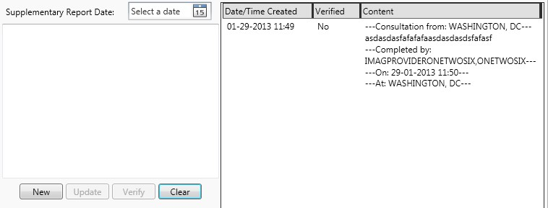

**Figure 51: Data entry for supplementary report**

The Supplementary tab allows users to enter new/update supplementary report. The field is a free text field. Users can only create a new supplementary report if none of the existing supplementary reports on the supplementary report list is selected. Otherwise, the content of the field will be populated with the content of the selected report and users can only make

updates given that it has not been verified yet. The verify button will be visible for users that have the credentials to perform that action.



**Figure 52: Search fields**

For searching inputs, usually it’s a combination of a free text field and a search button. The free text field requires at least two characters for the search function to be enabled.

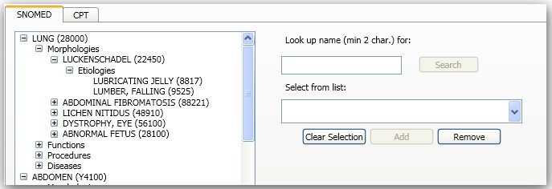

**Figure 53: Search combo controls**

For SNOMED Coding tab, existing SNOMED codes will be organized in a tree structure. The structure will start with Organ/Tissue level, then Morphologies, Functions, Procedures, and Diseases. Etiologies are sub-items of each Morphology branch. To add new SNOMED codes, users must select the appropriate grouping. Users can only add new Organ/Tissue SNOMED codes when the tree has nothing selected. They do this by clicking on Clear Selection. To remove existing SNOMED codes, users must select the code in the tree and click remove. If a group level item is selected, all sub-items will be removed along with the group.

For the rest of the application (such as notes, filter parameters,…), there are several free text controls to accept inputs. These controls standard controls for text entry from Windows.

## 8.3.Outputs

Results for search queries will be returned as items in a combo box

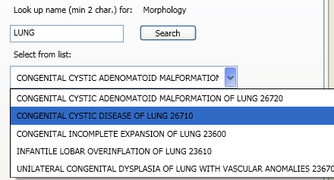

**Figure 54: Search outputs**

For the Main and Supplementary tabs, users will see existing data plus whatever they’ve entered in the session. Availability of the controls will be determined on whether or not the report has been verified and released. Once the main report has been verified and released, the data will be read-only.

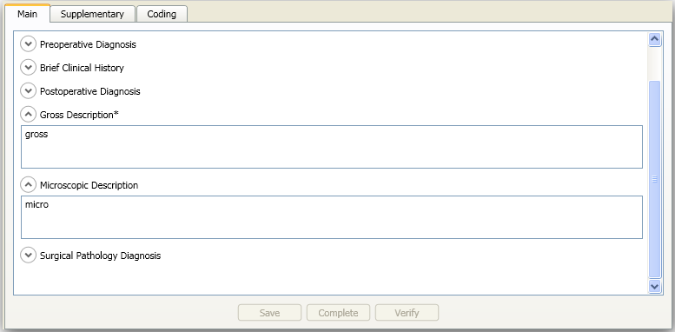

**Figure 55: Report outputs**

## 8.4.Navigation Hierarchy

The following sections show a graphic representation of the new applications and their key GUI components. The final look and feel of the GUI might be different than the screenshots here but the main functions will still be present.

### Telepathology Configurator

* + - 1. **Acquisition Site Setup**

This tab allows users to configure a list of acquisition sites. The worklist will retrieve case lists from sites in this list.

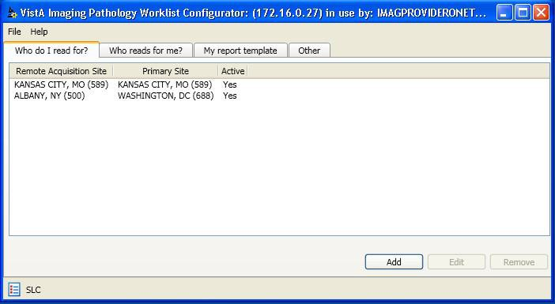

**Figure 56: Acquisition Site Setup GUI**

***Acquisition Site Add/Edit***

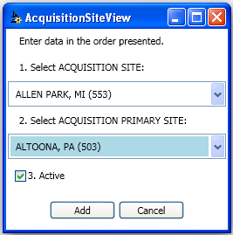

**Figure 57: New/Edit Acquisition Site GUI**

This GUI allows users to select a new site to be added or to modify the active status of existing site in the list.

* + - 1. **Reading Site Setup**

This tab allows users to configure a list of reading sites. Only sites on this list can request case list from their local VistA system. Users can request consultations to the active sites on this list.



**Figure 58: Reading Site Setup GUI**

***Reading Site Add/Edit***

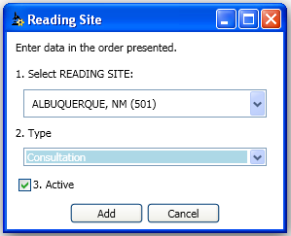

**Figure 59: New/Edit Reading Site GUI**

This GUI allows users to select new site to be added or to modify the site type and active status of existing sites in the list.

* + - 1. **Report Template**

This tab allows users to configure how the report looks in the report GUI at their sites. Users can select which report field is visible, ordering, and required fields.

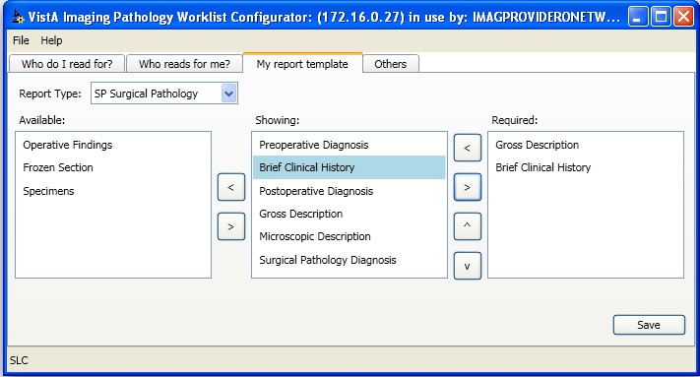

**Figure 60: Report Template Setting GUI**

* + - 1. **Others Settings**

This tab allows users to configure how their Pathology Worklist application works such as time out for report GUI. All fields must be in valid ranges to be able to save without error.



**Figure 61: Other Settings GUI**

* + 1. **Telepathology Worklist**
       1. **Main Worklists**



**Figure 62: Telepathology Worklist GUI**

The main worklist screen contains three main tabs identical in layout but different in content: Unread, Patient, and Read. The layout preferences will be saved to database based on individual user and system. Users can perform different actions on a case from this screen such as reserving, reporting, or requesting consultation.

* + - 1. **Consultation Requests Manager**



**Figure 63: Consultation Manager GUI**

For each case, users can use the Consultation GUI to request new consultations or recall pending consultations and or decline consultation requests. A list of sites will be available for choosing based on the site’s configuration.

* + - 1. **Health Summary Report**

This window allows users to configure their preferences for viewing patient records



**Figure 64: Health Summary List GUI**

* + - 1. **Worklist Filters**



**Figure 65: Worklist Filter GUI**

This screen allows users to modify their worklist filters. They can perform actions such as adding new filters, modifying or removing existing filters.

***Ad-hoc Worklist Filter***



**Figure 66: Temporary Worklist Filter Editor**

Users can also create an ad-hoc filter from existing applied filter or completely new filter.

8.4.3. **Notes**



**Figure 67: Notes editor**

User can also view and make notes for a case from the worklist.

8.4.4. **Message Log**



**Figure 68: Message Log Window**

A message log can be accessed from the main worklist. Depends on user’s role, system log may be enabled.

8.4.5. **Reporting**

Users can view existing data for the case or add extra data to the case for the report in the report GUI. The Main tab will contain all the primary data for the case. This data can be modified until the main report is verified and released.

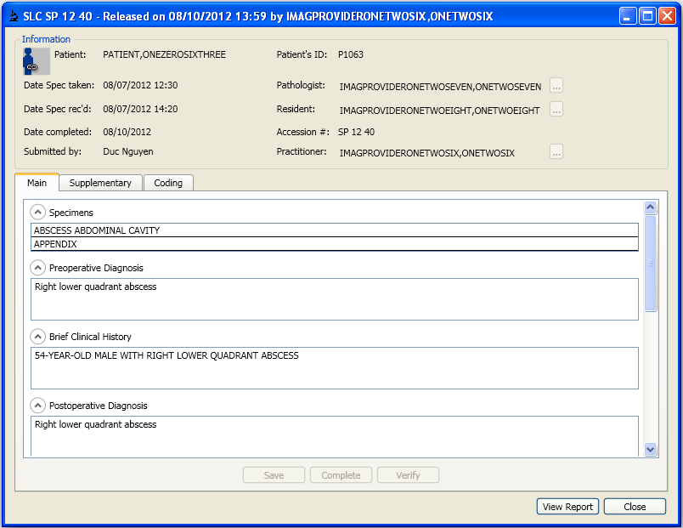

**Figure 69: Reporting GUI**

Supplementary tab allows users to enter additional information for the case or consultations.

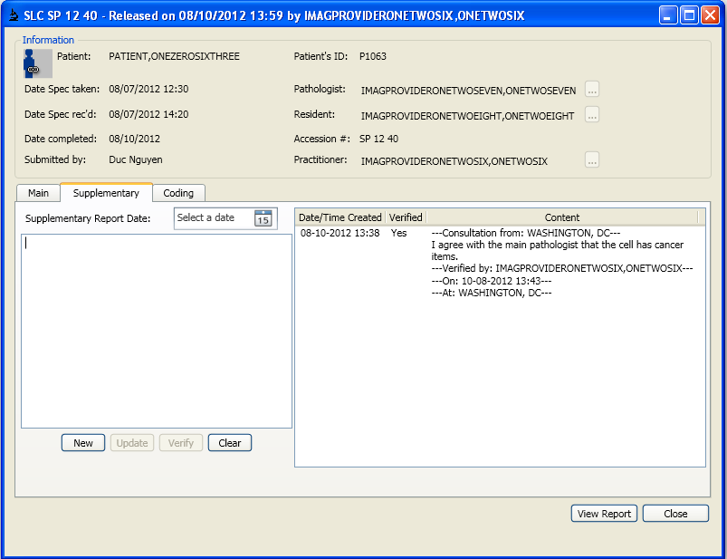

**Figure 70: Supplementary Report GUI**

The Coding tab allows users to enter appropriate codings for the case. SNOMED codes for case information and CPT codes for workload credit.

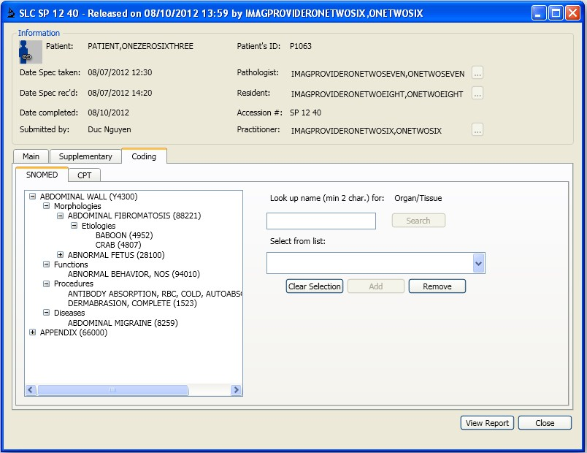

**Figure 71: SNOMED Coding GUI**

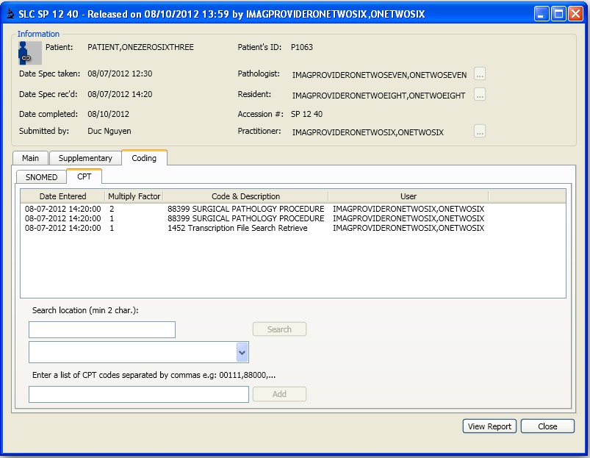

**Figure 72: CPT Coding GUI**

###### Users can also view the report as it is displayed in CPRS at any point in time.

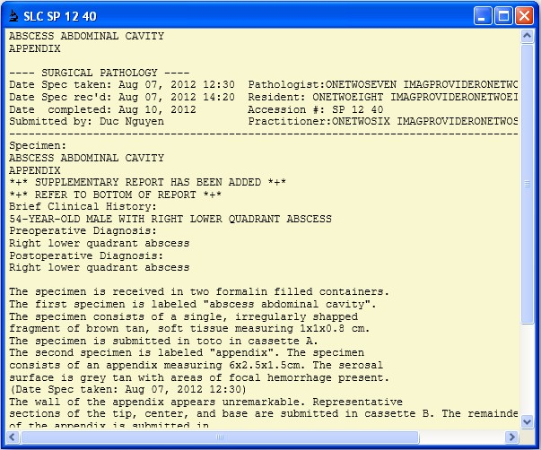

**Figure 73: CPRS Report GUI**

8.4.6. **Patient Sensitive Prompt**

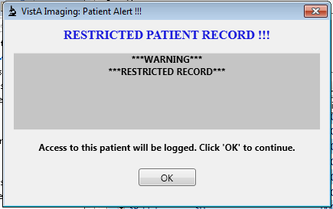

**Figure 74 Patient Sensitivity Prompt**

When a user is working on a case (edit report, view report, notes, viewing health summaries), if the patient of the case is sensitive, the user will be asked to acknowledge that the patient is sensitive and the access will be logged to VistA. Clicking on OK will record a log while canceling out will prevent the user from continuing with the actions.

# System Integrity Controls

###### There are no changes to the integrity control of the LAB package for the solution

# Appendix A

## Data Dictionaries (DDs)

|  |  |  |  |  |  |
| --- | --- | --- | --- | --- | --- |
| File Name and Number | MAG PATH CASELIST file (#2005.42) | | | |  |
| Enhancement Category | New |  | Modify | Delete | No Change |
| Requirements Traceability Matrix | TP-TPWL-FR-18, TP-TPWL-FR-19,TP-TPR-FR-13 | | | | |
| Related Options | MAGTP WORKLIST MGR | | |  |  |
| Data Dictionary (DD) References | NEW PERSON file (#200) | | |  |  |
| Related Protocols | N/A |  |  |  |  |
| Related Integration Control Registrations (ICRs) Agreements | | | | | |
| Data Passing | Input | Output | Both Reference | Global Reference | Local |
| File Documentation | Description  Telepathology CaseWorklist File: This file stores information for the Telepathology Worklist that cannot be stored in the LAB DATA file.  Storage tree  ^|"DVA"|MAG(2005.42,0) = 1="MAG PATH CASELIST",  2=2005.42, 3=highest IEN, 4=#  of entries  ^|"DVA"|MAG(2005.42,"B",CASE (cross-reference)  NUMBER,D0)  ^|"DVA"|MAG(2005.42,D0,0) = 1=CASE NUMBER, 2=PRIORITY,  3=SLIDE AVAILABLE , 4=FIRST LOCK, 5=FIRST LOCK DATE/TIME, 6=FIRST LOCK USER, 7=SECOND LOCK, 8=SECOND LOCK DATE/TIME, 9=SECOND LOCK USER, 10=METHOD  ^|"DVA"|MAG(2005.42,D0,1,0) = 1="NOTE", 2=2005.421,  3=highest IEN, 4=# of entries  ^|"DVA"|MAG(2005.42,D0,1,D1,0) 1=NOTE  =  2005.42, .01: CASE NUMBER, Case Accession Number  2005.42, 1: FIRST LOCK | | | | |

|  |  |
| --- | --- |
|  | 2005.42, 1.1: FIRST LOCK DATE/TIME  2005.42, 1.2: FIRST LOCK USER  2005.42, .04: METHOD  2005.42, 3: NOTE  2005.421, .01: NOTE  2005.42, .02: PRIORITY  2005.42, 2: SECOND LOCK  2005.42, 2.1: SECOND LOCK DATE/TIME  2005.42, 2.2: SECOND LOCK USER  2005.42, .03: SLIDE AVAILABLE  Traditional cross-reference(s) on single field(s) Cross-reference named "B" on Field CASE NUMBER (.01) S ^MAG(2005.42,"B",$E(X,1,30),DA)="" |
| File Auditing, Security, and Archiving |  |

|  |  |  |  |  |  |
| --- | --- | --- | --- | --- | --- |
| File Name and Number | MAG PATH INTERPRETATION file (#2005.43) | | | |  |
| Enhancement Category | New |  | Modify | Delete | No Change |
| Requirements Traceability Matrix | TP-CONSULTS-FR-1, TP-CONSULTS-FR-2, TP-CONSULTS-FR-3, TP-CONSULTS-FR-6 | | | | |
| Related Options | MAGTP WORKLIST MGR | | |  |  |
| Data Dictionary (DD) References | INSTITUTION file (#4) | | |  |  |
| Related Protocols | N/A |  |  |  |  |
| Related Integration Control Registrations (ICRs) Agreements | | | | | |
| Data Passing | Input | Output | Both Reference | Global Reference | Local |
| File Documentation | Description  Telepathology Interpretation File  This file stores information related to the Conlsultation/Interpretation functionality for Telepathology.  Storage tree  ^|"DVA"|MAG(2005.43,0) = 1="MAG PATH INTERPRETATION",  2=2005.43, 3=highest IEN, 4=# of entries  ^|"DVA"|MAG(2005.43,"B",CASE NUMBER,D0) (cross-reference)  ^|"DVA"|MAG(2005.43,D0,0) = 1=CASE NUMBER, 2=TYPE, 3=RESERVATION DATE/TIME, 4=INTERPRETING SITE, 5=PARENT INTERPRETATION INDEX, 6=STATUS  2005.43, .01: CASE NUMBER, Case Accession Number 2005.43, .04: INTERPRETING SITE  2005.43, .05: PARENT INTERPRETATION INDEX | | | | |

|  |  |
| --- | --- |
|  | 2005.43, .03: RESERVATION DATE/TIME  2005.43, .06: STATUS  2005.43, .02: TYPE  Traditional cross-reference(s) on single field(s) Cross-reference named "B" on Field CASE NUMBER (.01) S ^MAG(2005.43,"B",$E(X,1,30),DA)="" |
| File Auditing, Security, and Archiving |  |

|  |  |  |  |  |  |
| --- | --- | --- | --- | --- | --- |
| File Name and Number | MAG PATH CONFIG file (#2006.13) | | | |  |
| Enhancement Category | New | Modify | | Delete | No Change |
| Requirements Traceability Matrix | TP-TPWL-FR-10, TP-TPWL-FR-12, TP-TPWL-FR-14, TP-TPR-FR-13, TP-TPC-FR-2, TP-TPC-FR-4, TP-TPC-FR-5, TP-TPC-FR-6, TP-TPC- FR-7 | | | | |
| Related Options | MAGTP WORKLIST MGR | | |  |  |
| Data Dictionary (DD) References | NEW PERSON file (#200), INSTITUTION file (#4) | | | |  |
| Related Protocols | N/A |  |  |  |  |
| Related Integration Control Registrations (ICRs) Agreements | | | | | |
| Data Passing | Input | Output | Both Reference | Global Reference | Local |
| File Documentation | Description  Telepathology Configurations Stores site templates and other site-related parameters for the Telepathology GUI.  Storage tree  ^|"DVA"|MAG(2006.13,0) = 1="MAG PATH CONFIG", 2=2006.13,  3=highest IEN, 4=# of entries  ^|"DVA"|MAG(2006.13,"B",SITE,D0) (cross-reference)  ^|"DVA"|MAG(2006.13,D0,0) = 1=SITE  ^|"DVA"|MAG(2006.13,D0,4) = 1=NUMBER OF HOURS (LOCKING)  ^|"DVA"|MAG(2006.13,D0,1,0) = 1="CY TEMPLATE", 2=2006.131,  3=highest IEN, 4=# of entries  ^|"DVA"|MAG(2006.13,D0,1,D1,0) = 1=CY TEMPLATE  ^|"DVA"|MAG(2006.13,D0,2,0) = 1="EM TEMPLATE", 2=2006.132,  3=highest IEN, 4=# of entries  ^|"DVA"|MAG(2006.13,D0,2,D1,0) = 1=EM TEMPLATE  ^|"DVA"|MAG(2006.13,D0,3,0) = 1="SP TEMPLATE", 2=2006.133, | | | | |

3=highest IEN, 4=# of entries

^|"DVA"|MAG(2006.13,D0,3,D1,0) = 1=SP TEMPLATE

^|"DVA"|MAG(2006.13,D0,5,0) = 1="READING SITE LIST", 2=2006.135,

3=highest IEN, 4=# of entries

^|"DVA"|MAG(2006.13,D0,5,"B",READING SITE,D1) (cross-reference)

^|"DVA"|MAG(2006.13,D0,5,D1,0) = 1=READING SITE, 2=READING SITE TYPE, 3=ACTIVE

^|"DVA"|MAG(2006.13,D0,6,0) = 1="ACQUISITION SITE LIST",

2=2006.136, 3=highest IEN, 4=# of entries

^|"DVA"|MAG(2006.13,D0,6,"B",ACQUISITION SITE,D1) (cross-

reference)

^|"DVA"|MAG(2006.13,D0,6,D1,0) = 1=ACQUISITION SITE, 2=PRIMARY SITE, 3=ACTIVE

^|"DVA"|MAG(2006.13,D0,7,0) = 1="USER PREFERENCES", 2=2006.137,

3=highest IEN, 4=# of entries

^|"DVA"|MAG(2006.13,D0,7,"B",USER,D1) (cross-reference)

^|"DVA"|MAG(2006.13,D0,7,D1,0) = 1=USER

^|"DVA"|MAG(2006.13,D0,7,D1,1,0) = 1="USER LABEL", 2=2006.1371,

3=highest IEN, 4=# of entries

^|"DVA"|MAG(2006.13,D0,7,D1,1,"B",USER LABEL,D2) (cross-

reference)

^|"DVA"|MAG(2006.13,D0,7,D1,1,D2,0) = 1=USER LABEL

^|"DVA"|MAG(2006.13,D0,7,D1,1,D2,1,0) = 1="XML TEXT",

2=2006.1372, 3=highest IEN, 4=# of entries

^|"DVA"|MAG(2006.13,D0,7,D1,1,D2,1,D3,0) = 1=XML TEXT

2006.136, .01: ACQUISITION SITE

2006.13, 6: ACQUISITION SITE LIST

1. , .03: ACTIVE
2. , .03: ACTIVE

2006.13, 1: CY TEMPLATE

2006.131, .01: CY TEMPLATE

2006.13, 2: EM TEMPLATE

2006.132, .01: EM TEMPLATE

2006.13, 4: NUMBER OF HOURS (LOCKING), Number of hours before ignoring locks

2006.136, .02: PRIMARY SITE

2006.135, .01: READING SITE

2006.13, 5: READING SITE LIST

2006.135, .02: READING SITE TYPE

2006.13, .01: SITE

2006.13, 3: SP TEMPLATE

2006.133, .01: SP TEMPLATE

2006.137, .01: USER

2006.137, .02: USER LABEL

2006.1371, .01: USER LABEL

2006.13, 7: USER PREFERENCES

2006.1371, .02: XML TEXT

2006.1372, .01: XML TEXT

Traditional cross-reference(s) on single field(s)

Cross-reference named "B" on Field SITE (.01) S ^MAG(2006.13,"B",$E(X,1,30),DA)=""

Traditional cross-reference(s) on single field(s) Cross-reference named "B" on Field READING SITE (.01) S ^MAG(2006.13,DA(1),5,"B",$E(X,1,30),DA)=""

Traditional cross-reference(s) on single field(s)

Cross-reference named "B" on Field ACQUISITION SITE (.01) S ^MAG(2006.13,DA(1),6,"B",$E(X,1,30),DA)=""

Traditional cross-reference(s) on single field(s) Cross-reference named "B" on Field USER LABEL (.01) S ^MAG(2006.13,DA(2),7,DA(1),1,"B",$E(X,1,30),DA)=""

File 2006.13 is MAG PATH CONFIG

Field .01 is SITE Field information

The value of this field is stored in:

$PIECE(^|"DVA"|MAG(2006.13,D0,0),"^",1)

or $PIECE(^|"DVA"|MAG(2006.13,DA,0),"^",1)

|  |  |  |  |
| --- | --- | --- | --- |
| Last update was on 20 June 2012 Data type is "RP4'".  P = pointer to 4 = ^DIC(4,x,0), INSTITUTION |  | | |
| Learn As You Go Access is not granted. |
| R = required |
| General description |
| This is the local Site. |
| Syntax help text is |
| Enter the local Site IEN. Type a number between decimal digits. | 1 and | 10000, | 0 |
| Input transformation |  |  |  |

Q

Quit

Cross-reference, name is "B", type is "".

The cross-reference named "B" on Field SITE (.01) in file MAG PATH CONFIG (2006.13) is not executed when restoring data from 'interim archive'.

SET and KILL logic are standard (^MAG(2006.13,"B",<value>,DA)).

File 2006.13 is MAG PATH CONFIG

Field 1 is CY TEMPLATE Field information

The value of this field is stored in: sub-file ^|"DVA"|MAG(2006.13,D0,1,D1,0)

or sub-file ^|"DVA"|MAG(2006.13,DA(1),1,DA,0)

Data type is "2006.131".

2006.131 = multiple values stored in

^|"DVA"|MAG(2006.13,D0,1,D1,0)

(2006.131 = CY TEMPLATE)

General description

This is the XML template detailing the list of Lab Data fields to display in the GUI for Cytopathology (CY).

File 2006.131 is MAG PATH CONFIG (2006.13)

* CY TEMPLATE

Field .01 is CY TEMPLATE Field information

The value of this field is stored in:

$PIECE(^|"DVA"|MAG(2006.13,D0,1,D1,0),"^",1)

or $PIECE(^|"DVA"|MAG(2006.13,DA(1),1,DA,0),"^",1)

Last update was on 20 June 2012 Data type is "Wx".

W = word processing

x = input transformation performs I/O (aaaaargh!)

General description

This is the XML template detailing the list of Lab Data fields to display in the GUI for Cytopathology (CY).

Syntax help text is

Enter the XML code that displays the template for the Cytopathology GUI.

File 2006.13 is MAG PATH CONFIG

Field 2 is EM TEMPLATE Field information

The value of this field is stored in:

sub-file ^|"DVA"|MAG(2006.13,D0,2,D1,0)

or sub-file ^|"DVA"|MAG(2006.13,DA(1),2,DA,0)

Data type is "2006.132".

2006.132 = multiple values stored in

^|"DVA"|MAG(2006.13,D0,2,D1,0)

(2006.132 = EM TEMPLATE)

General description

This is the XML template detailing the list of Lab Data fields to display in the GUI for EM.

File 2006.132 is MAG PATH CONFIG (2006.13)

* EM TEMPLATE

Field .01 is EM TEMPLATE Field information

The value of this field is stored in:

$PIECE(^|"DVA"|MAG(2006.13,D0,2,D1,0),"^",1)

or $PIECE(^|"DVA"|MAG(2006.13,DA(1),2,DA,0),"^",1)

Last update was on 20 June 2012 Data type is "Wx".

W = word processing

x = input transformation performs I/O (aaaaargh!)

General description

This is the XML template detailing the list of Lab Data fields to display in the GUI for EM.

Syntax help text is

Enter the XML code that displays the template for the EM GUI.

File 2006.13 is MAG PATH CONFIG

Field 3 is SP TEMPLATE Field information

The value of this field is stored in:

sub-file ^|"DVA"|MAG(2006.13,D0,3,D1,0)

or sub-file ^|"DVA"|MAG(2006.13,DA(1),3,DA,0)

Data type is "2006.133".

2006.133 = multiple values stored in

^|"DVA"|MAG(2006.13,D0,3,D1,0)

(2006.133 = SP TEMPLATE)

General description

This is the XML template detailing the list of Lab Data fields to display in the GUI for Surgical Pathology (SP).

File 2006.133 is MAG PATH CONFIG (2006.13)

* SP TEMPLATE

Field .01 is SP TEMPLATE Field information

The value of this field is stored in:

$PIECE(^|"DVA"|MAG(2006.13,D0,3,D1,0),"^",1)

or $PIECE(^|"DVA"|MAG(2006.13,DA(1),3,DA,0),"^",1)

Last update was on 20 June 2012 Data type is "Wx".

W = word processing

x = input transformation performs I/O (aaaaargh!)

General description

This is the XML template detailing the list of Lab Data fields to display in the GUI for Surgical Pathology (SP).

Syntax help text is

Enter the XML code that displays the template for the Surgical Pathology GUI.

File 2006.13 is MAG PATH CONFIG Field 4 is NUMBER OF HOURS (LOCKING)

Number of hours before ignoring locks

Field information

The value of this field is stored in:

$PIECE(^|"DVA"|MAG(2006.13,D0,4),"^",1)

or $PIECE(^|"DVA"|MAG(2006.13,DA,4),"^",1)

Last update was on 20 June 2012 Data type is "NJ9,4".

J = fixed width, right adjusted, width is 9 digits with 4 digits following the decimal point

N = numeric value

General description

This is the number of hours before an access lock expires.

Syntax help text is

Enter the number of hours before the accession lock expires. Type a number between 0 and 9999, 4 decimal digits.

Input transformation

; Referenced variables and labels:

; .E15.N

; X

;

K:+X'=X!(X>9999)!(X<0)!(X?.E1"."5.N) X

Quit

File 2006.13 is MAG PATH CONFIG Field 5 is READING SITE LIST

Field information

The value of this field is stored in: sub-file ^|"DVA"|MAG(2006.13,D0,5,D1,0)

or sub-file ^|"DVA"|MAG(2006.13,DA(1),5,DA,0)

Data type is "2006.135P".

2006.135 = multiple values stored in

^|"DVA"|MAG(2006.13,D0,5,D1,0)

(2006.135 = READING SITE LIST)

P = pointer to 4 = ^DIC(4,x,0), INSTITUTION Learn As You Go Access is granted.

General description

This is the list of sites allowed to read a case in this site.

File 2006.135 is MAG PATH CONFIG (2006.13)

* READING SITE LIST

Field .01 is READING SITE

Field information

The value of this field is stored in:

$PIECE(^|"DVA"|MAG(2006.13,D0,5,D1,0),"^",1)

or $PIECE(^|"DVA"|MAG(2006.13,DA(1),5,DA,0),"^",1)

Last update was on 20 June 2012 Data type is "P4'".

P = pointer to 4 = ^DIC(4,x,0), INSTITUTION Learn As You Go Access is not granted.

General description

This is the list of sites allowed to read a case in this site.

Syntax help text is

Enter the sites allowed to read from this site. Answer must be 1-6 characters in length.

Input transformation Q

Quit

Cross-reference, name is "B", type is "".

The cross-reference named "B" on Field READING SITE (.01) in file READING SITE LIST (2006.135) is not executed when restoring data from 'interim archive'.

SET and KILL logic are standard (^MAG(2006.13,DA(1),5,"B",<value>,DA)).

File 2006.135 is MAG PATH CONFIG (2006.13)

* READING SITE LIST

Field .02 is READING SITE TYPE

Field information

The value of this field is stored in:

$PIECE(^|"DVA"|MAG(2006.13,D0,5,D1,0),"^",2)

or $PIECE(^|"DVA"|MAG(2006.13,DA(1),5,DA,0),"^",2)

Last update was on 20 June 2012 Data type is "S".

S = multiple choice value

0 = PRIMARY

1 = CONSULTATION

2 = BOTH

General description

This is the type of site in the reading list.

Syntax help text is

Enter the type of site in the reading list.

Input transformation Q

Quit

File 2006.135 is MAG PATH CONFIG (2006.13)

* READING SITE LIST

Field .03 is ACTIVE Field information

The value of this field is stored in:

$PIECE(^|"DVA"|MAG(2006.13,D0,5,D1,0),"^",3)

or $PIECE(^|"DVA"|MAG(2006.13,DA(1),5,DA,0),"^",3)

Last update was on 20 June 2012 Data type is "S".

S = multiple choice value

0 = NO

1 = YES

General description

This flag indicates whether a site in the reading list is active or not.

Syntax help text is

Select whether the site is active.

Input transformation Q

Quit

File 2006.13 is MAG PATH CONFIG Field 6 is ACQUISITION SITE LIST

Field information

The value of this field is stored in: sub-file ^|"DVA"|MAG(2006.13,D0,6,D1,0)

or sub-file ^|"DVA"|MAG(2006.13,DA(1),6,DA,0)

Data type is "2006.136P".

2006.136 = multiple values stored in

^|"DVA"|MAG(2006.13,D0,6,D1,0)

(2006.136 = ACQUISITION SITE LIST)

P = pointer to 4 = ^DIC(4,x,0), INSTITUTION Learn As You Go Access is granted.

General description

This is the list of sites holding cases this site is allowed to read.

File 2006.136 is MAG PATH CONFIG (2006.13)

* ACQUISITION SITE LIST

Field .01 is ACQUISITION SITE

Field information

The value of this field is stored in:

$PIECE(^|"DVA"|MAG(2006.13,D0,6,D1,0),"^",1)

or $PIECE(^|"DVA"|MAG(2006.13,DA(1),6,DA,0),"^",1)

Last update was on 20 June 2012 Data type is "P4'".

P = pointer to 4 = ^DIC(4,x,0), INSTITUTION

Learn As You Go Access is not granted.

General description

This is the list of sites holding cases this site is allowed to read.

Syntax help text is

Enter an acquisition site. Answer must be 1-6 characters in length.

Input transformation Q

Quit

Cross-reference, name is "B", type is "".

The cross-reference named "B" on Field ACQUISITION SITE (.01) in file ACQUISITION SITE LIST (2006.136) is not executed when restoring data from 'interim archive'.

SET and KILL logic are standard (^MAG(2006.13,DA(1),6,"B",<value>,DA)).

File 2006.136 is MAG PATH CONFIG (2006.13)

* ACQUISITION SITE LIST Field .02 is PRIMARY SITE

Field information

The value of this field is stored in:

$PIECE(^|"DVA"|MAG(2006.13,D0,6,D1,0),"^",2)

or $PIECE(^|"DVA"|MAG(2006.13,DA(1),6,DA,0),"^",2)

Last update was on 20 June 2012 Data type is "P4'".

P = pointer to 4 = ^DIC(4,x,0), INSTITUTION

Learn As You Go Access is not granted.

General description

This is the primary site for the corresponding acquisition site.

Syntax help text is

Enter the primary site for the corresponding acquisition site. Answer must be 1-6 characters in length.

Input transformation Q

Quit

File 2006.136 is MAG PATH CONFIG (2006.13)

* ACQUISITION SITE LIST

Field .03 is ACTIVE

Field information

The value of this field is stored in:

$PIECE(^|"DVA"|MAG(2006.13,D0,6,D1,0),"^",3)

or $PIECE(^|"DVA"|MAG(2006.13,DA(1),6,DA,0),"^",3)

Last update was on 20 June 2012 Data type is "S".

S = multiple choice value

0 = NO

1 = YES

General description

This flag indicates whether a site in the acquisition list is active or not.

Syntax help text is

Select whether the site is active.

Input transformation Q

Quit

File 2006.13 is MAG PATH CONFIG Field 7 is USER PREFERENCES

Field information

The value of this field is stored in: sub-file ^|"DVA"|MAG(2006.13,D0,7,D1,0)

or sub-file ^|"DVA"|MAG(2006.13,DA(1),7,DA,0)

Last update was on 5 July 2012 Data type is "2006.137P".

2006.137 = multiple values stored in

^|"DVA"|MAG(2006.13,D0,7,D1,0)

(2006.137 = USER PREFERENCES)

P = pointer to 200 = ^VA(200,x,0), NEW PERSON

Learn As You Go Access is granted.

General description

This field records a user together with the user's Worklist preferences.

File 2006.137 is MAG PATH CONFIG (2006.13)

* USER PREFERENCES

Field .01 is USER

Field information

The value of this field is stored in:

$PIECE(^|"DVA"|MAG(2006.13,D0,7,D1,0),"^",1)

or $PIECE(^|"DVA"|MAG(2006.13,DA(1),7,DA,0),"^",1)

Last update was on 5 July 2012 Data type is "P200'".

P = pointer to 200 = ^VA(200,x,0), NEW PERSON

Learn As You Go Access is not granted.

General description

This is the user whose Worklist preferences are stored.

Syntax help text is

Enter the user whose Worklist preferences are stored.

Input transformation Q

Quit

Cross-reference, name is "B", type is "".

The cross-reference named "B" on Field USER (.01) in file USER PREFERENCES (2006.137) is not executed when restoring data from 'interim archive'.

Missing marker for simple cross-reference.

field USER (.01) in File USER PREFERENCES (2006.137) defines a cross-reference named "B" for file NEW PERSON (200), but that file does not contain a marker for this cross-reference.

Standard reference is ^MAG(2006.13,DA(1),7,"B",<value>,DA)

SET logic is

; Referenced variables and labels:

; DA

; DA()

; X

; ^MAG(,,,)

;

S ^MAG(2006.13,DA(1),7,"B",$E(X,1,30),DA)=""

Quit

KILL logic is

; Referenced variables and labels:

; DA

; DA()

; X

; ^MAG(,,,)

;

K ^MAG(2006.13,DA(1),7,"B",$E(X,1,30),DA)=""

Quit

File 2006.137 is MAG PATH CONFIG (2006.13)

* USER PREFERENCES

Field .02 is USER LABEL Field information

The value of this field is stored in:

sub-file ^|"DVA"|MAG(2006.13,D0,7,D1,1,D2,0)

or sub-file ^|"DVA"|MAG(2006.13,DA(2),7,DA(1),1,DA,0)

Data type is "2006.1371".

2006.1371 = multiple values stored in

^|"DVA"|MAG(2006.13,D0,7,D1,1,D2,0)

(2006.1371 = USER LABEL)

General description

This is the label under which user's preferences are stored.

File 2006.1371 is MAG PATH CONFIG (2006.13)

* USER PREFERENCES (2006.137)
* - USER LABEL

Field .01 is USER LABEL Field information

The value of this field is stored in:

$PIECE(^|"DVA"|MAG(2006.13,D0,7,D1,1,D2,0),"^",1)

or $PIECE(^|"DVA"|MAG(2006.13,DA(2),7,DA(1),1,DA,0),"^",1)

Last update was on 12 July 2012 Data type is "F".

F = free text

General description

This is the label under which user's preferences are stored.

Syntax help text is

Enter the label under which the user's preferences are stored. Answer must be 1-30 characters in length.

Input transformation

; Referenced variables and labels:

; X

;

K:$L(X)>30!($L(X)<1) X

Quit

Cross-reference, name is "B", type is "".

The cross-reference named "B" on Field USER LABEL (.01) in file USER LABEL (2006.1371) is not executed when restoring data from 'interim archive'.

SET and KILL logic are standard (^MAG(2006.13,DA(2),7,DA(1),1,"B",<value>,DA)).

File 2006.1371 is MAG PATH CONFIG (2006.13)

* USER PREFERENCES (2006.137)
* - USER LABEL

Field .02 is XML TEXT Field information

The value of this field is stored in:

sub-file ^|"DVA"|MAG(2006.13,D0,7,D1,1,D2,1,D3,0)

or sub-file ^|"DVA"|MAG(2006.13,DA(3),7,DA(2),1,DA(1),1,DA,0)

Data type is "2006.1372".

2006.1372 = multiple values stored in

^|"DVA"|MAG(2006.13,D0,7,D1,1,D2,1,D3,0)

(2006.1372 = XML TEXT)

General description

This is the XML text detailing the user's Worklist preferences associated to a label.

File 2006.1372 is MAG PATH CONFIG (2006.13)

* USER PREFERENCES (2006.137)

- - USER LABEL (2006.1371)

* - - XML TEXT

Field .01 is XML TEXT Field information

The value of this field is stored in:

$PIECE(^|"DVA"|MAG(2006.13,D0,7,D1,1,D2,1,D3,0),"^",1)

or

$PIECE(^|"DVA"|MAG(2006.13,DA(3),7,DA(2),1,DA(1),1,DA,0),"^",1)

Last update was on 12 July 2012 Data type is "Wx".

W = word processing

x = input transformation performs I/O (aaaaargh!) General description

|  |  |
| --- | --- |
|  | This is the XML text detailing the user's Worklist preferences associated to a label.  Syntax help text is  Enter the XML text containing the user's Worklist preferences associated to a label. |
| File Auditing, Security, and Archiving |  |

## Requirements Traceability Matrix

###### N/A

## Packaging and Installation

###### The normal process for building and distribution is used for the solution.

## Design Metrics

###### This section is not applicable to the solution.

## Glossary of Terms

**Table 9: Glossary of Terms**

|  |  |
| --- | --- |
| **Term** | **Meaning** |
| Acquisition site | Refers to the originating location of the case |
| Primary Acquisition Site | Refers to the site that actually hosts the VistA database |
| CCOW | Clinical Context Object Workgroup |
| Concurrence | Agreement of opinion |
| Consultation | An opinion from a different expert on the matter |
| Consultation Site | A remote site that provide consultations for pathology cases |
| CPRS | Computerized Patient Record System |
| DD | Data Dictionary |
| DICOM | Digital Imaging and Communication in Medicine |
| EHR | Electronic Health Record |
| GUI | Graphical User Interface |
| HL7 | Health Level Seven |
| (Primary) Interpretation Site | A site that provides primary reading for a case, usualy locally but can be remotely |

|  |  |
| --- | --- |
| IT | Information Technology |
| LSRP | Laboratory System Reengineering Project |
| MVVM | Model-View-ViewModel |
| Pathology | The branch of medicine concerned with the cause, origin, and nature of disease, including the changes occurring as a result of disease. |
| RPC | Remote Procedure Call |
| RSD | Requirements Specification Document |
| SPI | Sensitive Patient Information |
| Telepathology | The use of telecommunications technology to facilitate the transfer of image-rich pathology data between remote locations for the purposes of diagnosis, education, and research. |
| TFS | Team Foundation Server |
| VA | Veteran Affairs |
| VHA | Veterans Health Administration |
| VISA | VistA Imaging Service Oriented Architecture |
| VistA | Veterans Health Information Systems and Technology Architecture |
| VI | VistA Imaging |
| VITA | VistA Imaging Telepathology Applications |
| VIX | VistA Imaging Exchange Service |
| WPF | Windows Presentation Foundation |
| WSS | Whole Slide Scan and/or Scanner |
| WSI | Whole Slide Images/Imaging |

## Required Technical Documents

*The following documents must be submitted for review to support proper approval:*

* Product Architecture Document;
* Disaster Recovery Plan;
* Interface Data Mapping
* Conformance Validation Statement (CVS) - Section 508

# Attachment A - Approval Signatures

###### This section is used to document the approval of the System Design Document during the Formal Review. The review should be ideally conducted face to face where signatures can be obtained ‘live’ during the review however the following forms of approval are acceptable:

1. Physical signatures obtained face to face or via fax
2. Digital signatures tied cryptographically to the signer
3. /es/ in the signature block provided that a separate digitally signed e-mail indicating the signer’s

approval is provided and kept with the document

###### The Chair of the governing Integrated Project Team (IPT), Business Sponsor, IT Program Manager, Project Manager, and the members of the Technical and Enterprise Architectural Review Team are required to sign. . Until the Engineering and Architecture Review Board is stood up, both the Engineering IPT member(s) and the Architecture IPT member(s) must approve/sign the SDD. Please annotate signature blocks accordingly.

###### __

Signed: Date:

*< Integrated Project Team (IPT) Chair >*

###### __

Signed: Date:

*< Business Sponsor >*

###### __

Signed: Date:

*< IT Program Manager >*

###### __

Signed: Date:

*< Project Manager >*

###### __

Signed: Date:

*< Enterprise Architecture>*

###### __

Signed: Date:

*< Service Delivery and Engineering >*